* ££££**************** BRECk H CAMP CML

PO BOX 47070

ATLANTA GA 30362-0070

**OFFICIAL INTERNATIONAL PUBLICATION OF THE ASSOCIATED LOCKSMITHS OF AMERICA, INC**

The Ambassador

Joe Lee, ALOA’s 28-year old Ambassador of Goodwill, is paving the way for communi­cation between Korean and English-speaking locksmiths. He makes routine trips to Korea, meets with the Korean chapter and visits Korean- owned lockshops—all with one goal in mind: to find out how ALOA can better serve Korean members. With his feet planted in two worlds with different languages, cus­toms and cultures, Joe Lee explains how both groups can come together.

Also** **Access Control Without Wires •** Mechanical **11s. Electrical** Systems **•** Board **Reports**

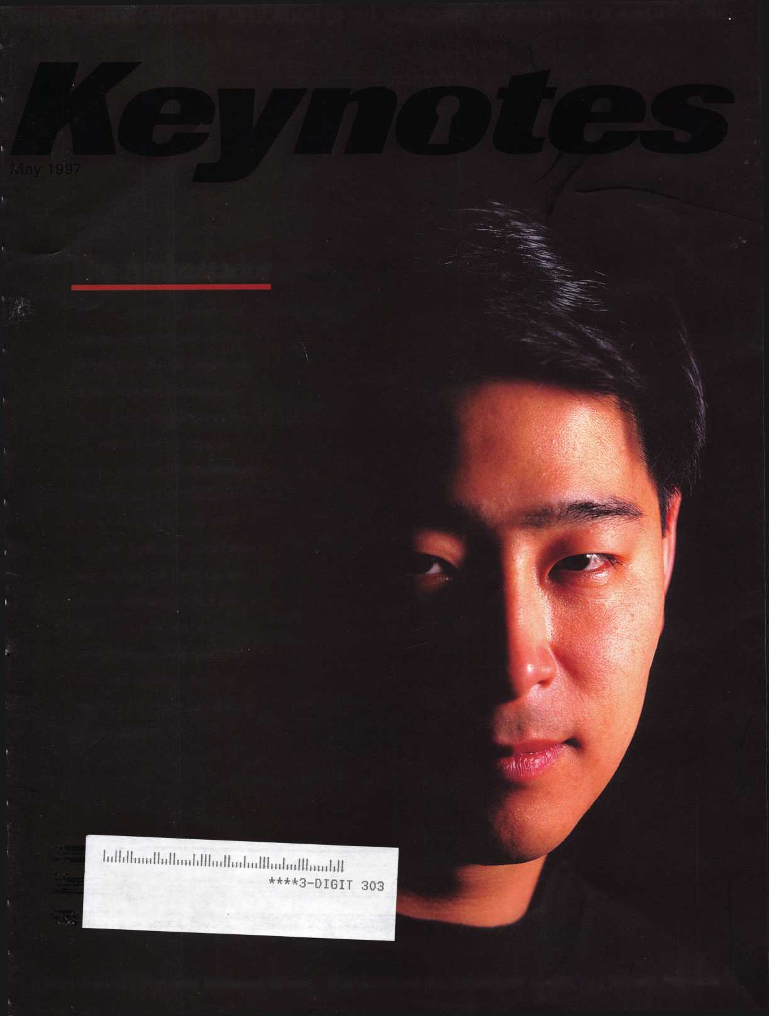

**RENO, NEVADA**

**UGUST 2,1997  
ONVENTION CENTER**

**ALOA ’97**

**ND SECURITY**

**XPO**

**WITH QUESTIONS OR COMMENTS CONTACT:**

**ASSOCIATED LOCKSMITHS OF AMERICA, INC. 3003 LIVE OAK ST.**

**DALLAS, TEXAS 75204**

**214-827-1701**

**800-532-2562**

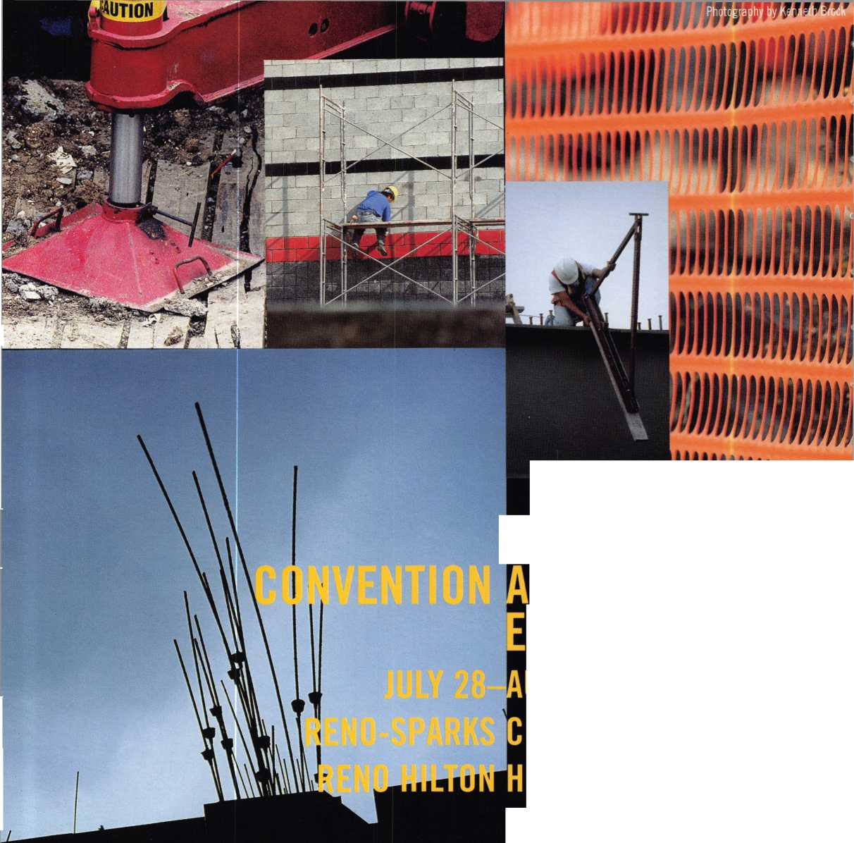

of „etwor¥ng.

**and Canada using the**

nKB..^uj^^HnEicoiiK^minRilSR^Snwflr_i_ ; j.il _

**Welcome to**

**Resource Search Library Forums Links**

**Member Index Press Releases**

**Associations**

**The Security Information Management On-Line Network**

**Employment**

**Listings**

AlphaScan *GL*

rn i ii Li 1 ii rm-B8Bv-^i»« k

**fet^yVf'/v^iy^rwi.'si'Tri oifrtii €tj t fc (Dm**

'r-

r i r r i f r r i i r i

CLKnow.

'••MJ

—1—

SIMON- The Security Information Management On-Line Network.

The SIMON image is a Registered Trademark of Locksmith Publishing Corp.

Free Information - Reader Service Card #3

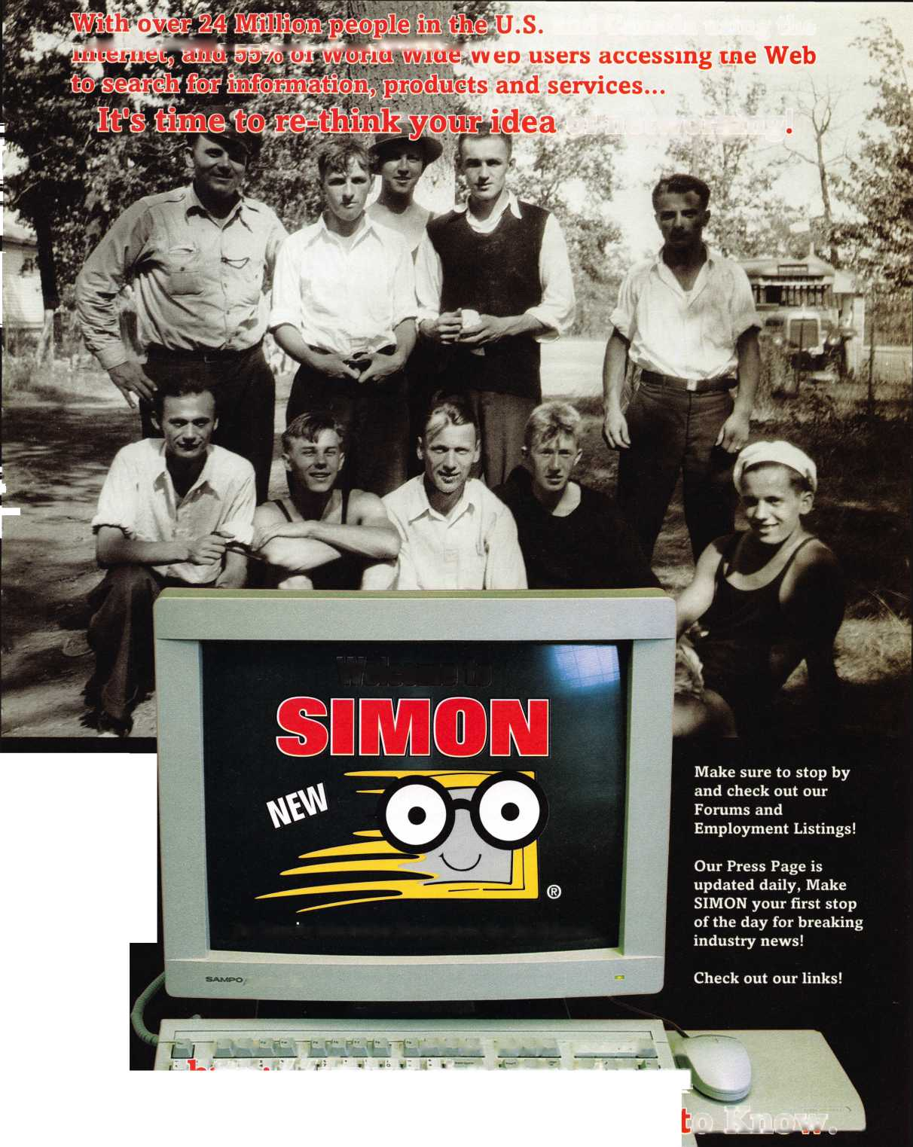

We’re doing all we can afford to do—and it’s not enough.

When I became the president of ALOA at the end of the convention in July 1995, many of  
you contacted me about the overwhelming issues now facing the locksmithing profession.

In response I, along with ALOA leadership, have struggled to come up with solutions to  
problems we didn’t have 10 years ago, maybe not even five years ago. Now that I’m nearing  
the end of my term, I have come to the painful conclusion that the very thing some mem-  
bers complain about is true: ALOA isn’t doing enough. As much as your association tries to  
meet your most important professional needs, the fact is that we have been falling short for  
several years. Why? Because we’re doing all that we can afford to do. Because dues barely  
cover the association basics: convention, this magazine, ACE classes (and not nearly enough  
of them), the PRP program. Those are important benefits but it’s just not enough these  
days.

Both the ALOA board and staff have initiated many changes to cut the “cost of doing  
business,” such as:

* The Headquarters ALOA staff has been cut from a high of 18 in July ’95 to the current 15, with a savings of approximately $100,000 in additional salaries and benefits per year.
* We now hold both the fall and spring board meetings in Dallas to cut down on staff travel and housing expenses for a savings of $10,000 to $15,000.
* The Education Committee in the past had a separate three- to four-day meeting in September at a cost of $12,000 to $15,000. This meeting is now just one day during the - regular spring board meeting, eliminating the cost of airfare and hotel for a separate meeting.
* Several board members have voluntarily given up their per diem allowances for expenses at meetings and the annual convention.
* Because we have had to use outside vendors for processing and delivery of membership ID cards and certificates, it has been an expensive, time sensitive and logistical problem for many years. After this year’s renewal batch, we now have the capability of producing these in-house on our own equipment at a greatly reduced cost and in a very timely manner.
* In an effort to further reduce costs by $10,000 to $15,000, the board of directors will be proposing that we reduce the number of directors to nine (which is the minimum required in the Bylaws) at the upcoming membership meeting during the convention in Reno.

ALOA’s 1998 dues will be $125. I feel it is important to let you know far enough in advance so that you can prepare for the increase. I hope you will not consider an additional two dollars a months much for all we plan to give you in return. We will continue to look for additional ways to cut costs while providing the level of service that an international association should provide. We will also be seeking funding from a variety of industry sources, and we are actively involved in a campaign to recruit additional members to reduce the need for future large dues increases. Additional funds will be the critical factor in the challenges we face.

i

<

Keynotes

May 1997

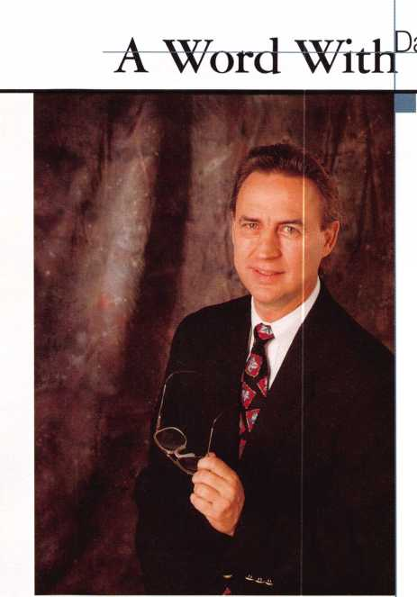

“If you want to be a big company tomorrow, you’ve got to start acting like one today.”

Thomas J. Watson, Jr. Founder of IBM

Number One. Were going to win the legislation  
game, whatever it takes. The lucrative market for elec-  
tronic access control and CCTV installations has proven  
such a temptation that entities only remotely related to  
locksmithing have almost succeeded in legislating us  
out of existence. We are going to do all that is necessary  
to fight the legislative efforts of certain large organiza-

tions that in the past have been better financed and equipped than ALOA.

Number One, too. We desperately need increased, affordable education for our members.  
Electronic access control, ADA compliance, vehicle security, safety systems and many more  
high tech items are making locksmithing in the ’90s a challenge to learn and maintain.  
Traditional approaches to training, such as apprenticeship, have their benefits, but our busi-  
ness has grown far too sophisticated to rely on these methods alone. ALOA has spent years  
developing a thorough curriculum for locksmith education, and it is well past time to  
implement this program. Accordingly, we plan to add a full-time education manager to the  
ALOA Headquarters—someone capable of structuring top quality classes supported by the  
latest equipment and taught by the best instructors with the possibility of advanced delivery  
systems such as audio/video cassette and computer based instructions.

Thomas J. Watson, Jr., the founder of IBM, said, “If you want to be a big company  
tomorrow, you’ve got to start acting like one today.” Looking around at what’s happening to  
locksmiths across the country and around the world, I believe the time has come for us to  
start acting like an international association.

I believe that together we can do it.

-David Lowell, CML, CMS

April 1997

***Keynotes***

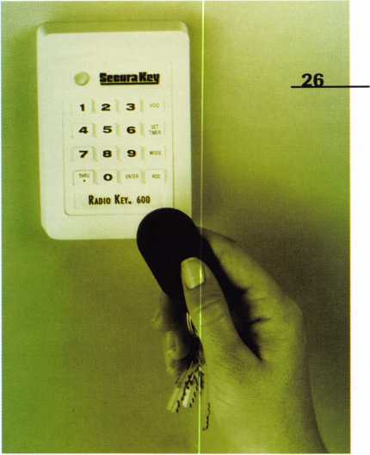

**May**

Volume 43,

ssue

A Word with David Lowell

9

Legislative Comment

By John Greenan

52

PRP Report

Chapters Should Pitch-In By James Watt, CML, CPS

54

Trade Tips

Picks, Cuts and Hondas By Tony Rammuno, CML, CPS

57

Focus on Education

IPs Everywhere You Look By James Glazier, CML

59

Chapter News

Suggestions to Boost Meeting Attendance By Dana Barnum, CML

7

Mailbox

Important people

10

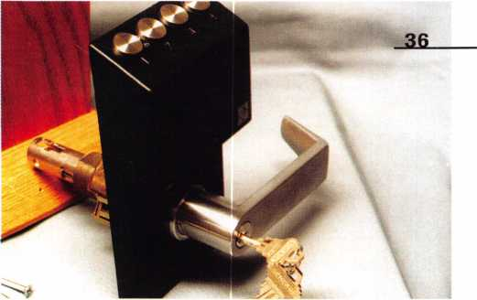

12

Applicants for Membership

Scheduled for clearance by June I

14

Industry News

Awards and online

15

Security Marketplace

Lots of new products

55

ALOA Extra

Get the password

60

Back Page

Just part of the job?

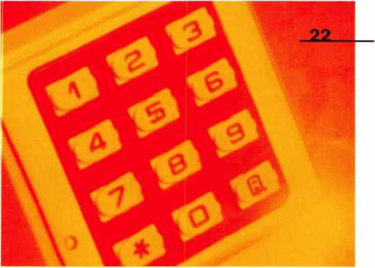

44

Associate Members

49

Classifieds

51

Buyers Guide

55

Ad Index



Keynotes

May 1997

**Columns Departments**

o

3

**cu**

0



3 0 Cover

**The Ambassador**

Meet the young guy who’s responsible for helping Korean

and American locksmiths unite.

By Laurie Kline

**Mechanical vs. Electrical Systems**

Learn about the requirements for multiple codes, and feast your eyes on some pretty fancy equations that’ll help you make sense of system combinations.

By Kim Bowers, CML and Ethan Benatan

26

**Are You Ready to Step Into Access Control?**

If access control is an animal you’ve been waiting to tame, here’s a chance to learn what it’s all about.

By Mark Ohno

33

**Access Control Without Wires**

A look at a few new products that take you into the new wave in locksmithing technology.

By Paul F. Chandler, CRL

36

**Electronic Access Control from Nanotechnology**

The latest and greatest version of Nanotech’s locksets, the installation procedure, programming and coding.

By Sal Dulcamara, CML

Featured:also

17

**Spring Board Reports**

21

**Dallas Brooks: Profile of a Presidential Nominee**

34

**[www.aloa.org](http://www.aloa.org)**

Everything you’ve ever needed and wanted to know about the ALOA web site.

By Kim Bowers, CML

40

**Master Keying 101, Part II**

More on the practice of master keying. Read about the capa­bilities of disc, lever and pin tumbler locks.

By Sal Dulcamara, CML

CD

O

O

May 1997

Keynotes

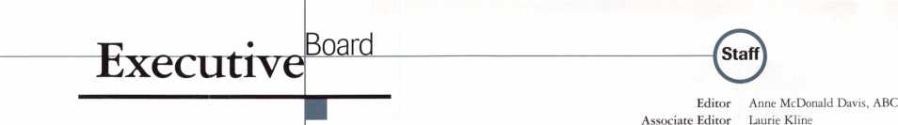

President

David M. Lowell, CML, CMS [602) 263-7716 Regional Vice Presidents Southeast

Dallas C. Brooks

Chairman: Finance Committee

C334) 826-8990

North Central

David A. Paulsrud, Sr., CML

Chairman: ALOA Scholarship Foundation, Inc.

C612) 533-6164

South Central

Carl King, CML

Chairman: Bylaws Committee

Curator: ALOA Museum

[713) 465-2500

Southwest

John I. Shandy, CML

Chairman: Membership Committee

C303) 443-9740

Northeast

John D. Cannon, CML

Chairman: Publications Committee

(703) 960-6413

Northwest

James M. Watt, CML, CPS Chairman: PRP Committee (406) 549-7667

Secretary

Ricardo Ohmit, CML (217) 384-6006

Trustees:

Breck H. Camp, CML, Chairman

(770) 455-6244

Henry H. Printz, CML

(201) 538-2737

Evelyn V. Wersonick, CML, CPS

(505) 247-9413

Leonard J. Passarello, CPL

(416) 752-7210

Edwin Toepfer, RL

(416) 225-5589

Directors

Dana L. Barnum, CML Chairman: Chapters Committee (610) 565-9900 Mark E. Blum, CML, CPS (517) 482-5809 James H. Glazier, CML Chairman: Education Committee (301) 831-5454 John J. Greenan

Chairman: Legislative Committee (773) 486-2030 Barry K. Leas, CRL (610) 272-9292 Raymond C. Lusk, CML Chairman: Convention Committee (509) 624-3152 Jeffrey S. Nunberg, CML (305) 324-8800

Anthony J. Ramunno, CML, CPS Chairman: Library/Museum Committee (330) 782-6204 Randy L. Simpson, CML Chairman: Public Relations Committee

1. 780-7026 Robert H. Stafford, CPL Chairman: Grievance Committee (860) 768-7917

William T. Straub, CML

1. 779-0383 Bruce J. Tarbet, CML (601) 924-4184

Chairmen of International Affairs

Laurence P. Mills Australia (129) 958-0445 Hans Mejlshede, CML Europe

Members-at-Large

Jerome V. Andrews, CML

(860) 621-3601

Steven G. Engel, CML, CPP

Chairman: Strategic Planning Committee

(414) 731-5400

Thomas Freehling, CML

(320) 629-6538

AJ. Hoffman, CML

(714) 474-8877

J. Thomas Hood, CML

(610) 539-9555

Donald E. Rule', CML

(601) 324-2658

Complete address and phone number listings for the ALOA Board and Keynotes authors are available in your membership directory or by contacting the ALOA office at [214)827-1701.

Art Director/Designer Advertising Sales

Contributing Authors

Publications Committee

ALOA Professional Staff

Executive Director Office Manager Receptionist Comptroller Financial Assistant Associate Executive Director Meetings & Education Coordinator Administrative Assistant Membership Coordinator Mailroom Assistant

Derek Holiman Mary Sadler Anelia M. Banda Jerome V. Andrews, CML Charles Cameron,CML Paul Chandler, CRL Claire Cohen, CML Bob De Weese, CPL Ray D’Adamo, CML Sal Dulcamara, CML James Glazier, CML Jon Griswold, CML A.J. Hoffman, CML Ken Holmlund, CRL Tom Hood, CML Richard A. Lacy, CPL Barry Leas, CRL Ray Lusk, CML Mark Ohno David Parrott Randy Simpson, CML Robert Stafford, CPL Dave Thielen

John D. Cannon, CML, Chairman

Jerome Andrews, CML

A.J. Hoffman, CML

Ricardo Ohmit, CML

Donald E. Rule', CML

John I. Shandy, CML

James Watt, CML, CPS

Charles W. Gibson, Jr.

Mary May

Margo E. Vela

Kathy J. Romo

Debra Bradshaw

Carmen D. Murphey, CMP

Jessica Vasquez

Janelle Vergara

Brandon Durrett

Jesse Morales Jr.



Mission Statement: The Associated Locksmiths of America, Inc. is dedicated to enhancing the professionalism, education and ethics among locksmiths and those in related sectors of the physical security industry. With approximately 10,000 members in the United States, Canada and the freeworld, ALOA is poised tc help members obtain the knowledge, the strength, and the confidence to perform their role in the physical security field with pride and dignity. But it is only through active involvement and participation that ALOA can fully achieve its potential-and can help members to achieve theirs.

Policies: Keynotes® is the official publication of the Associated Locksmiths of America, Inc. (ALOA). Keynotes8 acts as a moderator without approving, disap­proving, or guaranteeing the validity or accuracy of any data, claim, or opinion appearing under a byline or obtained or quoted from an acknowledged source. The opinions expressed by the authors do not necessarily reflect the official views of ALOA. Also, appearance of advertisements and new products or service information does not constitute an endorsement of products or services featured by the Association. The Association does not accept responsibility for the inac­curacy of any data, claim, or opinion appearing in this publication, due to typographical errors on the part of the authors, Association staff or its agents. Editor’s Note: This publication is designed to provide accurate and authoritative information in regard to the subject matter covered. It is provided and dis­seminated with the understanding that the publisher is not engaged in rendering legal or other professional services. If legal advice and other expert assistance is required, the services of a competent professional should be sought.

Authors’ Payment: Effective Nov. 1, 1995, payment will be made for original articles submitted exclusively to Keynotes" magazine at a rate of: technical arti­cles—$75 per page, double-spaced with standard one-inch margins; and business/human interest articles—$50 per page, double-spaced with standard one- inch margins. (If only a portion of an eligible article is published, payment will be made for that portion only.) Authors will be paid $10 for each photograph, chart, exhibit or illustration that is utilized for their article. Maximum payment for both copy and photos is $350 for technical articles and $150 for business/human interest articles.

Payment will not be offered for articles submitted by ALOA employees or members of the ALOA Board of Directors (unless material is of a technical nature), noi for articles submitted by a company that promote that company’s products or services. ALOA reserves the right not to pay for articles submitted by an individ­uals) that promote a particular company’s products or services.

Disclaimer: The Associated Locksmiths of America, Inc., (ALOA), reserves the right to refuse any article for any reason. Additionally, ALOA reserves the right to edit, amend or modify any article submitted for publication in order to preserve technical accuracy, clarity, fairness or grammatical correctness. ALOA will make the best efforts to notify the author of any changes. The extent of ALOA’s liability for any article or information contained therein will be a notice of correc­tion or retraction in the next possible issue.

Keynotes® (ISSN 0277 0792) is published monthly except for the combined July/August issue by The Associated Locksmiths of America, Inc., 3003 Live Oak St Dallas, TX 75204-6186. Telephone: (214) 827-1701; FAX (214) 827-1810; e-mail [aloa@anet-dfw.com](mailto:aloa@anet-dfw.com). Subscription rates for members-$15.00 per year. Seconc class postage paid at Dallas, Texas. POSTMASTER: Send address changes to: Keynotes, 3003 Live Oak St., Dallas, TX 75204-6186. © Copyright 1997, All rights reserved. No part of the contents may be reproduced or reprinted in any form without prior written permission of the publisher.

Keynotes

April 1997

Keynotes

Mail Box



Dept

Dear Editor:

A recent talk with Pat Baker, my Amsec representative, made me realize how impor­tant we are to many manufacturers.

Not all manufacturers look to the home centers and contract builders to wholesale their products. The untrained personnel in this medium are unable to explain the dif­ference between a fire box and a fire- or bur­glar-related safe.

Our knowledge is the reason we can sell safes, high security locks and key control, access control, telephone entry systems and quality door hardware. We’ve spent years learning the products inside and out. We see first hand the damage when products fail, and pass that information back to the manufacturer. We have the knowledge our customers need.

As the business climate changes, we see small companies gobbled up by the largest companies—companies that ignore our value and only see dollar signs. They will cut corners and cheapen products to increase profits and make products easier for untrained personnel to sell.

Manufacturers who make quality prod­ucts need us. They already know we are excellent technicians. They need our help to get their products to consumers. We can be the most knowledgeable sales force a manu­facturer could hope for.

These manufacturers are relying on us for their growth and survival. Are we up to the job? Can we open our eyes to see the whole picture and strengthen our role in the secu­rity industry?

Manufacturers are watching us and hop­ing that we can. They need us to learn sales and business skills in addition to our great technical skills. Many of them are willing to help us because helping us will help them.

Will we help? Will we use their knowl­edge to grow our business? Will we take advantage of a booming security industry to become good business men and women? Will we? They’re waiting for our answer! Kathy Zaniolo, CPL Owner, PHS Locksmiths

What to Write?

The poet Robert Frost once said: “Half the world is composed of people who have something to say and can’t, and the other half have nothing to say and keep on saying it!” We think alot of our members fall into the first category and we’d like to encourage everyone to speak out about their industry and their association.

But—what do you have to say? How about ...

* community safety concerns in your area;
* local association concerns and projects;
* reports from attending other industry shows and conventions;
* comments on ACE classes or other educa­tional experiences;
* feedback from attending the ALOA con­vention;
* ideas about ALOA’s future and member priorities;
* thoughts on licensing in your state;
* ethics concerns;
* questions about membership benefits or services overall.

It’s understandable that most of the time when we hear from you, it’s because you’re dissatisfied with a product or a service, or you have an immediate, short-term concern about an issue. At the same time, we’d like to encourage you to consider taking a moment in the coming year to sit down and write us a letter about something that is going to matter for a long time—such as the direction of ALOA or the changing skills required for locksmiths. You probably are laughing at the very idea that you have time to do this and run a business too ...but remember—ALOA is made up of people just like you, many of who we never hear from other than an annual dues check or a convention registration form.

It’s not as hard as you think and it proba­bly won’t take as long either. Just pick up your pen or sit down at your computer and write: “Dear ALOA, Here’s what I think.” We’ll listen.

Anne McDonald Davis, ABC Editor

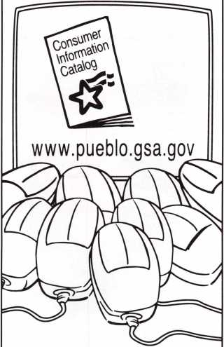

1. out of
2. mice prefer it.

If there’s a mouse in your house, catch the free Consumer Information Catalog online. There you’ll find, the latest info from more than 40 government agencies.

Just point and click your way to [www.pueblo.gsa.gov](http://www.pueblo.gsa.gov) to nibble on hunks of useful information on saving money, staying healthy, even educating your children. There are more than 250 free publications ready for you to read or download.

Or you can order the Catalog by mailing your name and address to Free Catalog, Pueblo, CO 81009. But for the fastest info running, scurry to the Consumer Information Catalog online.

[www.pueblo.gsa.gov](http://www.pueblo.gsa.gov)

(It’s the cat’s meow.)

U.S. General Services  
Administration

May 1997 *Keynotes*

The Price Is Right!

The Mas-Hamilton Auditcon™ can save  
your customer thousands by preventing  
internal & external theft. Now YOU can  
receive valuable discounts on the  
Auditcon™ System from the  
Mas-Hamilton Group!

**■-** Through July 31,1997 Receive This  
Money Saving 9ffer:

One Day Training **$125**

Auditcon Mounted On A Stand $734

Auditcon Software Package **$158**

Set of “Smart Keys” $1S Each

A Set of (12) $25 Coupons $80fr

A Total retail value of $1,328...

All this can be yours for the  
Low Price of $300

For more information please contact your local Mas-Hamilton Distributor or Michelle  
Vaughn at 1-800-950-4744 ext. 156 or Angel Gifford ext. 110 or mail to Mas-Hamilton  
Group 805-D Newtown Circle, Lexington, KY 40511 [www.mas-hamilton.com](http://www.mas-hamilton.com)

Upon completion of the training class, each attendee will receive a coupon book  
containing 12 coupons valued at $25 each.

Through July 31,1997 Mas-Hamilton is offering to locksmiths, a one day training class plus a lock on a stand, set of smart keys, and  
the PC software/interface, for $300. Included in the class a sales and marketing presentation on potential customers and financial  
justification for the Auditcon System. Coupons redeemable one for each lock you purchase. Expiration of the coupons is 12/31/97.

Free Information - Reader Service Card #2

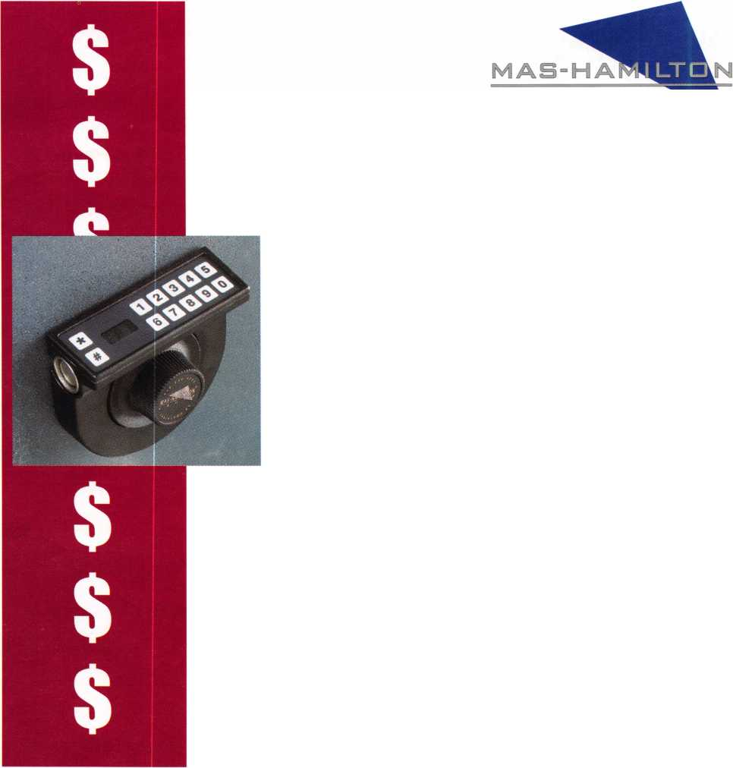

Legislative

o**mme**nl

ohn J.Greenan

Committee Chairman

It’s your business that’s at stake

Through the legislative contact network pro­gram, we have contacted every locksmith association we are aware of with information on legislation in their state. If you or your association did not receive, or would like to receive, legislative information, please fill out the legislative contact network form.

Maryland

On March 25, 1997, H.B. 1137 passed the house of delegates by a 125 to 9 vote. On April 2, 1997, it passed the Senate and is now awaiting the signature of the governor. This bill, incorporated with S.B. 85, will regulate locksmiths through the Maryland state police.

The bill was supported by the Maryland committee for locksmith legislation. Lester Brodsky, chairman, and Jonathan Mead, co- chairman, led the effort for the Maryland locksmiths.

Wisconsin

I was pleased to be the guest speaker at the Fox Valley Chapter of ALOA’s April meet­ing. The Wisconsin locksmiths are gearing up for another attempt to submit legislation. Last year they were successful in passing the House and Senate. But, unfortunately, the locksmith and alarm portion of the bill was line vetoed by the governor. Interested lock­smiths should contact chapter chairman John Engel, (4l4) 731-5400, for informa­tion.

Texas

The Texas Locksmiths Association (TLA) is working to effect changes to the alarm licensing law of last year. They have a lobby­ist working for them in Austin and are pre­senting legislation (S.B. 691/H.B. 1455) that would change the definition of “detec­tion device.” They have also presented an amendment to change the definition “alarm systems company.” According to a memo­randum from legislative consultant Jim Warren, the members of the Senate State Affairs and House Public Safety committees have expressed approval of the bill and the amendments.

They have also submitted bills of S.B.

922 and H.B. 2999 to make amendments to the peace officers’ exemption in the Private Investigators and Private Security Agencies Act to exempt locksmiths from that act.

On April 10, 1997, a hearing was held in Austin concerning S.B. 922. It was reported out of committee with a favorable recom­mendation.

It is very important that the Texas lock­smiths support these bills to help ensure their passage. I urge all locksmiths in Texas to get involved with this effort—it’s your business that’s at stake!

Legislative Comment is written by John Greenan on behalf of ALOA's Legislative Committee. Comments or questions can be directed to him at: Fink Safe & Lock; 2307 N. Western Ave.; Chicago, iL 60647; (773) 486- 2030; FAX (773) 486-4268.

1 About the Chairman: John J.

Greenan represents the fifth generation of lock-  
smiths and is vice president of Fink Safe & Lock  
in Chicago, IL. A locksmith since 1985, John  
also serves on ALOA’s Convention and Strategic  
Planning committees. He is also chairman of the  
Allied Locksmiths of Illinois

**Legislative Action Contact Network**

I am interested in:

* Working on Legislative Issues
* Fundraising
* Gathering/Giving Information

Company Address

Home Address

Telephone FAX e-mail

May 1997

Keynotes



When she designed a barrier-free playground, she didn't let anything stand in her way.

Meet Allison Falleur. Allison got the idea for an accessible play­ground while she was an Easter Seal camper. From then on, nothing could stop her, including cerebral palsy. Your support of Easter Seals helps the one million people like Allison who come to us each year for physical, occupational

Upcoming

Events

Dept

**May ’97**

5-10

SAFETECH ’97 Louisville, KY Contact: SAVTA Meetings (214) 827-1701 FAX (214) 827-1801

16

Vindicator Corporation Classes for Vindicator Lock II Contact: Tamara Martell (512)314-1200 [lock@vind.com](mailto:lock@vind.com)

18

Yankee Security Convention Weekend Express Education Seminars Sturbridge, MA Contact: (800) 209-8266

19-23

mark bates Associates 5 Day D.O.D./D.O.E. Combination Lock Training (888) 622-5495

**June ’97**

l

California Locksmiths’ Assoc. Sacramento Valley Chapter SWAP Meet, Trade Show, Lock­smith classes Elk Grove, CA Contact: Joe Longoria (916) 391-1744

28-Aug. 2

ALOA ’97 Security Expo and Trade Show Reno, NV

Contact: ALOA Meetings (214) 827-1701 FAX (214) 827-1810

**August ’97**

2

ALOA Annual Membership

Meeting

Reno, NV

Contact: ALOA Meetings (214) 827-1701 FAX (214) 827-1810

25-29

mark bates Associates 5 Day D.O.D./D.O.E. Combination Lock Training (888) 622-5495

**September ’97**

24-28

SERLAC Grenelefe, FL Contact: Kennith Moore (904) 526-5397

18-21

TAOL 24th Annual Convention Toronto, Canada Contact: (416) 321-2219 FAX (416) 321-5115

**Future Conventions**

1998

ALOA ’98 June 15-20 Nashville, TN

SAFETECH ’98 May 4—9 Valley Forge, PA

1999

ALOA ’99 July 25-31 Cincinnati, OH

SAFETECH ’99 May 3—8 Las Vegas, NV

2000

ALOA 2000 Date TBA Las Vegas, NV

SAFETECH 2000 May 8-13 Lexington, KY

2001

ALOA 2001 July 15-21 Baltimore, MD

and speech therapies and other programs.



V

Give ability a chance.

© 1995 National Easter Seal Society

1

3rd Annual Locksmith Swap Meet and Olympics Lyndhurst, NJ Contact: Jeff Sitar (201) 777-0620

**July ’97**

14-18

mark bates Associates 5 Day D.O.D./D.O.E. Combination Lock Training

(888) 622-5495

**October ’97**

21-26

24th Annual Tri-Regional Security Conference Bellevue, WA Contact: Harold Hasfjord (206) 846-1570]

FAX (206) 846-2291

For PRP dates, see p. 52. For ACE dates, see p. 5 7. Send in the dates of your organization’s activi­ties today!

*Keynotes*

May 1997



*Do you belong in the*

ALOA

President’s

Club?

How can I join the President’s Club?

You can earn membership in this  
prestigious club by recruiting just  
10 new members for ALOA.

Any ALOA member may participate.*

What do I get?

When you recruit 10 members, you receive a handsome blue blazer with  
a President’s Club crest. For each additional five members you recruit,  
you receive a lapel pin with gold-filled numbers, indicating your  
recruiting successes.

You also get the satisfaction of knowing that

you are helping your association, helping your industry grow, and you  
are helping fellow locksmiths achieve success.

How do I get started?

Contact the ALOA office for a supply of applications. One President’s  
Club credit is awarded for each new applicant. Credit is awarded only  
after the membership application is approved. However, the credit will  
apply for the period in which the application is received. Failure to  
identify yourself as the sponsor on

the application form at the time it is submitted to ALOA for processing  
will forfeit any credit.

**\*ALOA** Board of Directors not eligible for membership in the  
President’s Club.

|  |  |  |
| --- | --- | --- |
| 131 Members | PRESIDENTS CLUB ROSTER 013186 Kwok-kei Leung | |
| 73 Members | 019882 | Henry Raymond |
| 67 Members | 005354 | Stewart Levine, CML |
| 58 Members | 012566 | Mary Ohmit, CPL |
| 50 Members | 022598 | Allen Konrath |
| 41 Members | 012103 | Jack Hobin, CPL |
| 37 Members | 022907 | Toshihiro Asano |
| 36 Members | 021172 | Myeong-Rae Cho |
| 32 Members | 011133 | Salvatore Dulcamaro, CML |
| 29 Members | 006072 | Charles Robertson, CML |
| 27 Members | 008951 | William Neff, CML |
| 27 Members | 010464 | Jeanne Lodge, CML |
| 26 Members | 016675 | Roy Renderer, CML |
| 23 Members | 018521 | David Federico |
| 22 Members | 003296 | Danny Rudd, CPL |
| 22 Members | 014474 | Robert Carroll, CPL |
| 21 Members | 004371 | John Elliott, CML |
| 21 Members | 007215 | Jerome Cohen, CML |
| 20 Members | 004475 | Larry Warnick, CML |
| 20 Members | 019244 | Eugene Altobella |
| 19 Members | 019138 | Robert DeWeese, CPL |
| 18 Members | 007051 | D Lee, CPL |
| 18 Members | 009049 | John Heckman, CML |
| 18 Members | 014144 | James Fowler, CML |
| 18 Members | 014996 | David Harris, CML |
| 17 Members | 002501 | John Kerr, RL |
| 17 Members | 015283 | Ronald Heidzig |
| 16 Members | 007012 | Joseph Ferrero, CML |
| 16 Members | 008154 | Diana Barnum, CRL |
| 16 Members | 008617 | William Grant, CRL |
| 16 Members | 015696 | Barbara Watt |
| 16 Members | 018691 | Brian Reetz |
| 16 Members | 023788 | Jim Williams |
| 14 Members | 001657 | Rex Parmelee, RL |
| 14 Members | 001825 | Walter Lascar, RL |
| 14 Members | 005329 | Marian Swann, CRL |
| 14 Members | 007129 | Thomas Vandersteen, CML |
| 14 Members | 008168 | Charles Cole, CML |
| 14 Members | 008361 | James Cawby, CML |
| 14 Members | 016056 | Elvis Hammerschmidt, CPL |
| 13 Members | 007009 | John Dorsey, CPL |
| 13 Members | 008916 | James Gruber |
| 13 Members | 009172 | Peter Gauthier, CPL |
| 13 Members | 022358 | Russell Fuller, CRL |
| 12 Members | 000712 | Edwin Scott |
| 12 Members | 004361 | Robert Rodocker, CRL |
| 12 Members | 015305 | Lonnie McKinney, CML |
| 11 Members | 003430 | Lawrence Smith, CML |
| 11 Members | 009546 | Gary Teams, CPL |
| 11 Members | 010266 | William McElheney CML |
| 11 Members | 010909 | Rolando Bouza |
| 11 Members | 016525 | Philip Rovenolt, CPL |
| 11 Members | 018034 | Michael Robinson, CRL |
| 11 Members | 018805 | Robin Horsley |
| 10 Members | 004993 | Ernest Wright |
| 10 Members | 009305 | Frank Hartung, CML |
| 10 Members | 009482 | Lester Brodsky |
| 10 Members | 010602 | Herbert Dusenberry CML |
| 10 Members | 011316 | Robert Duman, CML |
| 10 Members | 016726 | Dale Knowles, CPL |

Yes! I want to join the ALOA President’s Club.

Please rush meapplications so I can start now to earn credit toward membership in the ALOA President’s club!

Name:

Company:

Address:

City: State: Zip:

Applicants

For Membership

***The following applicants are scheduled for clearance***

***as members of ALOA The games are published for  
member review and comment prior to June 1, 1997, to  
ensure applicants meet standards of ALOA’s Code of  
Ethics. Protests, if any, should be addressed to the Mem-  
bership Department and must be signed. Active Mem-  
bership applicants (A) have worked in the industry two  
or more years. Allied Membership (AL) applicants are  
not locksmiths, but work in a security-related field.***

ARIZONA

Payson

026744, James D Haggard, A SPONSOR: John Ilk Phoenix 026709,John A Gambescia, A SPONSOR: E White

CALIFORNIA

Glendale

026739, Krikor M Tavitian, A SPONSOR: H Neal

Orinda

026736, Russell E Abtalter, AP

Tahoe City

026727, Bart G Luvisi, A SPONSOR: Dean Sperlin

Yuba City

026731, Steven A Nelson, A SPONSOR: Teresa Ollar

COLORADO

Frisco

026706, Len Anderson, A

DISTRICT OF COLUMBIA

Washington

026729, Ronald G Franks, A SPONSOR: Charles Robertson

FLORIDA

Miami

026698, Larry Lazo, AP SPONSOR: William Wickward New Port Richey 026713, Danny L Brock, A SPONSOR: David Ohser

GEORGIA

Fayeville

026743, Abron Duff, A

IOWA

Dubuque

026742, Christopher S Leppert, A

Knoxville

026715, Robert R Tallman, A

ILLINOIS

Oak Park

026741, Robert J Palka, A SPONSOR: Kathy Zaniolo

Rock Island

026702, Gerald L Koester, A

Rockford

026718, Susan K Lahr, A

KANSAS

Lawrence

026705, Don E Stowe, A SPONSOR: David Rueschhoff

KENTUCKY

Butler

026746, Keith A Miller, A SPONSOR: Lawrence Smith

LOUISIANA

Gray

026720, Danny J Bourgeois, A SPONSOR: Paul Kennedy

MICHIGAN

Detroit

026693, Frank J Reahling Jr , AP

Trenton

026735, Ronald M Bryant, A SPONSOR: John Jarvis

Warren

026694, Jack G Oliver, A

Wyandette

026692, Timothy W Roberts, A

MINNESOTA

Prior Lake

026722, James Laupan, A SPONSOR: Richard Sievers 026721, Richard Schweitzer, A SPONSOR: Richard Sievers

MISSOURI

St Louis

026695, Juan A Saenz, AP SPONSOR: Ted Beishir

**MONTANA**

Great Falls

026740, Thomas C Miller, AP SPONSOR: Dale Crosby

Helena

026747, Dustin W Burdick, A

Missoula

026712, Travis C Walters, AP SPONSOR: Michael Alexander

**NORTH CAROLINA**

Asheville

026745, William G Chatham, A

**NEW JERSEY**

Chester

026703, Craig J McCormack, A SPONSOR: Kurt Mertens

**NEW YORK**

Southold

026708, Mike Reuter, A

**OHIO**

Bellefontaine

026696, Steve A Oppy II , A SPONSOR: Thomas Smith

Strongville

026732, William F Wittrock, A SPONSOR: Kenneth Wayne

**OKLAHOMA**

Lawton

026701, Otto W Jandik, A SPONSOR: Virachai Jandik

Oaklahoma City

026704, Kenneth D Coffey, A SPONSOR: Larry Goodson

**PENNSYLVANIA**

Philadelphia

026699, Joseph A Nicklas, AP

**TENNESSEE**

Chuckey

026719, Stephen R Peake, A SPONSOR: William Neff

TEXAS

Bay City

026726, Thomas L Quirk, AP

Beaumont

026714, Stephen D Morgan, A

Grapevine

026707, Mike Groover, A

Mabank

026725, James W East, AP SPONSOR: Kenneth Killgo

VIRGINIA

Centreville

026711, W. T McDonald, A

Charlottesville

026734, Eugene F Bellomy III, A

Fairfax

026717, John J Ferrari III, A SPONSOR: Michael Bellu

Woodbridge

026710, Donald J Barham Jr , AP SPONSOR: John Cannon

WISCONSIN

Milwaukee

026733, Jeff P Kamermayer, A SPONSOR: John Dorsey

WYOMING

Jackson

026728, Mike Dulaney, A SPONSOR: Sheila Dobben

JAPAN

Chiyoda-ku Tokyo

026730, Fujii Akira, AL SPONSOR: Keiichiro Aizawa

Kanagawa-ku Yokohama

026697, Takada Toshiyuki, A SPONSOR: Hideyo Yorozu

Nagata-ku, Kobe City

026737, Horikiri Hiroyuki, A SPONSOR: Yuriko Yanai

KOREA

Kimpo-Gun

026724, Kim S Jung, A SPONSOR: Dae Choi

12

Keynotes

May 1997

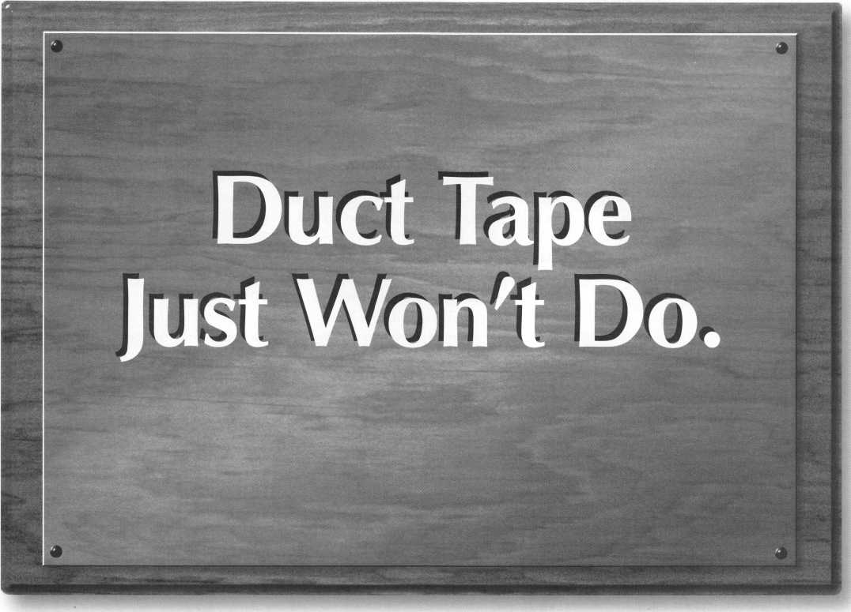

Got your membership or class certificate thumb-tacked on the wall? Short of renting a spotlight and a billboard, a wooden pocket plaque is the coolest way to bring attention to your ALOA accomplishments.

Get a pocket plaque and show off a little. Because ALOA firmly believes suc­cesses should be proudly displayed. But renting a skywriter might be a little much.

Pocket plaques are on sale for 12 bucks. Get 'em while they're cheap.* After all, those thumb-tack holes start off small, but they always get bigger.



Associated Locksmiths of America, Inc. 3003 Live Oak Street Dallas, TX 75204 (214) 827-1701

While Supplies Last

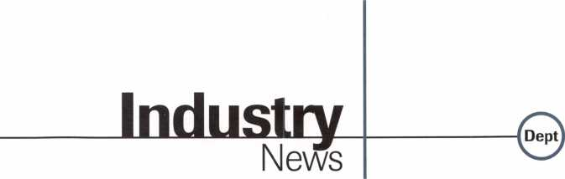

TESA’s Award

Security Industry Association (SIA) has  
awarded TESA’s ML500 Electronic Lock  
with the Product Achievement Award for  
Access Control Systems.

This award is an affirmation by SIA that  
the TESA ML500, which is a stand-alone  
electric lock, offers strong product perfor-  
mance features.

For more information, contact:

TESA Access Control  
(800) 472-TESA

Now Gathering

A new locksmith association has been estab-  
lished in Hong Kong: The Association  
Locksmiths of Hong Kong China S. A.R.  
(ALHKC). For more information, contact:  
Carroll Mann  
(+852)248-7619  
(+852) 248-6293 (Fax)

Great Response

ADI’s 1997 Expo series has enjoyed record  
turnouts. The Boise, Idaho Expo drew 158,  
Vancouver, Canada drew 427, Mahwah,  
New Jersey drew 400, Orange California  
drew 602, St. Louis, Missouri drew 302 and  
Toronto, Canada drew 657. Over 70 manu-  
facturers have committed to participate in  
the series. The Expo series offers tabletop  
exhibits and new product introductions,  
training courses for installing dealers, din-  
ner, entertainment, industry updates and  
prizes.

All ADI Expos are free to security profes-  
sionals.

Patrolling

Harold D. Wankel has  
joined Protection One  
as vice president of  
patrol services. He will  
manage and oversee  
Protection One’s  
expanding patrol and  
armed response services  
in the Los Angeles and

Las Vegas metropolitian areas.

Wankel served as chief of operations for

14 | KeynotesApril 1997

the U.S. Justice Department’s Drug Enforcement Administration prior to join­ing Protection One.

**Sales Director**

American Lock Company has appointed Lou Mintzer as sales director for the commercial and industrial markets. Mintzer will oversee American Lock’s nationwide network of regional sales managers.

Mintzer has 19 years of experience, and he previously held the position as a sales manager for a national hardware manufac­turer.

**Product Manager**

Dave Anderson has been named American Lock Company’s product manager. Ander­son will be responsible for all aspects of product introductions and will coordinate the product introduction efforts of all disci­plines within the company.

Anderson joined American Lock in 1987 and has served as inside sales manager and a commercial and industrial sales director.

**New VP**

Frank O’Brien has just been named Inger- soll-Rand’s senior vice president and chief financial officer. O’Brien will be responsible for all financial functions, including accounting, treasury and tax and investor relations.

Prior to joining Ingersoll-Rand, O’Brien served as senior vice president/corporate development and chief financial officer for NACCO Industries.

**Akron and Arrow**

Akron Hardware Consultants is now han­dling the Arrow Architectural Hardware line of door hardware products.

Akron stocks nearly 1,000 different Arrow items at warehouses, and the Akron staff has received Arrow factory training and in-house training to familiarize them with every aspect of the Arrow line.

For more information, contact:

Akron Hardware Consultants (800) 321-9602

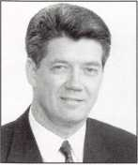

Harold D. Wankel

SPX Purchase

SPX Corporatoin has agreed to purchase A.R.Brasch Marketing, Inc. A.R. developes technical service and training material for vehicle manufacturers, and has annual sales approaching $10 million. A.R.Brasch will become a part of SPX Corporation’s OE Tool and Equipment group in Warren, Michigan.

Free Tool Kit

Businesses can reduce federal income taxes by donating overstock or slow-selling inven­tory to a charity. A free “tax reduction tool kit” has everything to get started. Interested parties should contact the National Associa­tion for the Exchange of Industrial Resources at:

(800) 562-0955

DHI Online

The Door and Hardware Institute (DHI) can now be accessed on the Internet at: <http://www.dhi.org>

The DHI page is a resource for the archi­tectural openings industry with information on technical literature, school information and dates, online classifieds, DHI member­ship and more.

New Website

Indiana Cash Drawer has expanded their website, although the address remains the same at: [www.icdpos.com](http://www.icdpos.com)

The new site lists items such as: new ICD products and services, dealer applica­tion forms and more.

Online for Legislation

The Maryland Legislature URL is

<http://mlis.state.md.us/1997rs/synopsis/syni>

ndx.htm#subs

This URL will take you directly to a screen with two columns—Senate and House. Click on a date in either column, and you will be led to a list of any bills acted upon this date in the House or Senate.

Along with each brief description listing will be another URL. Click on this and you will see additional information on that bill.

Security

Marketplace

New Model

Sargent and Greenleaf introduces the Model 6215 Time Delay Status Indicator, a LCD unit that shows time delay and opening window status when it is connected to S&G’s 6120 electronic combination lock.

The 6215 displays minutes elapsed for the time delay period and time remaining during the opening window. A red LED flashes during time delay and a green LED flashes during the opening window.

The 6125 can be mounted near the lock on the safe, or remotely up to 30 feet away. The timer is programmed to match the time delay settings of the electronic lock. The LCD has 3/4-inch numbers and can be programmed to count up or down.

For more information, request literature by calling:

(606) 885-9416 ext. 315

Reader Service#11

Free Tool

MAG Security is offering a free multi-pur­pose BuckTool to all interested locksmiths. Parties who purchase a specified amount of MAG door and window security reinforce­ment products, such as door reinforcers, high security strikes, hole cover plates, door viewers, window locks and patio locks, will be offered the tool.

For more information on this offer, con­tact your participating MAG distributor. Promotion ends July 31,1997.

Reader Service #12

Gloves in a Bottle

Gloves in a Bottle is a lotion that provides a barrier for your skin against irritants and toxins, such as grease, solvents, thinners, paint, herbecides, pesticides, poison ivy, industrial detergents and disinfectants, epoxies and glues, cement and lime, gaso­line and diesel and other chemicals..

For more information, call for the store nearest you.

(800) 600-1881 Reader Service #13



Little Marquee

The Little Giant Marquee from Speciality Store Services features red “chaser” lights in a gold frame designed to draw attention to featured items, such as books, magazine ads, promotional sheets or pricing and policy information. The marquee is 9 1/4-inches by 5 1/2-inches and can be placed on counter tops, shelves or sales bins.

The marquee runs on two AA batteries and a built-in light sensor automatically turns the unit off at night.

For more information, call:

(800) 998-9129 Reader Service #14

Exit Now

Security Lock now inventories Von Duprin series 98/99 Chexit exit devices, including rim, mortise lock and concealed vertical mounting types. These devices can be used on flush and wide stile doors with 86 and 161 stock hollow metal cut-outs.

Security Lock also offers a 530-page cata­log free upon request.

For more information, contact Security Lock at:

(800) 847-5625 (800) 878-6400 (Fax)

Reader Service #15

More Cameras and Monitors

Philips Communication and Security Sys­tems, Inc. offers an Allegiant model that expands surveillance system capabilities: the LTC8900 Series Allegiant Video Switcher/Control System.

The new Allegiant system accommodates up to 4,096 camera inputs, 512 monitor outputs, 64 keyboards, 1024 alarm points, computer interface ports and a logging printer port. The Allegiant switcher/control provides versatile modular construction combing both switching and computer technology.

The LTEC 8900 Series offers full matrix switching capability and can be pro­grammed to display video from any camera on any monitor, either manually or by inde­pendent automatic switching sequences.

The CPU bay incudes a main and back-up power supply. For more information, con­tact:

Philips Communication and Security Systems, Inc.

1004 New Holland Avenue Lancaster, PA 17601-5606 (717)295-6123 (717)295-6097 Reader Service #16

Jet Products

Five new automotive keys consisting of the Ford Probe, Escort, Contour and the Mer­cury Tracer and Mistique are featured with General Motors Malibu, Cutlass and Grand Prix for 1997.

Jet is also licensed to produce new Ford “original” replace keyblanks with the Ford trademark. The first four of a series are now available from your distributor.

For more information, contact:

(214) 234-8009 (214) 234-0339 Reader Service #17

Armed

Sargent and Greenleaf offers Arm-A-Dor, the back-door panic bar. The Arm-A-Dor is made of 12-gauge telescopic steel tubing and is the only back-door lock that com­bines the high security of a metal drop-bar with an easy-exit panic-push bar. The unit is UL listed and meets all the life safety codes of the National Fire Protection Asso­ciation.

Arm-A-Dor offers water-resistant alarm and automatic relocking options, and comes with a five-year manufacturer’s warranty. Standard model installation takes about an hour, and the unit attaches to almost any existing rear-exit door. To request literature and a sales video, contactv (800) 800-1194.

Reader Service #18

Safe from Interruption

The Port-A-Bolt is a portable locking device that offers security and privacy- regardless of location. Easy to transport in a briefcase, purse or baggage, the four-piece

May 1997

Keynotes

Security

Marketplace

device is composed of steel and rubber com­ponents.

To utilize the Port-A-Bolt, attach the latch plate within the striker plate hold of the door. When in place, the straight por­tion of the device protrudes into the room that is to be locked. The rod is positioned within the hole of the latch plate, and then holds the door securely locked.

For more information, contact:

National Invention Services, Inc.

4133 Highway 17N Pawleys Island**,** SC 29385 Reader Service #19

Powerlock

The Locknetics 390 Series powerlock offers 1650 pounds of holding force and an oper­ating voltage that is field sectable at 12 or 24 VDC. Modular circuit boards allow for upgrades. Top jamb and glass mounting kits are available, as well as angle brackets and filler plates. For more information, con­tact:

ACME Security (800) 348-2263 (800) 435-8233 (Fax)

Reader Service #20

Magnetically Inclined

Magnetic Drill Site Templates offer an accu­rate x-ray view of a lock and its critical parts. Each template is reproduced actual size, front and top view, and the spindle hole is pre-drilled for easy installation.

The Magnetic Drill Site Templates are resuable and made of coated, heavy duty vinyl.

To order call:

Lockmasters (800) 654-0637

Reader Service #21

Alternative Design

Mas-Hamilton will be introducing an alter­native design to the current X-07 lock. This alternative design will be free of patent roy- alities, which are currently being paid on the original design.

For more information, contact:

Kelly Kincaid 805-D Newtown Circle Lexington, KY 40511 (606) 253-4744

Reader Service #22

New Video Intercom

The Door Sentry features a compact door camera with the widest viewing area of any system of its kind. It allows a secured entry door to be safely answered from up to two room stations.

The camera is infrared and includes an automatic backlight control and illuminat­ed call button. The room station has a four- stroke chime, door release button and voice/chime volume controls.

The Door Sentry uses two wires as a doorbell, and includes a video door station, room station and power supply.

For additional information, contact:

Stan Kohagen Airphone Intercom Systems 1700-130th Avenue N.E.

Bellevue,WA 98005 (206) 455-0510, ext. 115 Reader Service #23

Tough Lock

American Lock’s model 1207B padlock is precision machined from a solid bar. It is case-hardened and triple-plated, and anodized for maximum corrosion resistance. Its five-pin cylinder is made of solid brass for resistance to corrosion and wear.

For complete information about Ameri­can Lock, call:

(800) PADLOCK Reader Service #24

Newly Designed Key Switches

Key Switches from Security Door Controls (SDC) are designed to be keyed the same as existing mechanical locks and incorporated into a master key system. Special keys are not required for release of electrically-locked doors.

Compatible with 1 1/8-inch and 1 1/4-inch standard and interchangeable core mortise key cylinders, SDC key switches are avail­

able in 18 different contact configurations, including time delay options. The key cylinders are recessed for tamper resistance.

SDC key switches are available for single gauge box or narrow frame mount, with options such as: LED status indicators, buzzers, sirens, push switches and time delay relays.

For more information, contact:

SDC Customer Service (805) 494-0622 (800) 959-4732 (Fax)

Reader Service #25

■Reference Material

New Additions to Catalog

R.Q. and Associates has reached an exclu­sive agreement with Angiolaz, Inc. to sell several new products under development to the safe and locksmith industry. To obtain a copy of the catalog that features these prod­ucts, contact:

R.Q. Associates

8093 Berkshire

Grosse lie, MI 48138

(313) 671 -2359 Fax and phone

Reader Service #26

Dealer Price Book

The new 1997 Locksmith Dealer Price Book from Jet is now available. The price book features keyblank unit price per hun­dred, and when a price appears in a second column, that particular blank is available in Jet’s “Personaline” series.

Locksmiths no longer have to view a let­ter or number in the group column and then turn to another page to find what the suggested dealer cost is for the particular keyblank in question.

For a free copy write to:

Jet Hardware 800 Hinsdale St.

Brooklyn, NY 11207 Reader Service #27

161 ***Keynotes***

May 1997



Bylaws Committee

Bylaws Committee meeting was called to order at 1:02 p.m., Thurs­day, March 13, at the Harvey Hotel in Dallas.

Members present: Chairman, C. King, M. Blum, A. Hoffman, L. Pas- sarello, J. Shandy, R. Simpson, B. Tar- bet, D. Lowell, Ex-officio. Members excused: J. Andrews. Guests present: D. Barnum, S. Engel, J. Nunberg.

Minutes of the previous meeting were approved and circulated.

The committee brings the follow­ing proposed bylaws changes to the Board with seconds:

Article III Section I—CLASSES A. ACTIVE: Persons who have been actively engaged in the locksmith/access control industry for a minimum of two years and can pro­vide at least two of the following items...

C. RETIRED: Persons who have been: 1. Active members for at least 15 years, have reached the age of 62 and have withdrawn from active engagement in the industry, or...(CARRIED)

1. COMPANY SPONSORED: Employers of at least one person qual­ified for active or apprentice member­ship. Sponsored individual members shall demonstrate eligibility for Active or Apprentice membership as set forth above and submit an appli­cation to the Association Headquar­ters. Dues shall be paid and member­ship^) owned by the company and shall be transferable in the case of changes in employees. Said individual members shall have all member privi­leges consistent with their member­ship class, including voting. (DEFEATED)

Amended to read:

1. COMPANY SPONSORED: ...Said individual members shall have all member privileges, including vot­ing. (CARRIED)
2. INSTITUTIONAL: Persons qualified for Active or Apprentice membership as set forth above and who submit an application to the Association Headquarters. Dues shall be paid and membership^) owned by the institution employing the mem­ber and shall be transferable in the case of changes in employees. Institu­tional members shall have all member privileges, including voting. (DEFEATED)

Amended to read:

I. INSTITUTION SPONSORED ...Institution sponsored members shall have all member privileges, including voting. (CARRIED)

Article VII Section 1—OFFI­CERS A. PRESIDENT: The presi­dent shall serve one term of two years or until his successor is elected and qualified. Upon the election of his successor, the President shall no longer be eligible to serve as an officer of the ALOA. (CARRIED)

Meeting adjourned 6:41 p.m.

Carl King, CML ***Chairman***

Chapter Committee

The Chapter Committee meeting was held at the Harvey Hotel, in Dallas, TX on March 13, 1997.

The following were in attendance: Committee Members: Dana L. Bar­num, CML, Chairman; Jim Watt, CML, CPS, Vice-Chairman; Tom Freehling, CML, Thomas Hood,

CML, Barry Leas, CRL, Rick Ohmit, CML, Donald Rule’, CML, Evelyn Wersonick, CML, CPS, President David Lowell, CML, CMS Ex-officio, Mary May, Staff Liaison-Excused: Henry Printz, CML, Bill Straub, CML.

The chairman stated the latest Tech-Train tape has been purchased and will be distributed to the chap­ters by the end of March. Chairman Barnum reminded the committee of the Board Policy concerning the visi­tation of each chapter. With the Asso­ciation Office’s Training Manual as the basis for visitation to the chapter, it was discussed that each Board member be assigned a chapter to visit and train their officers.

Chairman Barnum will be making requests of Board Members to instruct the Officers Training Course to those chapters having problems or struggling first.

The Chapter reception at ALOA ’97 will be an ice cream social. The Attendance Award will be the same as last years.

Some infractions of the ALOA bylaws were discussed and a proposed Bylaw’s change was recommended.

The committee brings the follow­ing motion to the board with asec- ond: Amend Article 12, CHAP­TERS, Section 4, MEMBERSHIP, to read: Chapter shall limit its active

membership to.. .(TABLED)

Dana Barnum, CML ***Chairman***

Convention Committee

Convention Committee Meeting was called to order on March 14, 1997, at 1:00 p.m. at the Harvey Hotel in Dallas, Texas. The following were in attendance: Raymond C. Lusk, CML, Chairman; Dallas C. Brooks, Vice- Chairman; John J. Greenan; Dana L. Barnum, CML; Mark E. Blum,

CML,CPS; Barry K. Leas, CRL; Rick L. Ohmit, CML; Donald E. Rule’, CML. Ex-Officio; David M. Lowell, CML,CMS; James H. Glazier, CML. Staff Liaison: Carmen D. Murphey, CMP. Guests: Jessica D. Vasquez, Janelle L. Vergara.

M/M Ohmit/Barnum: To approve minutes from the spring meeting as circulated. Motion carried.

Final details of ALOA ’97 were discussed. In Carmen’s report to the committee, she reviewed and updated the status of the advertising efforts in other industry publications. If locks appear in future advertising, the staff was directed to solicit financial sup­port from lock manufacturers in exchange for displaying their product in the ad.

There was much discussion on the funding of the kick-off party. It was decided that every effort would be made to secure a sponsor. In the event a sponsor could not be found, ALOA would assume the financial responsi­bility of the event. It was further decided that a cash bar with tickets being sold at the entrance of the event would be utilized to hold costs to a minimum. Medeco has expressed interest in sponsoring the kick-off party. Staff was directed to follow-up.

The theme and dress of the ban­quet was discussed. Rick suggested that the board dress be black tie.

Discussed various ways to increase attendance at the membership meet­ing. A treasure box format was decid­ed on. Keys will be given to the members at the membership meet­ing, opportunity to get additional key for a donation to the legislative booth, the box will be at the legislative booth. The first key to open wins. Carmen and Rick were directed to contact Jet or Ilco for donation of the key blanks and to work out details and procedures.

Plans for 1998 Nashville Conven­

tion were discussed. Carmen was directed to continue promotional/ advertising schedule as started for ALOA ’97.

The meeting adjourned at 4:15 p.m..

Raymond C. Lusk, CML ***Chairman***

Education Committee

The ALOA Education Committee Meeting was called to order March 11, 1997, at 8:02 am at the Harvey Hotel in Dallas, Texas. Those in attendance were Chairman, James H. Glazier, CML; Vice-Chairman, Robert H. Staffford, CPL; President, David M. Lowell, CML, CMS; Breck H. Camp, CML; Carl King, CML; Bruce

1. Tarbet, CML; Members-at-Large, Thomas P. Freehling, CML; J.

Thomas Hood, CML; Convention Chairman Liaison, Ray C. Lusk, CML. Staff present were Charles W. Gibson; Carmen D. Murphey, CMP; Jessica D. Vasquez and Janelle L. Vergara.

Guests present were Steven Engel, CML and James M. Watt, CML, CPS.

The class matrix for ALOA ’97 was discussed. All changes were noted. MLANJ classes were discussed. The ACE Class schedule for the year was discussed.

Each time ACE conducts a non­association class for 10 or more stu­dents, ALOA adds the price of a membership to the proposal.

Staff was directed to include mem­bership applications with all ACE class materials that are sent out. If students are not a member of ALOA and wish to join, the application fee will be waived.

Discussion was held concerning the preliminary class schedule for 1998 in Nashville. The dates of ALOA’98 are June 15-20.

Chairman to continue to work with Fox Valley Technical College and find out more information.

Chairman was directed to respond to Fox Valley Technical College with questions regarding ACE instructors, ACE logo, lesson plans, ALOA mem­bership, PRP, etc.

The Committee decided that when the Association Officers Train­ing Class is given, the chapter or asso­ciation sponsoring will have to pro­vide lodging, meals and transporta­tion/travel.

Chairman and staff were directed

April 1997

Keynotes

to review and revise the current ACE Brochure.

The recipients for the Don Davis Award and the ACE Award were determined.

The meeting was adjourned at 8:40 am, March 14, 1997.

James H. Glazier, CML ***Chairman***

Motion at Board meeting: That the Board approve the proposal for Education Manager as previously sub­mitted to the Board. (CARRIED)

Finance Committee

The meeting of the ALOA Finance Committee was held March 13, 1997, at the Harvey Hotel, Dal­las, Texas.

The draft of the auditor’s report for fiscal year 1996 was reviewed and approval by the committee. The auditing firm will be directed to make several changes for fiscal year 1997 when it is time to prepare the audit.

The committee was advised that the cost of the 1996 audit was reduced by the accounting firm in the amount of $1,500.00. The reduction was a direct result of the excellent preparation of the materials needed for the audit by the Comptroller, Kathy Romo.

The committee discussed the need for updating all of the computer equipment, financial software and publications software. The cost of replacement equipment and software will be investigated by staff and rec­ommendations will be presented at the Fall Board Meeting.

The committee discussed several different methods of generating new income and utilizing existing assets to generate income for ALOA.

The committee brings the follow­ing motion with a second to the Board:

To decrease Line 61-750-000 (Yard Maintenance) by $1500; Increase Line 70-300-01 (Computer Equipment) by $1500; Reduce Line 56-110-01 (Printing) by $17,694; Reduce Line 56-120-01 (Postage) by $3500; Reduce Line 56-120-02 (Delivery & Main Processing) by $750; Increase Line 50-290-00 (Membership Survey) by $21,944; Reduce Line 61-520-00 (Service Con­tracts) by $7000; Increase Line 67- 540-00 (Equipment Maintenance) by

$7000; Increase Line 67-400-00 (Strategic Planning) by $10,000; Increase Line 54-510-00 (Class Devel­opment) by $9000; Increase Line 44- 240-00 (Requested-ACE Classes) by $1800.

Dallas C. Brooks ***Chairman***

Finance Committee 2

The Finance Committee recon­vened on March 15, 1997, at 7:45 am, at the Harvey Hotel, Dallas, Texas, to discuss the proposed adjust­ments to the 1997 budget. All mem­bers were present.

A motion by John Cannon, sec­onded by Jim Glazier; To amend the motion to the Board concerning adjustments to the Budget to read:

To decrease Line 61-750-00 (Yard Maintenance) by $1500; Increase Line 70-300-01 (Computer Equipment) by $1500; Reduce Line 56-110-01 (Printing) by $17, 694; Reduce Line 56-120-01 (Postage) by $3500; Reduce Line 56-120-02 (Delivery & Mail Processing) by $750; Increase Line 50-290-00 (Membership Survey) by $21,944; Reduce Line 61-520-00 (Service Contracts) by $7000; Increase Line 61-540— (Equipment Mainte­nance) by $7000; Increase Line 54- 510-00 (Class Development) by $9000; Increase Line 44-240-00 (Requested ACE Classes) by $1800. (CARRIED)

The meeting adjourned at 7:55 am.

Dallas C. Brooks ***Chairman***

Grievance Committee

The meeting of the ALOA Grievance Committee was called to order at 1:00 p.m., March 14, 1997, at the Harvey Hotel, Dallas, Texas. The fol­lowing were in attendance:

Chairman: Robert H. Stafford, CPL; Committee: Carl King, CML; David Paulsrud, Sr., CML, Excused were: Leonard J. Passarello, CPL; Ex- Officio: David M. Lowell, CML,CMS, President, Staff Liaison: Brandon W. Durrett, Membership Coordinator, Guest:Charles W. Gibson, Jr., Execu­tive Director

Meeting opened with roll call. There were no grievances to be discussed.

A new draft of the grievance com­mittee procedure manual was reviewed and revised. Copies will be

sent to the entire board.

M/M Paulsrud/King—to adjourn meeting. Motion passed.

Robert Stafford, CPL ***Chairman***

Legislative Committee

The ALOA Legislative Committee meeting was called to order March 14, 1997, at 8:02 a.m.

Present were: John J. Greenan, chairman; Jeffrey Nunberg, vice chairman; Steven Engel, CML, CPP; Dallas Brooks; Randy Simpson, CML, recorder; President David M. Lowell, CML, CMS; Staff present: Charles W. Gibson, Derek Holiman and Anne Davis, ABC. Absent: Hank Printz, CML.

M/M Brooks/Nunberg: To accept minutes of November meeting as published. Motion carried.

The committee reviewed the mon­itoring service and reports. The com­mittee is happy with Multistate’s ser­vice. Colonel Gibson will contact Multistate to request weekly reports be sent to committee via e-mail.

The committee reviewed the leg­islative contact network program. Derek will design an ad page and logo for legislative committee. Jeff will contact Medeco to request assis­tance in writing a fund raising letter. Anne will get bids for a professional fund raising campaign.

An evening seminar will be sched­uled for ALOA ’97 Security Expo. Steve Engel will conduct seminar to aid locksmiths on how to address leg­islative issues in their states.

There was much discussion on ways to create interest in legislative booth at ALOA ’97 Security Expo.

Col. Gibson will mail legislative handbooks and report to individuals on the network.

Vice presidents will be charged with the responsibilities of contacting all ALOA chapters and local associa­tions in their regions to ask if they have received mailings and to get additional information. John will cre­ate a form to be used to retrieve this information.

The committee feels that it’s very important to continue to have repre­sentation at the NASIR and NBFAA meetings. Dallas Brooks will attend the NASIR convention June 4-6, 1997, in Raleigh, NC. John will appoint a representative to attend the

NBFAA meeting at ISC East in New York.

Each committee member was requested to write an article for the legislative comment in **Keynotes.**

M/M to adjourn at 11:45 a.m.

John J. Greenan, CPL, CPS ***Chairman***

Library/Museum Committee

Meeting called to order at 8:11 a.m. Thursday, March 13, at the Harvey Hotel, Dallas.

Members Present: Chairman A. Ramunno, A. Hoffman,C. King, B. Leas, B. Tarbet, E. Wersonick, Mem­bers Excused: J. Andrews, H. Printz, Staff Present: M. May.

Minutes of the previous meeting were approved as circulated.

Frequency of “hits” in the video lending library was reviewed. Impres- sioning and automotive topics were the most frequently borrowed.

It was suggested that a video tape of the museum be made and included in the lending library, as a way to allow members to view the collection and for showing at convention.

The new video tape critique form is now being sent out, but none have yet been received. In order to make better descriptions available for poten­tial borrowers, B. Tarbet will begin reviewing tapes.

The Great Texas Antique Padlock Show will take place Oct. 31, and Nov. 1, in Dallas. The committee rec­ommends a complementary display ad in **Keynotes** promoting the show, as was done last year. The committee further recommends inclusion of the various lock collector shows in **Keynotes** industry calendar

The museum will have four dis­play cases at the 1997 convention. C. King has contacted various California lock collectors for possible display of some of their material. ALOA Muse­um items will be displayed to fill any remaining space.

The special museum fund of mem­ber donations currently amounts to approximately $43,000, including interest. The committee requests a separate financial line item for interest accrued on the CD.

The committee wishes to obtain a tax-exempt status for the museum, possibly by moving it under the Scholarship Foundation as an educa­tional entity.

18 **| *Keynotes***

April 1997

As part of the ALOA web page, the committee will review the addi­tion photographs of the museum or items from its collection with Kim Bowers.

Motion by Leas seconded by Hoff­man to raise the shipping and han­dling fee from $5.00 to $7.50 effec­tive June 1, 1997, as a result of increased UPS rates. Passed.

Motion by Wersonick and second­ed by Leas to obtain for $80 the set of videos currently required by the Texas legislation for alarm and locksmith licenses.

Directive to the staff: Work with C. King to obtain a firm bid by the 1997 convention for construction of a metal building on the ALOA proper­ty, including information on green space, parking, fire walls and other zoning requirements. Building size to be minimum 2,500 square feet. The proposal must include a sketch of the building location on our property.

Directive to staff: Study the bylaws of the ALOA and the Scholar­ship Foundation, and possibly contact an attorney for advice on establishing favorable tax status for the museum. Prepare a feasibility report to the committee by the Fall Board Meet­ing.

Staff directive: Revise report for donation status to include the total balance of the fund with interest bro­ken out separately.

**Meeting adjourned at 10:15 a.m.** Anthony Ramunno, CML, CPS ***Chairman***

Membership Committee

The meeting of the ALOA Member­ship Committee was called to order at 8:05 am, March 13, 1997, at the Harvey Hotel, Dallas, Texas. The fol­lowing were in attendance: Chairman: John Shandy, CML; Vice Chairman: Jim Watt, CML, CPS; Recorder:

Dana L. Barnum, CML; Committee: Steve Engel, CML, CPP; Tom Freehling, CML; Donald Rule’, CML; Rick Ohmit, CML; Tom Hood, CML; Bill Straub, CML; Excused: Jerome Andrews, CML; Excused Ex-Officio: David Lowell, CML, CPS, President; Staff: Brandon Durrett; Carmen D. Murphey, CMP.

The minutes from the previous meeting were accepted as printed. Durrett reported that there are 6,500 paid members. Membership cards for

Board

Reports

the coming year will be sent out with the December dues renewal notice. A drop report for current membership status will be issued by February 1 of each year.

The committee agreed to send all membership recruitment concepts of programs to a few selected industry partners advertising/marketing departments for their comments. It was suggested that recognition be given to members of the President s Club by presentation of a certificate at convention. A subcommittee, headed by Ohmit was assigned to carry this out. Ohmit will develop a plan/proce­dure and inform the office by the end of March 1997.

The committee requests that Pub­lications insert a membership applica­tion in rotation with scholarship and board applications in **Keynotes.**

Carmen Murphey reported to the committee that there isn’t enough money in the budget to buy a new booth, but we are in the process of updating the booths we currently own.

The Membership Committee brings the following motions to the Bylaws Committee with a second: To change the bylaws Article III, Section 1, Paragraph C to read “active mem­ber for at least fifteen years,” That the Bylaws Committee for a new mem­bership status called Company mem­bership. That the Bylaws Committee form another membership class, known as institutional membership. Fee structure to be the same as Active membership.To amend the bylaws so the Associate membership can include additional employee member­ship.

The Membership Committee brings the following motions to the Board with a second: To start a new member program for 1998, (CAR­RIED) To increase the membership dues for 1998 to $125.00. (CAR­RIED) That the dues increase to at least $150 in the year 2000. (CAR­RIED) That the Retired status dues be equal to the Apprentice dues. That the company membership fee be set at $250 and each membership there­after be set at $75.00 if the company membership status is approved. (CARRIED)

Meeting adjourned at 12:20 PM **John I. Shandy, CML Chairman**

Nominating Committee

The ALOA Nominating Committee was called to order at 8:05 a.m. at the Harvey Hotel, Dallas, Texas. Those in attendance were Chairman Breck H. Camp, CML; Dallas Brooks; John Greenan, CPL, CPS; Jeffrey Nunberg, CML, CMS; David Paulsrud, CML and Robert Stafford, CPL.

The confidentiality agreements were reviewed and confirmed by all participants. Meetings were held with those prospective candidates for nom­ination who wished to address the committee, or with those from whom the committee had questions. The available pool of candidates was reviewed and the qualifications of each discussed in detail.

The inability to hold elections at the membership meeting in New Orleans in 1996 made it necessary to assign varying terms to available board positions in order to meet bylaws requirements for future elec­tions. The committee will place into nomination at the general member­ship meeting in Reno in 1997 the following:

President (1999): Dallas Brooks; NE Vice President (1998): James Glazier, CML; SE Vice President (1999): Jeffrey Nunberg, CML, CMS; NC Vice President (1999): John Greenan, CPL, CPS; SC Vice Presi­dent (1998): Randy Simpson, CML; NW Vice President (1998): Ray­mond Lusk, CML; SW Vice President (1999): John Shandy, CML; Secretary (1998): John Cannon, CML; Director, Three-Year (2000): Dana Barnum, CML; Director, Three-Year (2000): Robert Stafford, CPL; Director, Two- Year (1999): Donald Rule', CML; Director, Two-Year (1999): Bruce Tar- bet, CML; Director, Two-Year (1999): Tony Ramunno, CML, CPS; Director, One-Year (1998): Tom Hood, CML and Director, One-Year (1998): A.J. Hoffman, CML.

The Nominating Committee brings forth a request to the incom­ing President that he appoint as a full-voting committee member, three major Industry Partners from the manufacturing arena to the Conven­tion, Membership and Education Committees in order to permit such members to actual participate in com­mittee work and become familiar both with the degree to which board members function, and the amount of

dedication that is present on their part. This will also permit these Exec­utive Level Industry Partners to give up only one or two days of their valu­able time rather than be expected to make a full commitment of some three-plus weeks a year expected of board members. It was also noted by the committee that the pool of such possible candidates is severely limited and these positions should rotate at least every two years.

It was the consensus of the com­mittee that such representation from the distributor level of our industry should not be undertaken at this time.

Breck H. Camp, CML ***Chairman***

Personnel Committee

Members present: Dallas Brooks, Chairman; John D. Cannon, CML; Steven Engel, CML,CPP; James H. Glazier, CML; Raymond C. Lusk, CML; David M. Lowell, CML,CMS, Ex-officio, Staff: Bill Gibson

The committee discussed the need for developing written policies to govern two important areas: 1) Rela­tionships between the Board and Administration, 2) Limitations of Administrative Authority.

The Chairman was instructed by the committee to begin work on drafting written policies for presenta­tion to the committee and Board for review at the 1997 Fall Board Meet­ing.

The committee also agreed to begin work on developing written procedures for the monitoring and evaluating the performance of the Staff Administrator/Executive Direc­tor in his duties of implementing and fulfilling board policies.

The committee was given a report by the Staff Administrator on person­nel. It was pointed out that the 401K retirement program (in lieu of Life Insurance) appeared to be well received by the staff.

After reviewing the duties of the Staff Administrator, it was the deci­sion of the committee to take the fol­lowing action:

The committee brings the follow­ing motion to the Board with a sec­ond:

To change the title of our Staff Administrator to Executive Director. (CARRIED)

**April 1997**

***Keynotes***

Board

Reports

The meeting adjourned at 3:50 p.m..

Dallas C. Brooks ***Chairman***

Proficiency Registration Com­mittee

The ALOA Proficiency Registration Committee Meeting was called to order March 14, 1997, at 1:03 PM at the Harvey Hotel in Dallas, Texas. Those in attendance were Chairman, James Watt, CML CPS; Anthony Ramunno, CML, CPS; Bruce Tarbet, CML; Thomas Freehling, CML, and Steve Engel, CML, CPP. Excused were Jerome Andrews, CML; Bill Straub, CML and Vice Chairman, Breck Camp, CML. (Camp joined the meeting in progress) Guests: John Shandy, CML.

The minutes of the previous com­mittee meeting were discussed and accepted as circulated. The 1997 PRC Budget-to-date through 1/31/97 was reviewed. The current PRC Sitting Schedule was reviewed and proctor assignments were made. The Metro Dade County Locksmith Certification Testing Program proposal was dis­cussed. The Chairman will copy the committee with the proposal and inform the committee and the Presi­dent concerning any progress with this project. A request from the city of Fresno, CA, to develop a standard qualification test was discussed. It was decided that we would not undertake this project at this time. The commit­tee recommends that the Chairman write a letter to the City of Fresno stating that any candidate for employment should have at least a CRL designation.

A request from two ALOA mem­bers located in the Marshall Islands in the South Pacific for participation in the PRP Program via mail through a recognized educational proctor was discussed. It was the consensus of the committee that if they could not par­ticipate in a normal sitting, that spe­cial consideration would be given for future sittings on a one-on-one basis. The Chairman will write a letter con­firming this discussion. A request for a computer for PRP purposes and accompanying bids were discussed. It was decided that for the near term, that the committee would request funding for a copy of FILEMAKER PRO and a Zip Drive that could be

shipped at the appropriate time to future PRC Chairman.

M/M Tarbet/Ramunno: Request to Finance for $500.00 for purchase of FILEMAKER PRO database program software and ZIP DRIVE for PRC records. Carried. The use of the letters CPL by Foley-Belsaw was discussed.

A letter by the Chairman to Foley- Belsaw will be sent questioning the use of CPL, which ALOA has trade- marked. Elective L-07 and L-13 were distributed to the committee mem­bers with instructions for their review. Time lines were established for the preliminary review and final review.

Staffing for the ALOA ’97 PRC was discussed. The Chairman will discuss the PRP room setup with the ALOA Meeting Planner. The Chair­man will set proctoring schedules for the convention PRP and distribute them 30 days prior to the sitting date.

Dave McOmie’s request for NSO certification designations to be allowed to be placed on the ALOA convention name badges was dis­cussed. After a short discussion, the committee rejected the request and directed the chairman to write a letter to Dave McOmie stating the reasons.

The committee discussed a joint venture with the Education Commit­tee to offer chapter or local associa­tions a package deal that would include classes, a PRP sitting and/or officer training. The minimum sitting number would be waived for these packages. The Chairman will write an article to be placed in the PRP sec­tion and Chapter section of **Keynotes** announcing this program.

Special recognition for Fritzee Meunch, the lady that has done the calligraphy for 12 years for all of the PRP Certificates, was discussed. It was decided that Steve Engel will research an appropriate gift and inform the chairman.

The meeting was adjourned at 3:14 PM.

James M. Watt, CML CPS ***Chairman***

Publications Committee

The Publications Committee meeting was held on Friday, March 14, 1997, at the Harvey Hotel, Dallas, Texas.

The Reader Service Response Cards were discussed and changes will be implemented to try to improve the

response rate.

The 1997 grand prize winner for the Trade Lips Contest was selected.

The 1998 Editorial Calendar was approved as circulated.

A.J. Hoffman furnished a copy of the “Lewis Key Blank Cross Refer­ence Directory” for copying and eval­uation for reprinting.

The committee will be reviewing and soliciting manuscripts for consid­eration for publishing.

John D. Cannon, CML ***Chairman***

Public Relations Committee

The Public Relations Committee Meeting was held Friday, March 14, 1997, at the Harvey Hotel in Dallas, Texas.

Members present: Chairman Randy Simpson, CML; John Cannon, CML; A.J. Hoffman, CML; Tom Hood, CML; Jeff Nunberg,

CML,CMS; John Shandy, CML; Eve­lyn Wersonick, CML,CPS; David Lowell, CML,CMS, Ex-officio. Mem­ber excused: Henry Printz, CML.

Staff Present: Anne Davis, ABC.

Guest Present: Kim Bowers, CML.

Minutes of the previous meeting were accepted as circulated.

1. Bowers presented an update on the ALOA website. ALOA finally got the rights to the domain of ALOA.org at the end of February.

This has been the main delay for fin­ishing the website. Special software is being developed for the secure live chat room. It should be finished in about 90 days.

The committee requests that Con­vention Committee provide a phone connection and an Internet-ready computer to the membership booth to demonstrate the website. K. Bow­ers will endeavor to provide an 800- number hookup. Otherwise, the com­mittee will need to contract with an internet service provider for access during the during the convention.

The committee recommends avail­ability of Internet access at the office for most or all staff members. There­fore, while staff is pursuing the new computer equipment for the office, this should be kept in mind.

Meeting adjourned at 3:52 p.m.. **Randy Simpson, CML Chairman**

Scholarship Foundation

The meeting of the ALOA Scholar­

ship Foundation was called to order March 14, 1997 at the Harvey Hotel Dallas, Texas. The following were in attendance: President:David A. Paulsrud, Sr., CML; Vice President: Bill Straub, CML; Excused, Recorder: Dana L. Barnum, CML; Committee:Tony Ramunno, CML, CPS; Mark L. Blum, CML, CPS; Len Passarello, CPL; Barry K. Leas, CRL; Ex-Officio: David Lowell, CML, CPS; Staff Liaison: Kathy Romo, Comp­troller; Guests were: Charles W. Gib­son, Jr, Executive Director; John Greenan,CPL, CPS, and Jim Watt, CML, CPS.

The Scholarship Foundation approved the resolution to change the registered agent from United States Service Corp. to Charles W. Gibson, Jr. at ALOA 3003 Live Oak Street, Dallas,Texas.

Those individuals listed below have been selected to receive scholar­ships to ALOA ’97: Matthew Scott Payne, Oklahoma; Bradley James Polega, Michigan; John Soderland, Wisconsin; Jay Soderland, Wisconsin; Yyap Cheng Kian, Malaysia; Gordon Kith Barrow, Texas; Dana G. Rite, Florida; Brain Huddleston, Colorado; Michael Hursh, California; David Moen, California; Ronnie Hisaw, Alaska; Jeff Brickler, Ohio; Phil Hampton, Montana; Amy Hanawalt, Montana; Kathleen Mannix, Ohio; Shane Placzkiewicz, California; Joe J. Lee, Pennsylvania; Nathan Andrews, Minnesota; Patricia Pfaus, Colorado; Michael Tigner, Minnesota; Stephen Warner, Minnesota; Robert Voss, Minnesota and Joseph Rogers, Mon­tana

Those names that have been accepted for Scholarships for MLANJ ’97 are as follows: Ken Arditi, Penn­sylvania

M/M Greenan/Leas to adjourn meeting

The Scholarship Committee meet­ing was adjourned at 12:10 pm, March 14,1997.

David A. Paulsrud, Sr.

***Chairman***

201 ***Keynotes***

**April 1997**

**very two years, the ALOA presidential gavel is handed over to a newly elected successor. Meet an individual who is up to the challenge: Dallas Brooks.**

The Early Days During his elementary school years, Dallas spent many Saturdays hanging around the lock­smith shop where his father worked. In high school, he spent a lot of time cutting keys and dispatching. In 1963, he quit school and worked several odd jobs. During this period, he joined the U.S. Navy “Seabee’s” Reserves, which led him to serve two tours of duty in Vietnam between the years of 1963 and 1967.

During his first year in Vietnam, he took and passed the high school equivalency exam, and after his military tour was complete, he returned to Montgomery, AL, and met Linda, his soon-to-be wife. He graduated with a bachelor’s degree in Education from Auburn University Montgomery in June of 1972. He taught seventh grade history in the Montgomery School System for one year.

“One year was sufficient for me. I chose to try another profession.”

New Career Path In December of 1974, he started work at Wing’s Locksmith shop. He stayed there for 10 years and then left to begin American Lock & key, Inc. in Auburn, AL.

became more aware and interest­ed in ALOA.”

The chapter voted to send him to the ’91 convention in Anaheim, CA, so he could dis­cuss an important issue: member voting rights.

Getting Involved At the conven­tion, he placed his name in con­tention for the Southeast vice president position. Dallas had two major messages for members: to change the voting process to allow “all members” to partici­pate without having to attend the convention, and second, change the voting process to allow all the vice presidents to be elected only by their peers in their region. But Dallas lost the Southeast vice president position.

“Would I have lost if all the ALOA members in the Southeast had been able to vote? I’ll never

know the answer to that. I do know a lot of people listened to what I had to say, including several of the ALOA Board members,” stated Dallas.

Striving For Member Rights The next year, he was invited to serve on the ALOA Board as a member-at-large. He was elected to a three-year director position in 1993 and to the Southeast vice presi­dent position in 1994.

“My first year on the Board, I voiced my concerns. The Bylaws committee discovered that the laws in New York, where ALOA is incorporated, do not allow vote by mail. They do allow vote by proxy. I believe ALOA would be a stronger association if we give members a way to participate in elections and major decision mak­ing.”

As president, Dallas will work on this issue and others. The fol­lowing is a summary of four major parts of his platform: 1) Financial stability, cutting costs while increasing benefits to membership, improve efficiency of the staff and Board, develop a cash reserve poli­cy to assure stability; 2) Develop better communication with manu­facturers and distributors to better serve industry needs, especially with purchasing products, product knowledge and certification; 3)

ALOA must improve communication with members to determine the answers to many questions concerning membership services and 4) Increase efforts in protecting our trade from others that attempt to pass legislation excluding locksmiths from installing electronic access control devices.

“Remember, ALOA belongs to you. I urge all of you to attend the Membership meeting in Reno, Nevada and let your voice be heard.”

May 1997Keynotes | 21

The Shop “When American Lock & Key, Inc. was founded, I started with a little cash, good credit, one old service vehicle, an Apple II computer, a very small ‘hole in the wall’ storefront location (rent $150 a month), one additional employee, an existing customer base of approximately $ 3 5,000. ”

American Lock & Key, Inc. has grown into two store­front shops, located in Auburn and Montgomery, AL.

ALOA’s Helping Hand Dallas’ success stems from what he “two very important steps in my life.” The same he started his business, 1984, he joined ALOA. to give a lot of credit to ALOA for assisting so many ways. The education that I and my employees receive, and the personal contact with manu­facturers, distributors and other locksmiths at the ALOA Conventions were important to the development of my business. And, of course, Keynotes, ” said Dallas. “I honest- believe I could not have grown my business to what it is today without having a national association such as

Other Ventures In 1988, a group of 18 formed the Heart of Dixie Chapter of ALOA. Dallas served as vice chair­man the first two years and as chairman the second two years.

“During the years that I served as the chairman, I

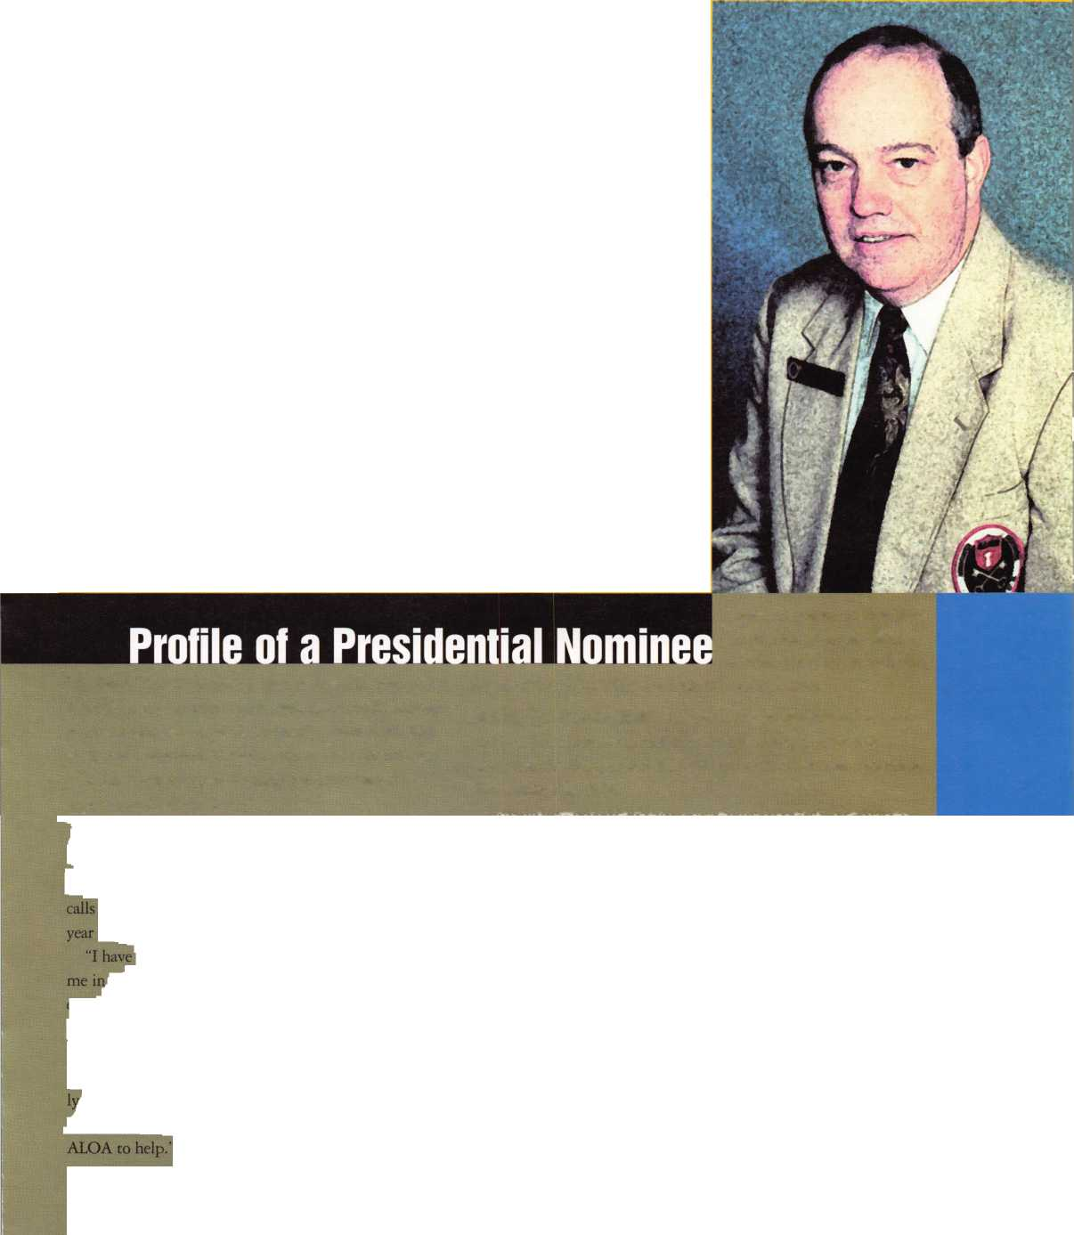

O

ver the years I have only occasionally  
been asked, but often wondered, just  
what the number of possible combina-  
tions for a Simplex-Unican combination  
chamber might be. It seems that I never

got around to doing the numbers, and no piece of litera-  
ture that I have ever seen discloses the rotational parame-  
ters for Simplex. These old stand-by models have reliably  
served in a host of applications for many years and still fill  
an important niche in the access control market for a vari-  
ety of functions. When deciding whether to specify these  
locks for clients or to recommend the more expensive  
electronic models available for keyless entry, several other  
concerns ordinarily arise before the limitations for possi-  
ble combinations come up. Among these requirements,  
which call for electronic access control over the mechani-  
cal variety, are the following:

• A requirement for multiple codes

Allows one code to be changed without affecting others

Allows for levels of security to be implemented Allows for a master code or management levels for control level programming • A requirement for a transaction archive or audit record

• A requirement for time zones Daily Hours of Business Shifts

• Automated recognition of exceptions

Holidays, weekends, daylight savings time, leap years, etc.

• Central control of a network by a host PC

BY KIM **BOWERS, CML & ETHAN BENATAN**



*Keynotes*

May 1997

We should add here that none of these systems are generally regarded as “high security” solutions, but rather as “access control” technologies, ancillary to pri­mary or perimeter security devices like mechanical locks. The day is dawning, however, for high security electronic systems. Certainly no security system may any longer truly be considered “high security” without electronic monitoring, CCTV or various other qualifiers. It follows with the old saying that I repeatedly quote to clients, “There is no security device yet devised by men that can­not be circumvented or defeated by another.” Back-up systems are then necessary for “high security” applica­tions. ADA, Life Safety codes, available coding parame­ters, vulnerability to manipulation and physical attack are also issues that must be considered when specifying security devices, especially for perimeter doors.

Manipulation techniques for mechanical locks like Simplex are far “simpler” than for most quality electron­ic varieties. Of late, I have become increasingly aware of another often overlooked difference between mechanical keyless entry and the growing unitized electronic options from companies like Locknetics, Ilco, Alarm Lock and a host of others. This particular difference is what this arti­cle focuses upon. This issue at hand is of course the lim­ited number of combinations that can be used with a mechanical combination lock like the old reliable Simplex-Unican. The method for determining the total number of possible combinations available for “program- ming”differs markedly from the method of projecting the expansion parameters of such things as key bitting arrays, since with the Simplex combination chamber multiple buttons may be depressed simultaneously.

The method used to determine this number is both interesting and illuminating.

There are two bits of mathematical background that set the stage for the calculations described below. The first is the concept of recursion; the second is how to cal­culate combinations.

Recursion, a fascinating concept, is simple in essence but sometimes a little tricky to understand. Basically, it is a sort of nesting—a recursive definition is one that refers to itself. You might liken it to the popular Russian novelty dolls where each one is sized in a progression so that they may each contain the next smaller size and yet fit within the next size larger while looking otherwise identical. It is almost as if each doll fitted inside itself]

To be of practical use, it must refer to a simpler version of itself, so that the self-reference eventually ends with the simplest case. By way of an example, consider calcu­lating the factorial of N (referred to as N!).

N! = lx2x3x4x ....x (N-l) x N.

Another way of looking at it is to say that N! = N x (N-l)!; that’s a recursive definition, since the definition

le to five events. To [ it N), we can multi-

Keynotes !_H

m \

SfcJ

refers to the thing it is defining. As

mentioned above, we also

plest case, a stopping ]

don’t recurse forever (no ref

the language we might consider when  
faced with mathematical problems).

In the case of the factorial,, we simply  
define that 1! = 1. Bit i

Then 3! = 3 x 2!; 2!= 2 x 1!; and

we reach the stopping point with

= 1. Then we can go backwards, and  
get 3! 3 x 2 x 1 =6.

Recursive solutions are often the  
easiest ones to understand and to  
write programs for. It’s the only algo-  
rithmic way we could find to solve  
the Simplex problem. (A simplex  
problem... there’s an oxymoron for  
you.)

For further reading on the fascinat-  
ing subject of recursion in mathemat-  
ics, art and music, see the book model,

Escher, Bach: an Eternal Golden Bmid  
by Douglas Hofstadter, (Vintage®

Books, New York, 1989).

Moving on to the second piece of  
background: In mathematical ternls,  
combinations refer to the number of  
ways one is choosing k things from a

set of n. This is referred to as C(n,k)|  
and is equal to n!/((n-k)!k!).So if well  
want to know how many ways there .  
are to pick two crayons from a set ofl  
five colors, it would be C (5,2), which

is equal to 5!/((5-2)! 2!) or 5!/(3!2!)J 1  
Now 5! = 120, 31=6, 2!=2, so the  
answer is 120/(6 x 2) = 10 ways.

The basic unit of a Simplex combi-  
nation is the simultaneous depression  
of one or more keys; we’ll call this a

“key press event” (or just “event,” for short). A Simplex combination may thus cd

calculate the number of possibilities for a combination with a known number of events (  
ply two numbers:

(the number of possibilities for event 1) < “Number A” times the number of possibilities for all the

remaining events). <’’Number B”

Now these numbers can’t be calculated in isolation because they affect each other. So let’s express them in  
terms of the number of buttons that are available to us for the event. For instance, imagine the last event of a  
three-event combination. If the first two events each involved a single button-press, then there are three  
unpressed buttons to choose from. We may choose either one, or two, or all three buttons, so the total number of  
possibilities is seven:

C(3,l) + C(3,2) + C(3,3) = 3 + 3 + 1. That is the sum, for k from 1 to 3, of C(3,k).

An additional constraint is that for each event (except the last) we must also be sure to leave enough buttons  
for the remaining events. In fact, the most buttons we can use for any event is equal to the number of unpressed

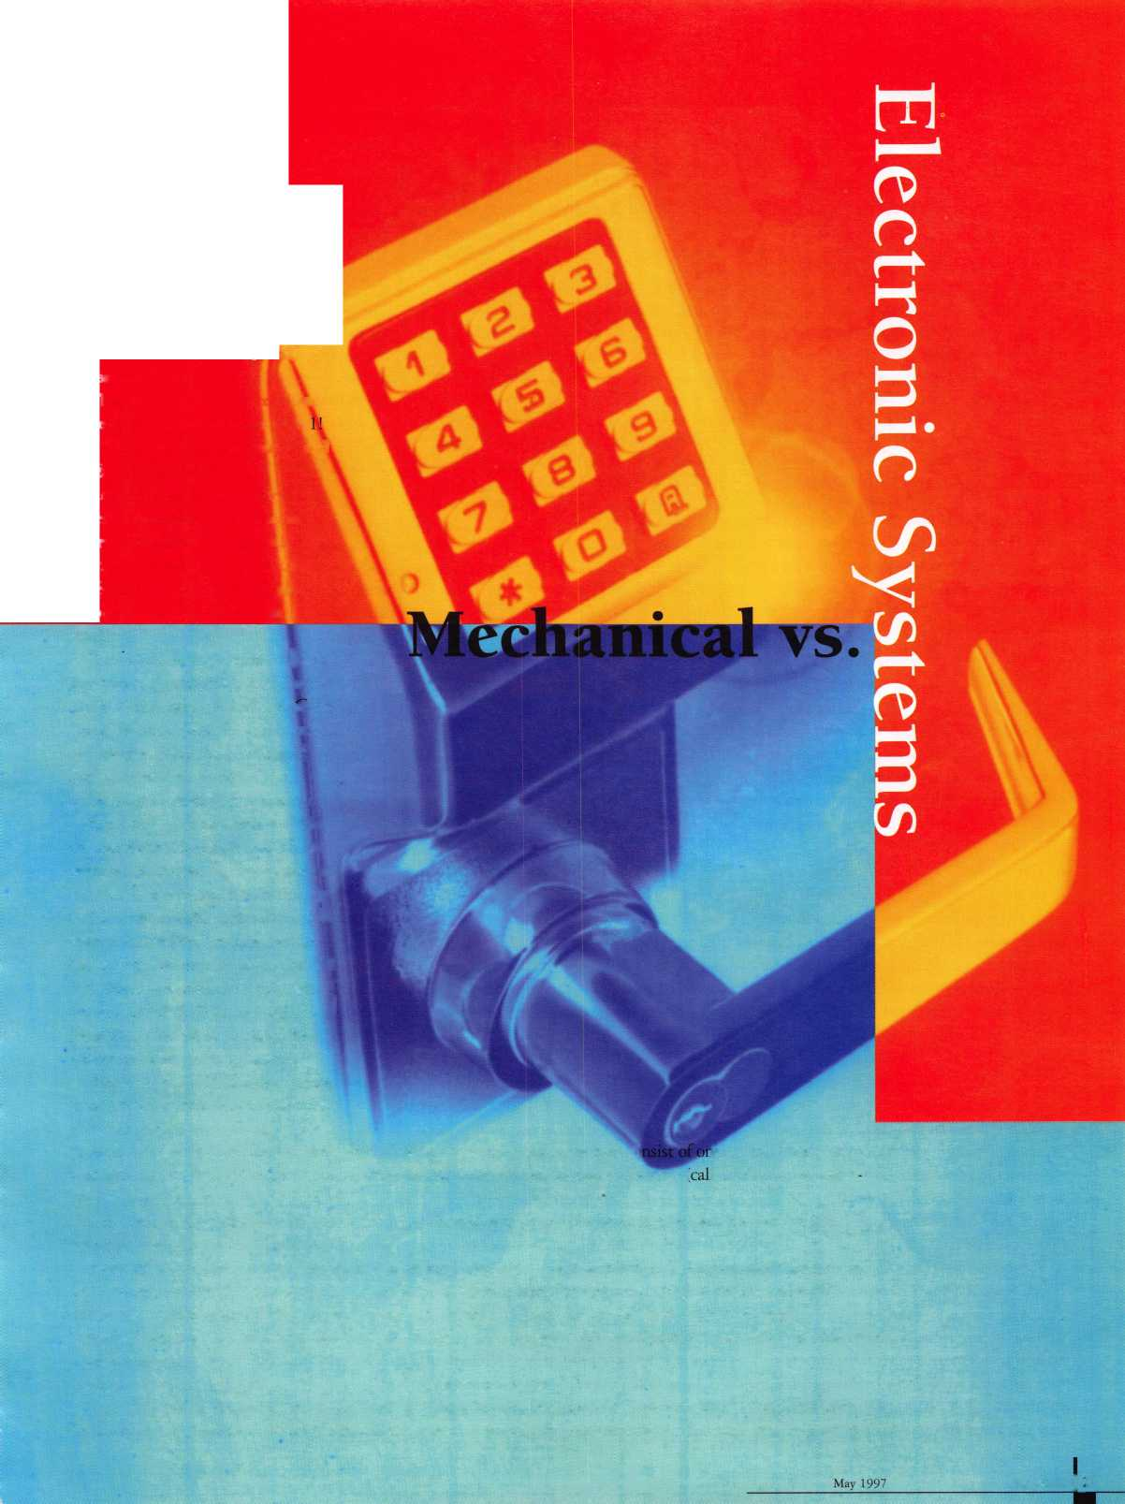

buttons minus the number of events to fol­low (we can always choose to use fewer but­tons). So, we can rewrite the equation above by breaking out every separate case for “Number A.” That is, if we choose one but­ton for this event, or two buttons, or three... The total number of possibilities for an N- event combination is equal to (the number of possibilities for event one using one but­ton) times (the number of possibilities for remaining events if we used one button in event one)

PLUS

The number of possibilities for event one using two buttons) times (the number of possibilities for remaining events if we used two buttons in event one)

PLUS

Et cetera, until we run out of events. The first part of each of these pairs is easily calcu­lated, and the second part has exactly the same form as the original question- but it is simpler because the numbers are smaller! Thus, we can solve the second part by recur­sion. And eventually we must get to the last event, which is always easily calculated, as described above, so we can guarantee a stop­ping point.

Here is the recursive solution, expressed in terms of two numbers: “unpressed,” being the number of buttons not yet used in the combination, and “remaining-events,” being the number of events still remaining in the combination:

Possibilities (unpressed, remaining events) equals the sum for i from 1 to (unpressed minus remaining-events) of C(unpressed, i) multiplied by Possibilities ((unpressed minus i) (remaining-events minus 1))

With the special case that (when there are no events remaining after this one):

Possibilities(unpressed, 0) = the sum for i from 1 to unpressed of C (unpressed, i) which stops us from recursing forever (Thank Goodness!).

So, you can see that the recursive function possibilities is defined in terms of itself, except for the ending case. It is a testament to the power of recursive approaches that the algorithm is only about six lines long, but the explanation requires as many paragraphs. By summing the results of Possibilities (5,0) through Possibilities (5,4) you can calculate

the number of possible combinations on a five-button Simplex, which turns out to be just 1081 (a number small enough that even an unskilled person can search through all the possible combinations in 30 minutes or less). Just for fun, here are the number of combinations that a hypothetical Simplex- type lock with other numbers of buttons would have:

|  |  |
| --- | --- |
| > 2 buttons | 5 |
| > 3 buttons | 25 |
| > 4 buttons | 149 |
| > 5 buttons | 1,081 |
| > 6 buttons | 9,365 |
| > 7 buttons | 94,585 |
| > 8 buttons | 1,091,669 |
| > 9 buttons | 14,174,521 |
| > 10 buttons | 204,495,125 |

It is noteworthy that, if it were practical to produce a seven-button Simplex instead of the present five, there would be almost 100,000 possible combinations! Physical size and mechanical limitations would probably make such a device impractical, however. Here is where the revolution in electronic security qualifying devices comes in. Other elements are the enormous quantity of mov­ing parts to wear out or become damaged and the economy with which such devices could be made and maintained.

Just by comparison, one of the lowest priced electronic digital locks, Alarm Lock’s Trilogy, has 6,000,000 possible combina­tions and costs little more than Simplex. To be fair, we must point out that the weakness of many economical electronic, single door, unitized access control systems like Trilogy is the problem of recidivism. If power is cut off and drained out from the circuit, the combination reverts to the default code and all programming is lost. Of course, more sophisticated electronic systems have non­volatile memory and other safeguards. Even economy models of the future will almost certainly also have this feature, since it is not a significant design problem to economically engineer. The power requirements of the tiny servo-mechanized power trains of these affordable electronic products have come

down significantly. Locknetics products boast 80,000 cycle battery power life, and Alarm Lock has recently redesigned the Trilogy (the T-2) to use “AA” batteries instead of the former twin 9VDC power supply, doubling their product’s battery life to 80,000 as well, according to the company. Although excellent profit is achievable by effectively marketing more advanced prod­ucts like the Ilco Millennium, the Series 800 or the variety of Locknetics single door access controls, far too few locksmiths are taking these products to market. Certainly every building you survey, every quotation you prepare and every customer you make a proposal to will have slightly different con­cerns, needs and preferences. Be informed of all the options so that you may have the opportunity to adequately inform your clien­tele of theirs to serve their best interests.

Come to the ALOA Convention and Trade Show, contact the manufacturer’s rep­resentatives and knowledgeable distributers in your area and arm yourself with the best solutions and technology with which to pro­fessionally serve your valuable customers.

About the authors: Kim Bowers, CML ([advansec@e-tex.com](mailto:advansec@e-tex.com)) a past ALOA Director, is president of Kim Bowers & Associates and Advanced Security Concepts Marketing (AdvanSec), providing Web Site Design, Internet Services and Consulting Ethan Benatan (ethan+@pitt.edu) is currently completing his Ph.D. in Computational Biology at the University of Pittsburgh, where he started think­ing about this when he returned from vacation on a Sunday to find himself locked out of his office.

*Keynotes*

May 1997

**croKey 'f**5 **Presents** 1 **A Golden Sales**

I ake good care of your J

customers with high J 4

security technology that ^ A

creates repeat business

for you. _ % %*

The computerized j ,

MicroKey Series is ^ ,

easily installed in new Jm

or retrofit construction \ applications without \ electrical wiring. Easily expandable, it is adaptable to s/na// or mid-size projects.

It accommodates mortise or cylindrical door prep conditions.

Winfield's sophisticated engineering has instilled the MicroKey System with these state-of-the-art features:

* Audit trail records date, time, authorized user names, unauthorized attempts (1200 entries)
* Five-level keying capabilities (also construction keying)
* System capable of controlling more than 60,000 users
* Instantaneous re-keying capabilities following installation
* Time zone keying control
* Smart, reusable micro-chip key blanks

Don't miss this golden opportunity for increased sales from one source. Call Winfield today for complete information.

A Division of CSS  
1020 West 17th Street, Dept. C-6  
Costa Mesa, California 92627  
Phone: 800-562-5733 (ask for ext. 407)  
(or) 714-722-5400  
Fax: 714-722-0129

Free Information - Reader Service Card #4

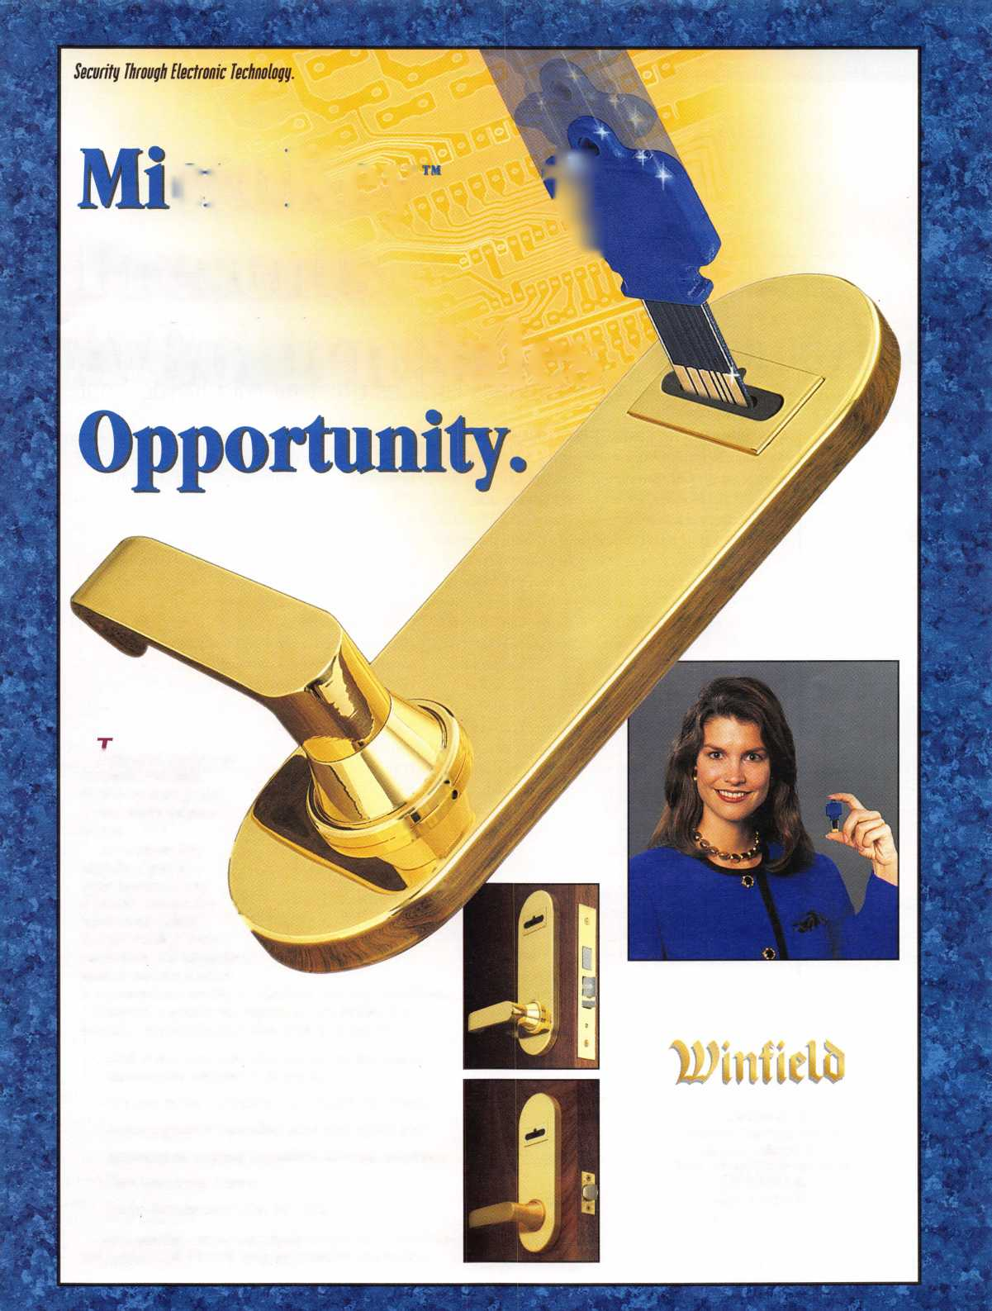

By Mark Ohno



TO STET INTO ACCESS CJWVllCLT

Computerless Devices Get Your Foot In The Door

MARCHING INTO THE COMPUTERIZED LOCKING ERA

Are you a locksmith thinking of getting involved in access control? OK, you’ve read articles proclaiming the arrival of the glorious new era of microchip security. And yes, the demand for electronic based access equipment is growing quickly. If you view it from a historical perspec­tive, all of the major changes in door security have been about convincing people to discard serviceable locking mechanisms in favor of new designs that make the older ones seem obsolete. This is as true for the transition to pin tumblers in the early part of the century as for the recent popularity of high security keys. Electronics has the ability to deliver all sorts of sexy and practical and innovative features that appeal as perceived benefits.

This makes electronics a perfect vehicle to speed us into the next round of “must have” locking hardware. By cre­ating hardware replacement and sales activity that would not otherwise exist, opportunities abound.

The popularity of using electronic devices to control access is not really that new, but it is now at a point of rapid growth—it has gone mainstream, so to speak.

This is due to a number of factors. According to Andrea Demakopoulos of the M. Zion company, a major aspect in the growth of their access business has been the way products and computers have become more affordable, which has expanded the access control customer pool.

In 1976, when their firm added access control to their conventional hardware lines, access control clients were almost exclusively made up of large corporate clients with deep pockets. These days, a typical customer may be almost any size business that has managed to lose control of their keying system, or wants to exert greater control over their premises and what goes on there. In other words, costs and the integration of electronics into all sorts of everyday products have made their inclusion into locking mechanisms a natural, logical step.

LOOK BEFORE YOU LEAP

New and evolving markets and industries seem to have a sort of “shake out” period. In a lot of ways, it separates the merely enthusiastic from those who can actually cre­ate a living once business realities set in, and electronic

access control is no exception. An access control business that does nothing else is unlikely to prosper in a mral farming community like West Fence Post, North Dakota, population 923. So a number of over-specialized access installation and consultation firms have gone by the wayside—enough so that I can name at least 67 individual firms on the eastern seaboard that have gone belly up in the past year or so, and this can’t be more than a small fraction of the overall total.

Diversity seems to be part of the recipe for success in electronic access control, and many successful access installation businesses combine all sorts of security-relat­ed sales and service activities such as: CCTV, alarms, door hardware and locksmith work, parking controls, telecommunications and intercoms, telephone entry, gates and fences, and so forth. However, the inclusion of traditional electronic access control into door and locking mechanism businesses is by no means an easy transition. Traditional access control systems demand a new and really rather different set of financial and trade capabili­ties. The ideal access control dealer might have the skills of a computer wonk, electrician, locksmith, carpenter, estimator, electronics technician, sales whiz and small business genius, and all with a banker’s ability to “float” money. “Fix my broken door” in access terms now can mean a bad reader or wiring connection or control panel or electric strike or transformer. But it can just as easily mean a muddled user, software incompatibility, line noise, program corruption, modem problems, computer virus, or any number of sticky software setup problems. And sometimes it means a door that’s not locking because it’s not latching due to a warp or drag or worn hinges or a leaky closer, or because it got hotter or colder. In terms of financial pitfalls, the purchase of traditional access control system equipment can add up very quick­ly. A relatively “small” job in access control terms can easily involve $7,000 in equipment—dealer cost. And a large job might involve $200,000 in equipment—your cost. To be honest, a $1,000 credit line with suppliers just isn’t going to work. The business ability to get a substantial credit line and to float sizable accounts

Keynotes

May 1997

Dyna Lock's new 7200 Keypad refines a popular product category.

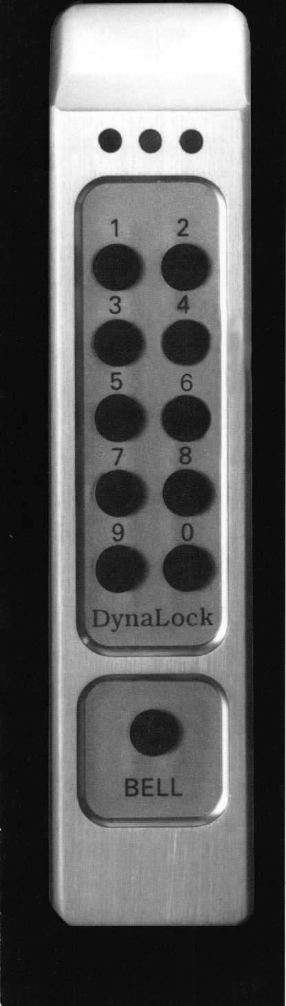

receivable is just part of the business. Few access control system jobs are going to gen­erate a check written on the spot. And it isn’t unusual for payment to be withheld until everything is to the customer’s satisfac­tion.

Since access control systems are computer controlled, they require reasonably well developed computer skills, as well as a solid comfort level with software. It is not merely a matter of making things work under ideal conditions: there is a whole swamp of Murphy’s law ways in which computers defy your best efforts to get them to cooperate. A brilliant software engineer of my acquain­tance recently walked around a major access control show. He reported later that he was able to lock up every access control program he tested that was trying to run in Windows ’95. This just points out that software oper­ating systems and computers change con­stantly, which makes software change con­stantly. And software changes always seem to involve lots of unforeseen surprises in the form of glitches.

Since installation of online access control is largely about low voltage wiring, good wiring skills and wiring troubleshooting skills are necessary. And Murphy’s law says that while it’s great fun racing along con­necting wires all over, it’s a real slog after­wards to figure out what on earth you con­nected where it didn’t belong, or, worse yet, after you get that distinctive electrical smoke that smells so much like lost money. And of course, doors mean hardware installation, including cutting and installing electric strikes and mag locks, and getting those cuts and holes pretty close to correct the first time. As is happening to the locksmith trade, individual states here and there have started to impose regulations and licensing requirements affecting prospective installers of access control equipment. Among other things, this involves a transfer of money from you to the licensing authority. And of course, some states require licensing for low voltage wiring.

According to Mark Ahuna of Tweeds, this licensing can be quite involved. He uses the example of Virginia, where a business engaged in the sale or installation of any device that may detect theft or intrusion, including any access control system with monitoring or alarm capability, must be licensed by the State Department of Criminal Justice. Additionally, every single

employee of the licensed firm that is involved in selling or installing the equip­ment must also be individually tested and licensed as either an electronic security sales rep or electronic security technician.

WALK BEFORE YOU RUN Having mentioned some of the enticements and perils of traditional electronic access con­trol systems, you are probably aware that there is another rapidly growing segment of the access control market. It doesn’t really have a name, but it consists of non-system- oriented electronic access control devices that do not require a computer for programming.

It’s not that you couldn’t install a number of them in a building, it’s just that they operate completely individually and do not require the use of a computer or the purchase of spe­cial software for their set-up and program­ming. Obviously they are a great way for locksmiths to get their feet wet and make money in the access market without some of the complexities.

KEYPAD DOOR UNITS: MODULAR AND INTEGRATED

There are really two categories of units. One type controls electrical relays (usually two or three) to give you control over whatever elec­tric strike or mag lock you choose to use.

They usually consist of a keypad and a remote mounted controller module that con­tains the circuit board with memory and relays. It is easy to think of this as the “mod­ular” approach. You mount the keypad on the door frame or wall, and the control mod­ule in any out-of-the-way spot inside, such as above a hung ceiling. The advantage of this approach is that it works for any door on which you can install an electric strike or mag lock, including the ubiquitous store­front aluminum and glass doors found every­where. The disadvantage is that there is a certain amount of wiring involved to con­nect the modular bits, and these units do require wiring to a power source (so does the electric strike). And if you are particularly unlucky, every frame you have to install an electric strike into will be concrete filled.

The second type, an “integrated” approach, combines a lock with a keypad housing and electronics as one package, and mounts on the door. It is often battery powered. The advantage of this approach is that it is easy to install on doors it is suited for, and involves no wiring beyond plugging a con­nector together. The disadvantage is that this approach is generally not suited for alu-

May 1997 Keynotes k

minum and glass doors, and some units can­not be put into a passage mode for public entry. Battery power (or the departure of it) can cause tiresome “lock outs” on high-use doors, or if low battery warnings are not heeded. Some units can be provided with electrical power by wiring through the door, through a wired hinge or door loop, and to a power supply.

THE PRODUCTS

The “modular” keypad product market seg­ment has been a hotbed of product competi­tion, with manufacturers updating product frequently to meet demand and gain market share. Many products have evolved in similar ways. Typically the units will accommodate narrow stile mounting, run on 12-24 volts AC or DC, have LED indicators, operate in any environment, and program through the keyboard without requiring a computer. Dynalock’s new 7200 series digital keypad accommodates 60 or 120 users, has 11 active keys, audible feedback, three LED indicators and non-volatile memory against informa­tion loss after a power disruption. Features include duress, tamper lockout, anti-tailgat­ing, and doorbell, plus the ability to com­bine two keypads for one controller. The list price is $320 at the time of writing. An excellent aspect of the Dynalok design is a tamper-resistant concealed mounting plate and security screw, instead of a hidden through-screw. According to John Schum of Dynalock, the locksmith and consumer has benefited greatly from the strong competi­tion in this hot market segment, which has resulted in refined products with better physical durability, features, and simplicity of use than was previously available. Securitron’s popular DK26 digital keypad entry unitsupports 59 users, has a stainless steel housing against corrosion, has 11 active keys, three LED indicators, audible feedback, non-volatile memory, and a two-year warran­ty. It has functions such as doorbell, request to exit, tamper lockout, anti-tailgating, and duress, and allows two keypads to be con­nected to one controller for both sides of a door.

Locknetics’ well known 770 series digital entry devices features aluminum or stainless steel housings, 20 or 150 users, six active keys, non-volatile memory, and two LED

indicators. While the units self-program  
through the keypad, there is an audit trail  
option that would require a computer and  
computer interface pack for those customers  
desiring a history of door use.

IE Is 200 series keypad entry units  
supports 120 users in a variety of key-  
pad styles. Secura Key’s newly intro-  
duced Radio Key 600 is a particularly  
interesting product design in that it  
uses proximity tags (radio frequency  
125 KH) for entry, yet it does not  
require a computer for programming.  
According to Secura Key’s application  
specialist, Bob Hollings, “Even lock-  
smiths who are computer savvy would  
prefer not to spend hours wiring data  
cables, diagnosing memory and hard  
disk problems, configuring modems,  
or dealing with possible software con-  
flicts.” He notes that in many cases  
corporate accounts will call locksmiths  
for single door and non-system access  
control. The Secura Key Radio Key  
600 accommodates 600 users in non  
volatile memory. The tags have a  
claimed read range of five inches. A  
keypad is used for programming the  
unit to accept tags. The suggested  
retail price of around $330 at the time  
of writing and user quantity makes

this an attractive alternative where digital  
entry is not desired.

The integrated category includes door mounted electronic units with integrated locks, and again we are talking about units that do not require a computer to program and operate (so it does not include Ilco Unican’s popular 800/900 cardlock, Best’s Vantage Point card lock, Locknetics CM5400, and the various hotel cardlocks).

OSI’s Omnilok is available with either mortise or cylindrical lockbodies, has an 11- button keypad, and supports up to 500 user codes, depending on model. While they do not require a computer to program, all mod­els except one require the purchase of a spe­cial printer device to initiate the program­ming sequence. But the printer device gives interrogation (audit trail, or record of entry) capability.

Alarm Lock’s Trilogy T2 (DL2700 series)—which can be mated to many popu­

lar cylindrical locksets such as Schlage, Arrow and Falcon—uses a clutched knob or lever, self-programs through its 12-button keypad, and is battery powered. It allows 15 user codes plus a master and manager code,

**SeenraKew**

**Radio Key.**

Secura Key's new Radio Key 600 features prox tag sophistication: no computer required.

and a one time use code. It also has a pro­grammable passage mode and tamper lock­out feature.

CHOICES

The products jostling for a piece of the elec­tronic access control market will continue to proliferate. Fortunately, it is an inclusive mix that allows lock professionals to get involved as heavily or progressively as they wish and as the market demand increases in their locality. The number of locksmiths advertising “access control” in their yellow pages ads has grown every year and will continue to do so.

About the Author: Mark Ohno is the author of tech­nical articles on a wide range of topics, and has 15 years involvement in electronic security product marketing, product management and specifying.

He is currently general manager of the Kolram Security Group, which provides consulting and other services.

Keynotes

May 1997

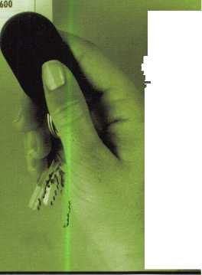

**Good Things  
ome To Thos  
Who Wait!**

o o o

MAS0H;i||LK

o o o

® €55

**MAS,**

AUDITCON LOC l Easy Retrofit: Has the same footprint as most mechanical locks, so it's easy to install. Records last 8 entries in sequential order.

Offers quick entry. Wrong Try Entry: Will not allow access to any user for a period of 30 seconds after 3 incorrect combinations are entered. Up to 6 users with no costly combination changes.

AUDITCON LOCK 200V & 200R Offers all the features of the 100 plus: Provides

a complete listing of the user's ID, plus the type of entry/activity for up to 100 events, in sequential order. Alarm Interface: (optional) Activates the lock's duress condition,.when, connected to an existing alarm system. Print, display or

file the lock audit reports. Up to 20 users.

AUDITCON LOCK 400V & 400 Offers all the features of the 100 and 200 plus: Up to 100 users Number <

entries is increased to 200 records and stamps the date and time of entry or activity.

**Now all your customers, large or small  
can afford Mas-Hamilton technology.**

***Defining the future***

|  |  |
| --- | --- |
|  | ***** |
| o o | <p |
| 1 o o  -;0H-4iitTTN |  |
| 1 o o | ! |

800.950.4744 • [www.mas-hamilton.com](http://www.mas-hamilton.com)  
805-D Newtown Circle, Lexington, Kentucky 40511-1240 Phone 606.253.4744 Fax 606.253.4748

Free Information - Reader Service Card #5

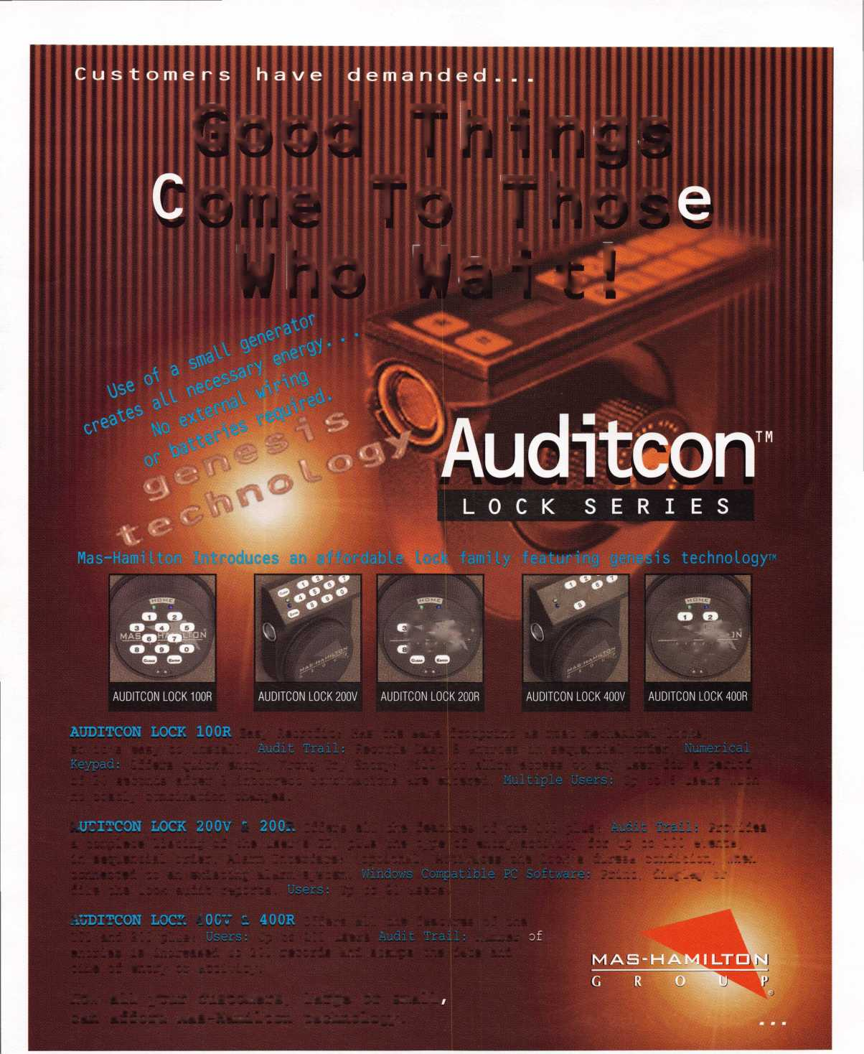

One Nicii it, a fresh-faced college student named Joe left the security of his apart-  
ment to brave the unknown waiting outside. The wind blew roughly...the dogs  
growled loudly...the front dcx>r shut tightly. And Joe’s keys waited snugly inside.

On this particular night, a fresh-faced college student named Joe found him-  
self locked out of his apartment. One hour and eighty dollars later, Joe learned a  
valuable lesson that he would carry with him for the rest of his life:

Locksmithing is cool.

**New Moves**

A few years following his college lockout experience, Joe Lee graduated from  
Penn State with a bachelor’s degree in advertising. But after landing a job in a  
corporate ad department, he discovered office life didn’t meet his needs.

“Sitting behind the computer playing Tetris’ while the supervisor is out isn’t  
really satisfying,” said Joe.

So he looked in the newspaper for a new job, and that’s when he saw an ad  
from Houdini Lock and Safe. He sent in his resume, and soon found himself  
employed. And after a two-month, no-pay apprenticeship, Joe became a regular  
paid employee.

“At that junction in time, I really wasn’t experienced,” said Joe, “but you  
learn the trade as you go. A person who has the ability will figure it out.”

Although locksmithing is a long way from advertising, Joe said finding a pas-  
sion for the trade wasn’t as big of a surprise as one might think.

“I was that little kid who took the radio apart to try to put it back together,”  
he said.

From radios to removable cores, Joe has turned a passion into a career.

“Locksmithing is a natural high. I’m probably one of the only people who can  
say, ‘I love my job.’ 1 don’t think I’ll ever get tired of it.”

**Culture Clash**

Joe was born in Carbondale, IL. When he was 11, his family moved to Korea.  
Five years later, after his visa had expired, Joe returned to the states to preserve  
his U.S. citizenship.

“I couldn’t really live in Korea anymore. It was too hard because the cultures  
are so different.”

Differences in custom are easy to see—people dress a certain way or eat certain  
fo(xls. But when it comes to the uniqueness of a culture—the worldview of a  
particular group of people—those differences are often a lot more subtle. A large  
difference between eastern and western societies lies it the way elders are treated.

“Western culture doesn’t have as much respect for elders as Asian culture does.  
If you’re older than me, I have to call you a certain name to show respect. If I’m  
in the fifth grade and you’re in the sixth, there’s a certain word that I have to call  
you to show you’re an upper classman. You can call me Joe if you’re older than I  
am, but if not, then you need to show respect.”

Another difference between Eastern and Western culture lies in the way  
tradespeople, particularly locksmiths, are viewed.

“In Korea, locksmiths are not viewed as professionals—they’re viewed as  
handymen—the guy across the street in the little shop.”

As in America, Korea has it’s own type of SIC coding, and Korean locksmiths

The Ambassador



have run into some of the same walls  
as American locksmiths. In Korea,  
locksmiths fall under the “Fire  
Security” category, but according to  
Joe, locksmiths should be classified as  
“Window and Door Security” profes-  
sionals. On his last visit to Korea, Joe  
met with politicians and officers of the  
Korean chapter to discuss moving  
locksmiths to the “Window and Door  
Security” category.

“I don’t know if locksmiths are  
stuck in this category because the gov-  
ernment didn’t want to put up with  
them,” said Joe. “but, it seem like  
they said, Just shove them in there.’”  
In America, locksmiths have only  
recently received fair and proper classi-  
fication. In Korea, locksmiths have an  
additional battle to fight: their image.

“Koreans think American lock-  
smiths are the luckiest people in the  
world because of the way people treat  
locksmiths in the states. Customers  
treat you like a professional. They  
don’t just treat you like Joe Schmo. In  
Korea they cut the locksmiths down  
so much that their self esteem is low.”  
One possible reason for the lack of  
respect towards the locksmithing pro-  
fession may be the fact that many  
Korean locksmiths don’t receive a for-  
mal education. In Korea, diplomas  
and degrees are highly regarded. Since  
a locksmith’s education is measured by  
PRP certification, and because the

PRP examinations are written in English, Koreans don’t  
enjoy the same level of status as Americans. This is not  
to say that Koreans are less skilled than Americans, but  
rather, Koreans have not had the same opportunity for  
certification.

“If I put together some questions in Korean and then translated them into English and then got it approved, I could probably work with headquarters to put some­thing together so we could give them a PRP test. Of course, I would have to do it in Philadelphia under the highest security,” said Joe. “ It’s like any other test—you don’t give out the answers.”

**Building a Walkway**

Because Joe has the unique perspective that could only come from belonging to two distinct membership groups within ALOA—Korean and American—he is in a position to lay the proverbial cape over the water so members from each camp can walk over to the other side. Members who know Joe, or know of him, voted to recognize his unique position. At the fall 1996 Board Meeting, upon the recommendation of Dana Barnum, CML, the board members unanimously voted him “Korean Ambassador.”

“He is the liaison between ALOA and Korean lock­smiths. He is able to interpret for us,” said Barnum. “He’s a very nice fellow, and he’s good at what he does.”

**Stereotypes**

Find a definable group of people who hasn’t had to bat­tle stereotypes. The fact is, the more limited one’s expe­rience is with a person or people belonging to a certain group, the easier—and more common—stereotyping becomes.

“I think the stereotype is that Koreans own dry clean­ing or grocery stores or fruit shops,” said Joe. “Other stereotypes are that Koreans are doctors, engineers or lawyers.”

Dissolving stereotypes starts with basic communica­tion. But when people do not speak the same language, it is harder to make a connection. Joe works toward fill­ing the language gap between Koreans and Americans by taking a first step—he translated the Professional Glossary of Terms into Korean. He also had the glossary copied and bound for members. He presented the copies to the Korean chapter members at a recent meeting.

The lack pf communication between Korean and American locksmiths has greater implications than the inability to speak with one another. If no common ground exists between the two groups, then Koreans will not be able to understand what goes on in ALOA— which is composed of primarily English-speaking mem­bers—or how membership is beneficial to them. If Koreans do not communicate with ALOA members, they will not be educated on new policies, practices, leg­islature, classes, conventions and other pertinent infor­mation. And this lack of communication limits progress.

Finding a way to overcome the language barrier plays a leading role in Joe’s work . He attends conventions not only for the personal education, but also to meet people and help Koreans meet other members.

May 1997

*Keynotes*

“Last year at the New Orleans convention, some American members from the Georgia chapter came up to the Korean members and started talking. They got along really well. And then we met a member from Hong Kong, and after that, every time we saw each other we’d go out and do something. I’ve made friends from Belgium, Germany, Japan, Great Britain. After this year, I’ll have taken all the classes I can take, but that doesn’t mean I won’t show up next year.”

Joe also points out that despite the language differ­ence, many Korean members attend conventions—sim­ply for the chance to learn.

“Most of the members who show up at conventions are gung ho—they want to learn. Even though they don’t understand what the instructor is saying, some­times by just looking at what he’s doing, they learn. Just to learn a little, they invest the time and money to come over here.”

Joe’s job as Korean Ambassador doesn’t stop there. To further his cause, he translates Keynotes articles.

“Even though the Korean members have the obstacle of language, the pictures in Keynotes help them and give them incentive to learn.”

Joe realizes that education for Korea members not only makes them better locksmiths, but helps to shape a strong reputation for the industry as a whole. By looking at the big and small picture, Joe sees what is needed now and in the future: education for Koreans in Korea.

“In the near future, after I become an instructor, maybe I can put a class together for them. In the states, we have the benefit of taking ACE classes. In Korea, it takes a lot of money to put on a class. If I do something small like this, it makes me feel better and I’m doing something for my association. And the members in Korea feel like ALOA is doing something for them.”

**Speciality Strengths**

In Korea, if a home is burglarized, the locksmith who serviced the house can count on a phone call from inves­tigative officials, which is not common practice in the United States. Detectives on the case speak with the locksmith to try to determine the cause of the break-in, and to see if the intrusion was a result of poor workman­ship. Usually, the area locksmith is not at fault.

Another difference between American and Korean locksmiths lies in their respective areas of specialty.

“Americans can learn a lot from Koreans about auto­motive and opening techniques for locks, and picking too,” said Joe.

Likewise, he said Koreans can learn a lot about master keying and access control from Americans.

“Locksmithing is leaning toward electronic access control. I think the states are more advanced in electron­ic security.”

Although Korea’s crime statistics are very low, and even though 95 percent of the locks in Korea are high security, actual physical security is weak because of the lack of key control. Joe said that none of the shops he visited had pin kits.

“I don’t think they service the locks—they mostly replace them.”

Last year, Korea experienced a breach in security that caused a red alert. Since the 38th parallel divides Korea into communist and democratic areas known as North Korea and South Korea, the two sides are not allies. When a North Korean submarine crossed the boundary and entered South Korea, the South Koreans felt threat­ened because the North Korean trespassers were spies.

“After that incident, the view of security changed a lot. People are now actually changing to new locks, adding new locks and trying to secure their homes a lit­tle better,” said Joe.

Keeping Korean locksmiths up-to-date on current technology shared through ALOA membership is anoth­er way to help strengthen security.

Do **Unto Others**

At 28, Joe already has several career goals mapped out. By the turn of the century, he hopes to have his own shop set up in Philadelphia. His shop will service all locksmithing needs with a special emphasis on lock-outs. But his number one concern is customer satisfaction.

“I’m a pretty good customer service person. I really care about my customers and how they’re treated.”

The fact that he cares is obvious. The Ambassador puts in a lot of extra hours—just for that very cause.

“If I could go out to Korea once a year and do some­thing small for Korean locksmiths, they think it’s big.

It’s like, ‘Wow, ALOA didn’t forget us—they know we’re here.’ It makes me happy to know that I can be a part of an association that is putting forth the effort.”

*About the Author: Laurie Kline is the Associate Editor of*

Keynotes.

BY PAUL F. CHANDLER CRL

Control Without Wires.

Electronic access control is not the future of our industry—it is the present. And whether we are ready for it or not, its here.

I talk to a lot of locksmiths about access control. My work involves helping my cus­tomers design, quote, implement and trou­bleshoot electronic locking systems of various types. And I love what I do—I get a kick out of figuring out a new application or finding an electronic solution to a new problem. Sometimes I forget that not everyone shares my enthusiasm for com­plicated circuitry.

I guess these people feel about electrical installations the way I used to feel about computers. Remember when you had to type in things like, “RAMDRIVE.SYS BACKSLASH CONFIGBAT.<C” just to turn the dang thing off? Who makes this stuff up, anyway? Why couldn’t they teach computers English, instead of COBAL or DOS or KLINGON or whatever that stuff is?

And then they did just that. Or at least they made them much easier to use with drop-down boxes and icons and mice and all the other neat things that even a computer illiterate like me can handle. And every year (heck, every month) they make these machines smaller, cheaper and easier to use. The same electronic revolution that is changing the face of personal computers is also bringing access control within reach of everybody—even those locksmiths who can’t tell a volt from an amp.

The big development in the last couple of years has been the self-contained, stand-alone access control sys­tem. Not long ago this field belonged exclusively to mechanical pushbutton locks, i.e. Unican. Today there are several products that are just as easy to install, but offer multiple user codes, audit trails, time zones and event scheduling. You can install units that use codes, cards, datachips or microkeys.

One of the least expensive and easiest to use of the new generation products is the Alarm Lock Trilogy. The original Trilogy, the DL2500, was released in 1992 and it caused quite a stir in the industry. Priced slightly higher than the mechanical pushbutton locks, Trilogy offered 15 user codes, a passage set mode, a lockout mode and automatic shutdown after a number of wrong attempts. You could even wire up a normally open but­ton to release the Trilogy lockset from a remote location. ADA approved levers, and key bypass (either inter­changeable core or conventional key-in-knob cylinder) were standard.

In late 1996, Alarm Lock began shipping the DL2700, a.k.a. “T2.” This new Trilogy has several improvements over the original product. For example, the T2 uses a clutched lever mechanism that moves

without retracting the latch when the unit is locked.

The old rigid lever stressed the entire lock chassis each time someone attempted to open a locked door. In addi­tion, the T2 has an internal terminal strip for connecting hardwired options. These include a remote release but­ton, an external AC power source and an on-board form C relay that can be used to shunt an alarm, start a CCTV recorder or turn on the lights when any key is pressed. You’ll also appreciate that the T2 is non-handed. To bet­ter match existing architectural finishes, they have added bright brass (605) and bright chrome (625) to the antique brass (609) and satin chrome (626) available in the old Trilogy.

The DL2700 provides your customer with the ability to add or delete users quickly and easily—right at the lock’s keypad. Taking away one person’s access does not effect the other 14 codes in the Trilogy’s memory. If you want to allow unrestricted access during certain periods of time, simply enter the passage mode and the Trilogy becomes a Grade 1, ADA passage lever. On the other hand, if you wish to prevent access by a group of employ­ees for a period of time, that group of codes can be “turned off’ temporarily. If you want to allow someone access just one time—the cleaning lady for example—a single use code can be programmed in.

Alarm Lock plans to introduce a weatherproofing kit in the very near future, which will allow installation on exterior doors.

Trilogy meets many access control applications. However, if your customer needs an audit trail—a record of activity showing user/day/date/time—or time zones— individual schedule of access times and days—the T2 is not the right lock. According to Alarm Lock, there will be a “Super Trilogy” with these features and more before 1998. Can’t wait ‘til then? Don’t despair. There are other self-contained, stand-alone products that meet your needs. Winfield Architectural Locks, Ilco-Unican- Marlok, Omnilock Security Incorporated, Intellikey, Locknetics and several other companies have brought exciting new products to market. In future articles, I will review these access control systems and explore ways that you can make money with them.

Access control systems that require power supplies, controller boxes and miles of wiring aren’t going any­where—yet. But the new self-contained, stand-alone access control locks are going to be big. And maybe this is the niche for you. Let’s look into it together.

About the Author: Paul Chandler, CRL, is the manager of the Electronic Security Department for I.D.N-ACME in Houston, TX.

May 1997

Keynotes

**ww-aloa-org**

Once again your association has introduced a member benefit that can make a positive difference in your busi­ness on a daily basis—the kind of difference that facili­tates getting your work done, exchanging ideas with other locksmiths all over the world, receiving technical assistance when you need it from your fellow locksmiths, marketing your business to your best potential clients and a host of other advantages, all without leaving your desk! As if that were not enough, ALOA is providing this benefit at no additional charge to its members.

The official site of the Associated Locksmiths of America on the World Wide Web may be found at <http://www.aloa.org>. The site is not only for your refer­ence, but just as importantly, it is also for the reference of your prospective customers. It helps customers in your locality find you, as a professional member of ALOA, over anyone else who may be in the business in your area. Any city, state or country may be searched for a list of local ALOA members from anywhere in the world. Searchers can find those ALOA locksmith members available to provide security services and merchandise for that locality. The list shows each members business address, level of certification, telephone number, e-mail address and, for those who are actively marketing on the Internet, a link to his or her company’s home page.

**Why has the Association Decided to Appear on the Internet?**

The challenge and costs of maintaining close contact with more than 10,000 members in nearly 50 countries world-wide demand the implementation of new infor­mation technologies that have only developed within the last few years. Your professional association takes its role of leading the way into new technologies seriously, and has set about actively serving your business interests through doing so. ALOA is larger and more active in operational fields like legislation, certification and public relations than ever before, and coordinating these activi­ties on behalf of our diverse membership while listening carefully to their needs, concerns and suggestions can be a daunting task. The Board of Directors hopes that you will take full advantage of the many new facilities avail­able to you through the association’s web presence, and continues to be interested in your input regarding the

| various aspects of new communications technologies.

Board travel and committee meetings have been as expensive as they have been essential to the smooth oper­ation of ALOA. Long distance telephone calls required for urgent action are expensive as well for the association. The Internet affords long distance communications with­out such charges and automatically archives the records of these communications as searchable data bases. Use of the secure communications feature on the ALOA web site allows committees to meet and the full board to dis­cuss critical matters in complete privacy. Best of all, the site affords a number of member benefits never before available to locksmiths.

What options and advantages does this mean for members?

Lock Chat: Talk to your fellow locksmiths all over the world without even having to pay any long distance charges! If you have a technical problem that requires specialized help, put word out on Lock Chat, and other friendly members can assist you with tips and sugges­tions. All ALOA members in good standing may access the “Members Only” portion of the site with the follow­ing name (aloa) and password (lockup97).

Find a Locksmith: A realtor or corporate manager needs to have a job done by a locksmith in a remote city. How can he find an ALOA member? All that is required is for him is to come to the ALOA Web Site Locksmith Search Page and enter the name of the city, state or even coun­try where a locksmith is needed. A list of all ALOA members along with their level of certification, business name, telephone number, address and e-mail address is generated by the ALOA Membership Search Engine.

For other “find” options, any of these fields may be searched by using the ALOA Advanced Search Engine.

If you know only a first name, business name or other specific data, chances are good that you can find the per­son you are looking for with “Find A Locksmith.” The search database is updated twice a year, and is therefore more accurate than the old paper version of the member­ship directory. Also, it’s a lot less expensive to publish. Keynotes E-Zine: Each month the lead article of I Keynotes is available electronically on the Keynotes E-Zine page, complete with pictures and how-to details. Write an article for Keynotes, and perhaps you’ll be published on

the Internet, too! You can even go back and view the rticles from earlier in the year on the E-Zine pages. Employment Opportunities: Need a new employee or looking for a job? There is no better place to check than the ALOA Employment Page. It’s more contemporary nd up-to-date than conventionally printed employment notices, and if the position is still posted, it is still open, echnical Assistance: Complete instructions for use of the various pages on the ALOA site are available on the “Set Up Help” page. Unfamiliar with “chat rooms” like ck Chat? Want to customize your Netscape Navigator r Microsoft Internet Explorer to open to your home age or [www.aloa.org](http://www.aloa.org)? Need to find out the fine details f telecommunications etiquette? You’ll be an expert in no time with the information on the “Set-Up Help” Page.

Register for Convention On-line: Registering for the ALOA International Convention and Trade Show could not be easier. Choose your classes and/or package, enter your credit card number on our secure transaction page and you’re done. It’s instantaneous and no postage is needed!

Get Up-To-Date Industry News: Stay on top of indus­try trends and issues practically as they happen.

Keep your eye on national and state legislation: The

ALOA Legislative Committee and your professional lob­bying team let you know what is happening in your state, across the nation and throughout the world.

Pay your dues on-line: Use our easy payment plan.

Just enter your credit card number, point and click. It’s all on a secure server for your protection. That means that all communications are encrypted for secure trans­mission.

Keep up with the ALOA Continuing Education Program: Soon you will be able to sign up for technical classes to be conducted on-line. Don’t forget to visit the ALOA On-Line Store.

Members and Associate Members get a free link from the ALOA home page to their personal/busi­ness home page on the Internet: Build your own web site and promote your business in this popular new medium. You can place a catalog of services and prod­ucts on the Internet for all to see and order from. (Don’t forget to put your web address on your business cards, stationery and telephone book ad, etc.)

A link to the ALOA site is sure to get attention from your prospective clientele. Just ask us for details about linking to the ALOA site. Contact “advansec@e- tex.com” (e-mail address) for further information.

What’s So Different About Advertising and Promoting Your Business on the Internet?

Economically market your products and services to your region and to the world. The largest marketplace in his­tory (and certainly the fastest growing one ever) is also the least expensive to advertise on. The customers who see your ad are typically the ones who have the greatest security concerns and should be willing to invest the most in adequate security. Your link from the premier



international security technicians association, ALOA gives you significant marketing advantages.

**Contact Fellow Locksmiths Anywhere in the World- free.**

Want to make friends or stay in touch with security pro­fessionals and acquaintances in other countries for free? Now it is easier than ever.

**Register for Convention and Trade Show, On-Line.**

Check out the lineup of classes in Reno this year. There’s even an evening seminar on the Internet and the World Wide Web. Choose your classes and purchase registration for them with your credit card right from your desk-top using ALOA’s encrypted secure server. But don’t worry, its all automated and self-explanatory to use.

**Purchase Official ALOA Member Items at the ALOA Virtual Store.**

Take a look at all those distinctive ALOA member items and place your orders through the secure server. Books, brochures, ALOA shirts and many other items to choose from are available to members only.

**How You Can Take Full Advantage of The ALOA Site for Your Business Future?**

The significance of your association publishing on the Internet does not end with using the ALOA site for these and other benefits, however. Think of it as a friendly introduction into the exciting world of informa­tion technologies and information security. The ALOA site is state-of-the-art, and using this one site will famil­iarize you with utilizing these powerful new technical features practically anywhere else on the Web.

As large as the ALOA site is, it is designed and implemented to do much more than pay for itself. That means that these great advantages will not cost the membership a lot of money, but will actually be an added benefit, and these features save money at the same time.

Think of it as a whole new arena of information, mar­keting and communications technologies rolled into one and provided to professional members of ALOA as the Association leads the way into the 21st Century.

*About the author: Kim Bowers, CML has over 20 years of experi­ence in high security technologies, biometrics and information security. A former member of the ALOA Board, he received the ACE Award in 1995. He is currently president of AdvanSec, who publishes the ALOA Website.*

Electronic Access Control

From

Nanotechnology

It was a couple of years ago when I saw the first ver­sion of an electronic push button lockset from Nanotechnology. That first version turned a lot of heads because of its unique self-contained power source. A small trigger-like part activated a built-in generator, which produced enough electrical power to operate the electronic lock. The use of non­

volatile memory allowed the lockset to set for extended periods of inactivity and still be able to pick up where it left off. That period of neglect could have been two weeks or two years, but the lock’s memory would not forget the access code.

Feedback from locksmiths and lock wholesalers caused John Chu of Nanotechnology to make some design changes. Besides the generator that self pow­ered the lock (no batteries were required for the orig­inal lock design), the actual power requirements to operate the lock were quite minimal. When feed­back from potential customers indicated a preference for a battery-powered lock, the low power lock mechanism helped to give the lock incredible bat­tery life, even for very high use applications. The estimated battery life in a NanoLox-B lock is almost the equivalent of the battery shelf life if the batteries were left in their package and never used.

by Sal Dulcamaro, CIVIL

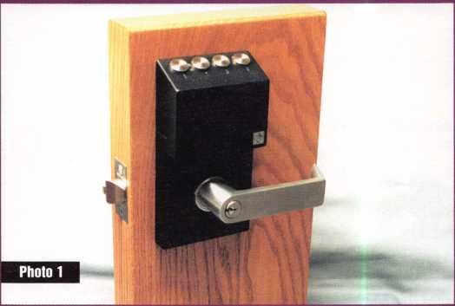

36 | *Keynotes*

May 1997



An early production version of the NanoLox-B250 is shown in photo one. Because it is battery powered instead of self powered, it is nearly identical in appearance to the original version except for the lack of the trigger, which would have operated the power generator.

The NanoLox-B locks are built around the chassis of a Schlage D series Rhodes lever lockset. The original version was going to be a kit that a locksmith (or other technician) would assemble onto the Schlage chassis. Concern for inconsistent quality (if electronic lock kits were assembled by untrained peo­ple) put that idea on hold. For the time being, lockset assembly (of all versions of the lock) will remain at the factory.

The NanoLox-B Locksets The NanoLox- B125 and B-250 locksets allow for 125 or 253 user programmable codes respectively. The code length is programmable from three to seven digits. Although there is a four-but­ton keypad, the digits are definable from one button pushed to as many as three buttons pushed simultaneously. The digit configura­tions are as follows. Single button: 1, 2, 3 or 4. Double button: 12, 13, 14, 23, 24 and 34. Triple button: 123,124, 134 and 234.

Any configuration can be used within the same user code. For example, a three digit user code could be: 34-123-2. “34” indicates 3 and 4 pushed together. “123” indicates 1,

2 and 3 pushed together. “2” indicates 2 pushed alone. The individual digit configu­rations (combining single, double or triple button variations) total 14 different ones.

Security against random guessing is accomplished in two ways. First, the large

base of user definable codes can make guess­ing difficult, especially when programming more digits into individual user codes. With 14 different digit configurations, the num­ber of usable codes to choose from (of 125 or 253) are as follows: Three digit user codes: 2,744 (14x14x14=2,744); four digit user codes: 38,416 (14x14x14x14=38,416); five digit user codes: 537,824 (14x14x14x14x14=537,824); six digit user codes: 7,529,536

(14x14x14x14x14x14=7,529,536) and seven digit user codes: 105,413,504 (14x14x14x14x14x14x14=105,413,504).

Using a seven digit user code, even if all 253 different codes are programmed into the lock, the mathematical odds of just guessing even one of them is nearly one in 4l6 thou­sand. Making things even more difficult, the other security feature is a lockout mode that activates after three unsuccessful attempts. Even knowing a correct code will then require the combination to be repeated twice before the lock will respond.

Because of the lockout mode, even if you tried every one of the over 105 million pos­sible combinations, the lock would not open. To be successful, you would have to try every combination twice. If you were to punch in the correct combination while in the lockout mode, the lock would indicate that the combination was incorrect (even though it was actually correct) and would only respond when the combination was repeated in succession the second time. That would change the actual odds of finding any one of the usable combinations (that were currently programmed into the lock) to nearly a million to one. Not very good odds.

Lock Installation Photo two shows the key pad and housing for the electronic unit that is mated to the chassis of a Schlage D series (grade 1) Rhodes lever lockset. It is actually modified from a Schlage storeroom function lockset. In normal mode, the outside lever is always rigid unless a correct access code is input. The lever handle unlocks for one operation. When the return spring returns the lever to its normal position, it re-locks. The lock cylinder acts as a key bypass to the electronic unit. It is possible, by rotating the key 360 degrees clockwise, to temporarily switch the lock to a passage function. The lock will then be open all the time and access codes will not be required for entry. Rotating the key back 360 degrees counter­clockwise, it returns to normal and requires input of a correct access code to gain entry.

The back of the electronic unit is shown in photo three. The serial number for the particular unit is printed on a label on that plate. The serial number is important because the grand master code programmed to a unit will be tied to the serial number.

The cover plate has been removed, in photo four, to expose the three AA batteries that power the lock. The lock must be removed from the door when replacing bat­teries, although it will likely be years between battery changes.

Photo five shows all the parts to the lock for assembly. The lock will install in a stan­dard door prep hole pattern, with the addi­tion of the extra mounting holes at 12 o’clock and six o’clock, which are usually used for many types of lever handle locks.

The inner and outer parts are shown part­ly assembled in photo six. If it goes together

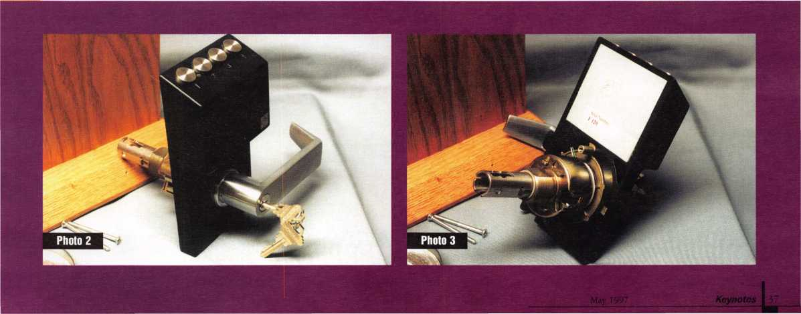

snugly within the extra mounting holes, it could affect the alignment of the parts and cause binding. The first time I installed the lock on the wooden mount, it was binding and the outside lever handle lock would intermittently not spring back to the neutral position to re-lock. I reamed out those holes slightly until the lock fit together without binding.

The inside attaching plate is fastened in two ways. The first is with two screws that run through the two extra mounting holes above and below the cross bore hole. The second is with a threaded ring that is tight­ened with the tool shown in photo seven. Even if there is no binding in the mounting holes, you could cause yourself some prob­lems by over-tightening that ring. Your main concern is that you don’t want to inter­fere with the free movement of the outer lever handle. If the return spring cannot bring the lever handle back to the neutral position, the lock will not re-lock after someone has input an access code and opened the lock.

It is neither difficult nor is it time con­suming to make sure that everything is turning smoothly and not binding. It is, however, very important to verify that fact—before you complete the installation. The lock (when binding) may not remain open after every entry, but remaining open just once will compromise your customer’s security.

Grand Master Code. If such people quit or are fired from the company, their knowledge of the Submaster Code will give them absolutely no access, presuming that some­one at the company changes the Submaster Code.

Grand Master and Submaster Codes The

length of individual user codes can be pro­grammed from three to seven digits. The greater the number of digits that are used, the more resistant to random guessing the lock will be. The Grand Master and Submaster Codes are always eight digits in length. With all the different permutations of one, two or three button digits (fourteen variations), there are close to one and a half billion possible different codes. The possibil­ity of someone just guessing either the Grand Master Code or a (temporary) Submaster Code are virtually nil. The only way anyone is likely to find those codes is by reading them (in the instruction book) or observing them being input.

As long as the Grand Master Code is suit­ably protected, the Submaster Code can be changed as often as necessary, if it is ever dis­covered. Since the lock will expect a certain number of digits for user codes, it must be notified in advance that a Grand Master or Submaster Code is about to be input. The notification is accomplished by pressing all four buttons together.

I indicated earlier that a digit can involve pressing one, two or three buttons together. There are only two uses for pressing all four buttons together. One is to alert the micro­

access codes, the programming procedure is pretty much the same for either the NanoLox-B125 and the NanoLox-B250 locks. Programming is accomplished through the four-button key pad and veri­fied by two LEDs (light emitting diodes). The LEDs are located between the first and second buttons (from the left). The top LED is green and the bottom LED is red. The symbolism is pretty much the same as a traf­fic light, green being “yes” and red being “no.”

There is very important information con­tained in the programming instruction book. Each book is customized to a particu­lar serial number. The book comes in a sealed poly bag. Although the general pro­gramming instructions are identical in every book, the back section lists pre-programmed codes of the particular lockset. Among the codes listed are the individual user codes, the Submaster Code and the Grand Master Code. Although you won’t want any of the codes to slip out, the Grand Master Code is critical. It is the only one of the codes to be permanently programmed into the lock. Everything else can be reprogrammed by the user. The lock must be returned to the facto­ry in order to change the Grand Master Code. That code must be guarded carefully.

The primary purpose of the Grand Master Code is to reprogram the Submaster Code. The Submaster Code is used for all other programming of the lock. An employee of the facility (where the lock is installed) des­ignated to reprogram the lock can do so without ever having knowledge of the

Programming the NanoLox-B Except for the existence of additional blocks of user

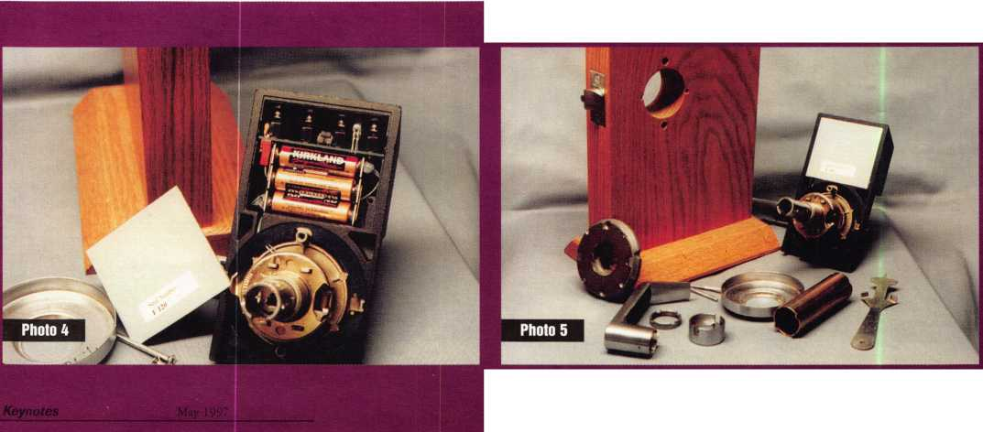

processor that a Grand Master Code or Submaster Code is about to be input. The other use is to clear the system. Pressing 1234 together will reset and power down the system. This can take place while pro­gramming or just inputting an entry code. If you lose track of where you are during pro­gramming or opening and become confused, you can reset and start all over again. Make note of the fact that a reset is always fol­lowed by a green LED signal. If the green LED doesn’t light (and neither should the red LED light) following the pressing of all four buttons, it means the lock is prepared to accept the Grand Master or Submaster Code. The lock will not anticipate the Grand Master or Submaster Codes if the LED lights.

Submaster Programming The lock will come from the factory pre-programmed with I a Grand Master Code, Submaster Code, and j 125 or 253 user codes—depending on the I lock model. The Grand Master Code is the only permanent code. To change the Submaster Code, you start by entering 1234 (pressing all four buttons simultaneously).

No LED should light up at this time. If the green LED goes on, it means you just cleared the system. If so, press all four buttons again. Providing that no LEDs have turned on, you should then enter the Grand Master Code. If you entered the code properly, the green LED should flash twice. Enter a new eight-digit Submaster Code. The green LED should light again. The programming ses­sion is complete. You should now have a

new Submaster Code.

Other Programming I will not go into the details of all the other programming proce­dures. All other programming is done with the Submaster Code. Except to re-program the Submaster Code, the Grand Master Code is not used. For all practical purposes, the Grand Master Code can be securely locked away, because it is not needed for standard day to day programming.

The individual user codes are partitioned into groups of 32. The B125 has four groups of codes and the B250 has eight groups of codes. The codes can be activated or deacti­vated in groups. Individual codes (or target codes) can be deactivated or changed indi­vidually.

The length of the code can be pro­grammed from three to seven digits. Your customers should choose the length based on security needs. More digits will make it harder to guess user codes. Obviously a longer code will be harder to memorize, so take that into account, too.

Other Options The lock will also be avail­able in a weather-resistant version. Also, a spy shield and adaptor plate (to cover the additional holes from retrofitting a Simplex 1000 or Trilogy) will be available. The Grand Master Codes are mated to particular serial numbers. If a customer needs more than one lock with the same Grand Master Code, they can be programmed at the fac­tory that way. Remember that the Grand Master Code can only be changed at the

factory.

Currently in the works is a version of the lock with audit capability. It will come with a built-in clock that will control access of individual users by day and time, and with audit capability will be able to track open­ings and attempted openings.

Final Thoughts The NanoLox-B locksets have been available in limited use mainly on the west coast of the United States to iron out all the details, and get feedback about changes and improvements in some of the features. It will soon be given a full introduction throughout the country. Some of the individ­ual details and features may be slightly changed by the time full introduction takes place. From what I’ve seen, it seems to be a rather interesting lock. I’m looking forward to seeing the version with audit capability. For additional information about the lock or avail­ability, contact: Nanotechnology, Inc., 22997 Standing Oak Court, Cupertino, CA 95014. Telephone and FAX: (408) 973-8280.

*the Author: Sal Dulcamaro,*

*CML*, *has been in the locksmith business for over  
22 years. He is the president of All Pro Security*,  
*Inc. in Michigan and has been an ALOA member  
for 15 years. A past president of the Locksmith  
Security Association of Michigan, Sal currently  
serves as editor of the association newsletter. He  
was named* “Keynotes *Author of the Year1’ for  
1996.*

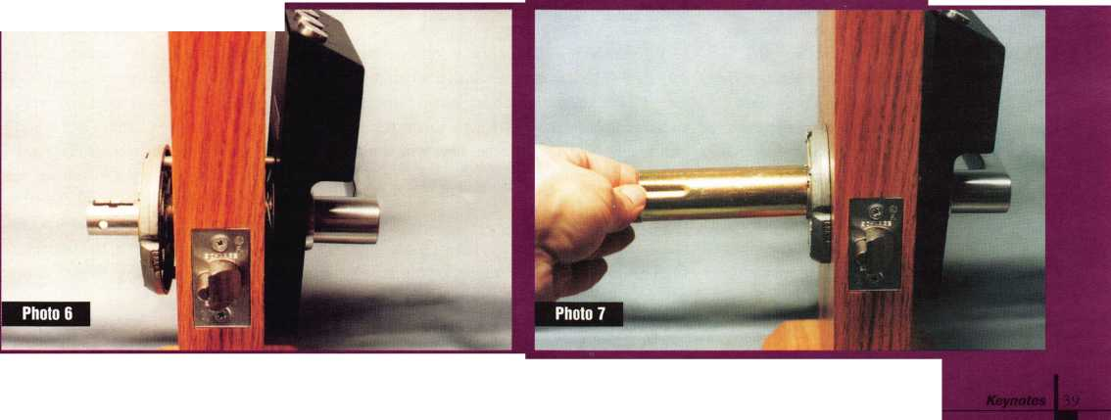

**Masterkeying 101,**

Part II

by Sal Dulcamaro, CML

This is the second of a two-part series on master keying. As I stated in my last article, this will not prepare you to be able to design a large master key system—and it’s not intended to. I’ve written this article to tell you what master keying is, and what some of the risks and benefits are.

Lever Tumbler Locks

Figure one is an example of how lever tum­bler locks are master keyed. A normal lever tumbler will usually have one gate. The proper depth of cut will cause the tumbler to be raised to a sufficient height, allowing a part —sometimes called the fence—to move into the gate and lock or unlock the device.

If only one gate exists in the tumbler, it can only be operated by a key of a matching depth for that tumbler position. To allow a second (and different) key to operate the same lever tumbler lock, there should be two gates.

In “A” there is a #3 depth cut in the key. The lever tumbler above it has two gates.

The higher gate will allow key operation by the #3 cut. The lower gate will only allow key operation by a #1 cut. In “B” there is a #4 depth cut in the key, and the higher gate in the tumbler can be operated by it. Like “A,” its lower gate will also operate by a #1 cut. “C” has a #3 cut key and a tumbler with the higher gate matching. Again, the lower gate is for a #1 cut. A #6 cut and matching (higher) gate applies to “D,” with the lower gate for a #1 cut. “E” is the master key. It has a #1 depth cut. All four of the tumblers

40 | KeynotesMay 1997

will operate with a #1 cut, but the individ­ual operating keys will only operate their own locks.

Figure two illustrates master keying locks with rotary disc tumblers. Although differ­ent in shape, rotating disc tumblers also have variably positioned gates. Likewise for master keying, a tumbler with an extra gate is required for this type of lock mechanism.

A rotating disc tumbler lock usually has a key with cut angles rather than depths. For our example, the gates are numbered clock­wise from one to five.

“A” has a tumbler with two gates. The gate at the top of the tumbler is for a #1 angle cut. The gate just clockwise from it is for a #2 angle cut. That key cut is illustrated just to the right of the tumbler. The top of the tumbler in “B” also has a gate for a #1 angle cut. The other gate is for a #3 angle cut. The key has a #3 angle cut. For “C,” the #1 gate is also there with a #4 gate further clockwise. A #4 angle cut is on the key. The #1 gate in the tumbler in “D” is followed by a #5 gate. The key matches with a #5 angle cut. “E” is a key with a #1 angle cut. Since all four tumblers have a #1 gate, this is the master key. None of the other keys will work other than their own lock.

Disc Tumbler Locks

Standard disc tumbler locks have a some­what unusual method of master keying, which is illustrated in figure three. The unusual method is dictated by the construc­tion of the lock and the way the tumblers

work within it. “A” shows a keyway with an unusually wide top. “B” and “C” show two different key blank profiles that will both fit into the keyway. One key blank profile will be used for individual operating keys, while the other profile will be for the master key.

Specially designed disc tumblers are required for master keying. The cut surface of the operating keys (for our example) will interact on the left side of the tumbler, while the surface of the master key will interact on the right. In “D,” the left side of the tumbler calls for a #1 cut, while the right side—for the master key—calls for a #3 cut. The left side of “E” requires a #2 cut, and the right side a #3- A #3 cut is needed for both sides of the tumbler in “F.” And finally, “G” indi­cates #4 at the left and #3 at the right.

In our imaginary one tumbler locks, the operating key for “D” has a #1 cut, “E” has a #2 cut, “F” a #3 and “G” is #4. A key— with the keyway profile shown in “C”—that has a #3 depth cut will be the master key and operate all the locks. Because the master and operating keys don’t share the same side of the keyway, disc tumbler locks can break a rule that is otherwise required of any other tumbler based master key system. That rule is that an operating key and a master key cannot share a common key cut for the same (master keyed) tumbler. If that rule was bro­ken for any other type of lock, the key that broke the rule would be some level of master key.

We can see that the operating key for “F” has a #3 depth cut. The master key, that

operates all the locks also has a #3 depth cut. Should we be concerned that the operating key for “F” will be a master key? Not at all. Although the depth would seem to make it a master key, the fact that the key surface is on the left side of the keyway prevents it from ever interacting with the master (right) side of the tumbler.

Pin Tumbler Locks

Pin tumbler locks can do certain things that the previously mentioned locks cannot. You can add additional tumblers to the tumbler chambers. Since only one tumbler would fit per chamber, for the earlier examples, spe­cially altered tumblers were required to allow two different key cuts —for the same position—to operate the lock. Master keying is accomplished in pin tumbler locks by adding master pins to the pin chambers. Examples are shown in figure four.

We are again using a one-tumbler lock to simplify the explanations. A non-master keyed pin tumbler lock will normally have two pins per chamber. That would be a bot­tom pin and a top pin. That would allow only one key cut depth to create a shear line for the tumbler position. In order to allow a key with a different cut in the same position to operate the same pin chamber, the pins would have to split at another depth. That is accomplished by adding a third pin to the chamber—the master pin. With two split points, two different key cut depths will operate the pin chamber—one for the master key and one for a change key.

Returning to figure four, you will see four different pin chamber combinations, each with a separate operating—or change—key. “A,” “B,” “C” and “D” each indicate a differ­ent pin chamber combination and operate by a change key that will not work with any of the three other combinations. “E” is the master key, with a #5 key cut depth, which will operate all four of them.

“A” has a #1 cut depth for the key and combination of a #1 bottom pin and a #4 master pin. With a #1 key cut depth, the pin stack is lifted so that the top surface of the bottom pin and the bottom surface of the master pin are aligned at the shear line— ready to unlock. If the master key (with a #5 cut depth) had been inserted in

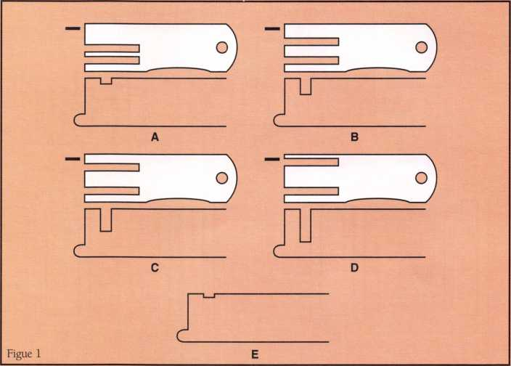

place of the change  
key, the top surface of  
the master pin and  
the bottom of the top  
pin would instead  
align at the shear line  
to unlock it.

The change key  
cut in “B” has a #2  
depth, and the pin  
combination is a #2  
bottom pin and a #3  
master pin. Again,  
with the change key,  
the top of the bottom  
pin and bottom of  
the master pin are at  
the shear line. As in  
“A,” the combined  
bottom and master  
pin stack in “B”

equals five (2 + 3 = 5), allowing the master key cut to also unlock it.

The pin combination in “C” is a #3 bot­tom pin and a #2 master pin. The change key, with a #3 cut depth, brings the top sur­face of the bottom pin to the shear line. The master key—like the previous examples with a combined pin stack of five—would cause the top of the master pin to reach the shear line.

And finally, “D” has a #4 key cut depth, and #4 bottom pin and #1 master pin com­bined in the pin chamber. Again the change key brings the top of the bottom pin to the shear line, while the master key brings the top surface of the master pin to the shear

May 1997*Keynotes*

line. Ultimately, each of the four pin combi­nations allows two different keys to unlock it—the change key assigned to it and the master key. The wrong change key would cause one of the pins to block the shear line.

Master Keying Capabilities

Locksmiths who have difficulty with num­bers are often hesitant to get deeply involved in master keying. The concept of how mas­ter keying works—as I have just explained—is generally not that difficult to understand. The actual practice of creating the master key system and dealing with all the numbers can be confusing and, to some, quite exasperating. I’m going to try to keep

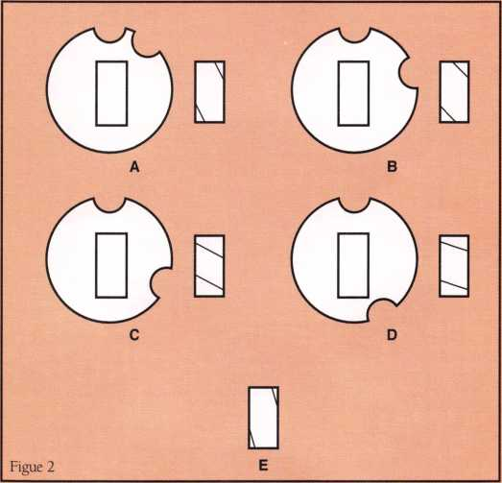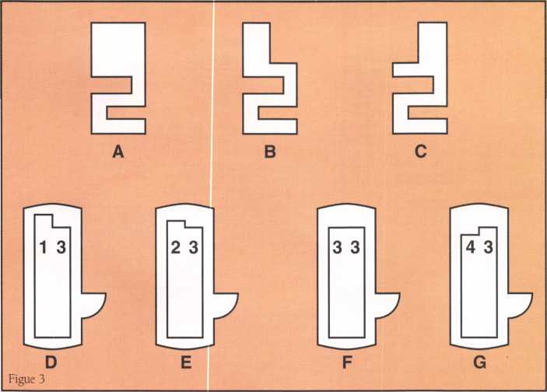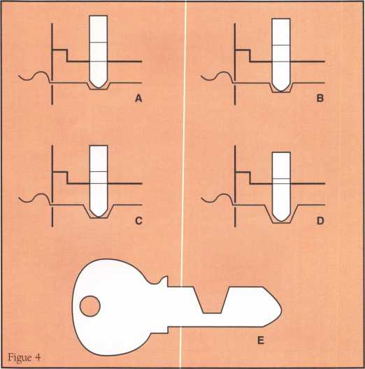

the numbers as simple as possible.

I will temporarily return to the examples in figure four, and deal with the (theoretical) one-pin tumbler lock with five different depth increments. I will first explain the concept of keying capabilities—non-master keyed locks—and then swerve into how things change when we are dealing with master keying capabilities.

In non-master keyed locks, for every depth increment available for keys there is a matching tumbler that will mate and allow the lock to operate. If I have a one-tumbler lock and have five different sizes of tumblers, I will only be able to generate five different

(and unique) operat-  
ing keys to operate  
any of the locks. If  
the lock has a #1 size  
tumbler, I will need a  
key with a #1 cut  
depth to operate the  
lock. A lock with a  
#2 tumbler will  
require a #2 cut  
depth to operate it.  
Likewise, a #3 tum-  
bler will require a #3  
cut; a #4 cut works  
with a #4 tumbler  
and a #5 tumbler and  
#5 key cut go  
together.

Master keying will  
require that each lock  
operate by two differ-  
ent keys. The

mechanics of pin tumbler locks allows two  
differently cut keys to operate the same pin  
chamber by introducing a master pin which  
provides the two different split points. For a  
group of master keyed locks to work proper-  
ly, they must all open with the same (master)  
key, and separately by a unique key that will  
open that particular lock but won’t open  
other locks.

For the example of non-master keyed locks, I indicated that there were only five total key cut depths and therefore only five unique keys possible for coded locks. After the five combinations were exhausted, repe­tition of some or all of the five key cut pat­

terns would be required for amounts of locks that numbered greater than five.

In figure four, “E” was the master key with a #5 cut depth. Since there are only five depths available and one of the depths (for master keyed locks) must be reserved for the master key, only four depths remain for use as unique operating (or change) keys. “A” through “D” were the different pin combina­tions with key cut depths ranging from #1 through #4, and all of them opened with the master key which had the #5 depth. The master keying capabilities of such a lock are four individual change— or operating— keys. That number is determined by taking the total number of usable depths and sub­tracting one—to account for the cut depth reserved for the master key. If there was a six depth lock, there would be five change keys available (6-1 = 5).

The previous example was based on a make believe single pin chamber lock. Most pin tumbler locks, that you will see, will probably be with four-, five-, six- or seven- pin chambers. The vast majority will be five- pin locks. Your master keying capabilities will not generally be based on how many pin chambers exist within a lock cylinder, but rather by how many of those pin chambers are master pinned, i.e. chambers that contain master pins. So, a group of locks with five- pin chambers (and five available depths) will still only have master keying capabilities of four unique change keys, if only one of the pin chambers is master pinned.

Master keying capabilities are increased by increasing the number of pin chambers that are master pinned. If we still presume five usable depths and one depth reserved for the master key cut, each chamber position has four different key cut possibilities avail­able for change keys. Multiplication will help us figure the largest theoretical size of any particular master key system. The small­est system would be four changes with one chamber master pinned. If two chambers were master pinned, both chambers each would have four different depth possibilities. If you multiply four times four you get 16, which is the total number of changes possi­ble with two chambers master pinned.

Master keying capabilities increase as fol­lows: three chambers: 64 changes

*Keynotes*

May 1997

(4x4x4=64), four chambers: 256 changes (4x4x4x4=256), five chambers: 1024 changes (4x4x4x4x4=1024), six chambers: 4096 changes (4x4x4x4x4x4=4096), and the last example with seven chambers: 16384 changes (4x4x4x4x4x4x4=16384). The totals are theoretical maximums. Certain key cut combinations may prove unworkable for a variety of reasons.

Locks with more available depths will use a larger factor to multiply out the combina­tions, and consequently have greater master keying capabilities.

The Price of Convenience

I mentioned much earlier in the article that master keying is done primarily for conve­nience. I indicated that this great conve­nience did not come without paying a price. That price is lower security for the lock, which shows up in a number of different ways.

With the exception of disc tumbler locks, tumbler based master keying requires that at least two different key cuts operate each mastered tumbler position. A lever tumbler lock will have mastered tumblers with two gates instead of one. The rotating disc tum­bler lock will likewise have two gates rather than one. The master pin in a pin tumbler lock will create a second split point so that two different key cut depths will work.

A lock cylinder that is not master keyed will normally only allow one key cut pattern to unlock it. If any pin chambers are lifted too high or low, a top or bottom pin will block the shear line and the lock will not open. Adding a master pin in just one of five chambers will allow two different keys to operate the same lock cylinder. Master pins in two chambers allows four different keys to operate (2x2=4). Three chambers each with a master pin added brings the number of different keys that will work to eight (2x2x2=8). Four master pinned chambers raises the number of differently cut working keys to 16 (2x2x2x2 = 16). For every addi­tional pin chamber that contains a single master pin, the number of keys that will operate the lock cylinder doubles again. The security of the lock is reduced.

Resistance to picking or manipulation also decreases as master pins are added.

Depending on how you look at it, you may say that a lock with master pins in four chambers is 16 times easier to pick than the equivalent lock that has no master pins.

We know that master keying diminishes the security of a lock. The resulting level of security in a master keyed cylinder ultimate­ly depends on your starting point, or what the level of security was when not master keyed. You can often maintain a high level of security and get the convenience of master keying by working with high security locks. High security locks by ASSA, Medeco and Schlage Primus are sometimes so difficult to manipulate in the first place, that even with the slight reduction in security from master keying, they still remain very secure locks. Plus the important aspect of key control will often make it an important option to present to your customers when they ask for a mas­ter key system.

One other weak link of master keying is probably one of the best arguments for sell­ing key control. It is possible, with a master keyed cylinder and an operating key, to decode the cuts required to make a top mas­ter key. If you decode all the bottom and master pins in a lock and compare them to the cuts on the operating key, the remaining key cut option (not used by the operating key) in each cut position will belong to the top master key. All it takes is one lock cylin­der and its operating key, and the secret to the master key is revealed. This gives some­one who decodes it full access to all locks on the master key system. If the system is based on a commonly available key blank, the system can be compromised. If the key is restricted, only someone with access to keys that will work in the locks will be able to actually create such a key. Without key blanks, you just know what the key should look like, but you can’t make it.

Master Keying and Electronic Locks

Master keying mechanical locks creates side effects of unintended operating keys. Most electronic locks—those with a microproces­sor that can identify individual user codes— are capable of extremely complex master keying. Since they are often able to identify a user by his or her key, they are capable of allowing entry by different groups or indi­

viduals for different locksets. It is possible to program certain locks to accept certain user keys or combinations by large numbers of people, and at the same time allow entry to few or only one person at other locks, with personnel using the same electronic key or combination (that identifies them) at every lock that they have access to gain entry.

The complex master keying systems that can be designed for electronic locks would be nearly impossible with mechanical locks. The unintended key operation in a similarly complex mechanical system would probably create havoc and seriously compromise secu­rity Of course, electronic locks tend to be more expensive, so there’s a tradeoff.

Not a Toy

Master keying is not something that should be toyed with by people who don’t under­stand the consequences and unintended side effects. The greater the value of property and person that is being protected, the more you should examine what master keying will do to the overall security of a facility. Don’t be afraid to suggest going to high security locks to minimize the impact of the inevitable reduction in security that master keying poses.

Master keying programs are handy and save you time, but they are not a substitute for clear understanding of what master key­ing is and what it does. If you intend to do anything more than the most rudimentary of small master key systems, I suggest you take a full fledged one- or two-day class on the subject. At the very least get one of the books or courses available in the industry on master keying.

IP!

m About the Author: Sal Dulcamaro,

CML, has been in the locksmith business for over 22 years. He is the president of All Pro Security, Inc. in Michigan and has been an ALOA member for 15 years. A past president of the Locksmith Security Association of Michigan, Sal currently serves as editor of the association newsletter. He was named “Keynotes Author of the Year” for 1996.

May 1997 Keynotes | 43

Associate

Members

|  |  |
| --- | --- |
| Manufacturers | Alarm Lock Systems, Inc.  345 Bayview Ave.  Amityville, NY 11701 (800) ALA-LOCK; (516) 789-3383  © |
| A & B Safe Corp.  171 S. Delsea Dr.  Glassboro, NJ 08028 (800) 253-1267; FAX (609) 863-1208  0 0 0 0 | All-Lock Company  900 Ravenwood Dr.  Selma, AL 36701  (334) 874-9001; FAX (334) 874-6011  0 (0 |
| Access Protection Mfg.  216 Plaisto Rd.  Plaisto, NH 03865  (603) 382-0822; FAX (603) 382-0833  ® | Allied-Gary Safe Company  West 425 2nd Ave.  Spokane, WA 99204 (509) 458-2633; FAX (509) 458-2633  (0 0 |
| Adesco Safe Manufacturing Co.  16720 S. Garfield Ave.  Paramount, CA 90723 (800) 821-6803; FAX (310) 408-6427  0 | American Lock Co.  3400 West Exchange Road  Crete, IL 60417-2099 (708) 534-2000; FAX (708) 534-0531  © © |
| ASSA Inc.  10300 Foster Ave.  Brooklyn, NY 11236 (718) 927-2772; FAX (718) 257-2772  ® | American Security Products  11925 Pacific Ave.  Fontana, CA 92337-6963 (909) 685-9680; FAX (909)685-9685  0 0 |
| Abloy Security, Inc.  6015 Commerce Drive Ste. #450  Irving, TX 75063  (972) 753-1127; FAX (972) 753-0792  ® | Arrow Lock Company  10300 Foster Avenue  Brooklyn, NY 11236 (718) 257-4700; FAX (718) 649-9097  0 0 (0 0 |
| Abus Lock Company  P.0. Box 47507  Plymouth, MN 55447-0507 (800) 225-5348  © | Auto Security Products (A. S. P.)  P.O. Box 10  Redmond, WA 98073-0010 (206) 556-1900; FAX (206) 558-1205  0 0 |
| Adams Rite Manufacturing Co.  4040 S. Capital Ave.  City of Industry, CA 91749 (310) 699-0511; FAX (310) 699-5094  0 (0) | Baton Locks & Hardware Co.  14275 Commerce Dr.  Garden Grove, CA 92643 (714) 265-3636; FAX (714) 265-3630  0 0 |
| Adrian Steel Company  906 James St.  Adrian, Ml 49221  (517) 265-6194; FAX (517) 265-5834  © | Chicago Lock Company  10100 88th Ave.: P.O. Box 0069  Pleasant Prairie, Wl 53158-0069 (414) 947-7177; FAX (414) 947-7178  © |
| Aiphone Intercom Systems  1700-130th Avenue, NE  Bellevue, WA 98005 (206) 455-0510; FAX (206) 455-0071  0 © (0 | Corbin Russwin Architectural Hardware  P.O. Box 25288  Charlotte, NC 28229 (704) 283-2101  0 0 0 0 |
|  |  |



Associate members of the Associated Locksmiths of America (ALOA) manu­facture or distribute materials or equip­ment, or provide services, for the securi­ty industry. Many have donated money, services and equipment to ALOA in addition to their annual dues. Their sup­port of ALOA projects enhances overall membership benefits and we encourage our members to patronize these firms. If you know of a potential candidate for associate membership, please contact the ALOA Sales staff at (214) 827-1701. Associate member dues are $500 per year and entitle the payor to use the ALOA logo, and selected discounts on ALOA products and services.

**Legend**

© Alarms: Personal, vehicle, electronic, fire, burglar, and exit

© Bank security equipment

© Automotive: Lockout equipment, key chains/rings

© Builders Hardware: Door closers, furniture/decorative hardware, viewers, emergency exit devices

© Business/Technical & Educational:

Books, reference guides, publications, computer software

© CCTV/Photo Imaging: Cameras, monitors, photo ID equipment, cables

© Electric/Electronic Security: Card access control and readers, surveil­lance, electric/magnetic locks and strikes, keypads

® Lock Devices: Auto locks, cylinders, emergency exit/entrance control, locks (various types), strikes

© Tools & Supplies: Key blanks, cutters, picks, rings/hooks, custom van/truck supplies

© Safes/Vaults

® Other

Keynotes

May 1997

Associate

Members

|  |  |  |
| --- | --- | --- |
| Curtis Industries  6140 Parkland Blvd. Ste. 300  Mayfield Heights, OH 44124-4103 (800) 555-5397 | Glenncraft Corporation  205 Fortin Dr.  Woonsocket, Rl 02895-6116 (401) 769-0101; (401) 766-1170 | Jet Hardware Mfg. Co.  800 Hinsdale Street  Brooklyn, NY 11207 (718) 257-9600; FAX(718) 257-0973 |
| • 9 |  | 9 |
| DETEX  302 Detex Dr.  New Braunfels, TX 78130 (800) 729-3839; FAX (210) 620-6711 | Grobet File Co. of America  750 Wasahington Ave.  Carlstadt, NJ 07072 (800) 962-7242; FAX (800) 243-2432 | KABA High Security Locks  P.O. Box 490  Southington, CT 06489 (860) 621-3601; FAX(860) 621-9727 |
| • • • • | • | • |
| DOM Security Locks North America  100 Central Ave,  Brockville, Ontario, Canada K6V 5W6 (800) 363-4803; FAX (613) 498-5820 | GT-85 International, Inc.  P. 0. Box 21185  St. Petersburg, FL 33742-1185 (800) 525-4885; FAX (813) 526-1234 | Kenstan Lock Company  101 Commercial St.  Plainveiw, NY 11803-2412 (516) 271-2700; FAX(516) 271-2759 |
| • | • | • 9 |
| Don-Jo Manufacturing, Inc.  P.O. Box 929  Sterling, MA 01564 (508)422-3377; FAX (508) 422-3467 | H.E.S., Inc.  2040 W. Quail Ave.  Phoenix, AZ 85027 (602) 582-4626; FAX (602) 582-4641 | KEY-BAK; Div. of W. Coast Chain Mfg. Co.  1460 S. Balboa Ave.  Ontario, CA 91762 (909) 923-7800; FAX(909) 923-0024 |
| 9 9 | see | • • • • |
| Door Controls International  2362 Bishop Circle East  Dexter, Ml 48130  (800) 742-3634; FAX (800) 742-0410 | Highland Glen Products, Inc.  218 Parkdale Ave.; P.O. Box 924  Buffalo, NY 14213 (716) 883-1110; (800) 248-KEYS | Knaack Manufacturing Co.  420 E. Terra Cotta Ave.  Crystal Lake, IL 60014 (800) 456-7865; FAX(815) 459-9097 |
| • • • • | • • | • |
| Emtek Products, Inc.  15250 E. Stafford St.  City of Industry, CA 91744 (800) 356-2741; FAX (800) 577-5771 | Hill Security Products  711 East Walton Avenue  Spokane, WA 99207 (509) 487-1142; (800) 722-1142 | Kwikset Corp.  One Park Plaza, Suite 1000  Irvine, CA 90638  (714) 474-8818; FAX (714) 474-8879 |
| • • | • | 9 9 |
| ESP Lock Products, Inc.  375 Harvard Street  Leominster, MA 01453 (508) 537-6121; FAX (508) 537-1699 | HPC, Inc.  3999 N. 25th Avenue  Schiller Park, IL 60176 (847) 671-6280; FAX(847) 671-6343 | LCN Closers (Division of Ingersol)  121 W. Railroad Ave.  Princeton, IL 61356 (815) 875-3311; FAX (815) 875-3222 |
| 9 | 99 9 | 9 |
| Federal Lock Company  14247 E. Don Julian Rd.  City of Industry, CA 91746 (800) 682-9851; FAX (708) 378-4767 | Hurd Corporation  Box 1450  Greeneville, TN 37744-1450 (423) 787-8800; (423) 787-8817 | LAB Security  700 Emmett St.  Bristol, CT 06010  (800) 243-8242; FAX (203) 583-7838 |
| • | see | • |
| Folger Adam Security, Inc.  16300 W. 103rd Street  Lemont, IL 60439  (630) 739-3900; FAX (630) 739-6138 | llco Unican  400 Jeffreys Road  Rocky Mount, NC 27804 (919) 446-3321; FAX (919) 446-4702 | La Gard, Inc.  3330 Kashiwa Street  Torrance, CA 90505 (310)325-5670; FAX (310) 325-5615 |
| 9 • | ^ ® ^ | • |
| Fort Lock Corp.  3000 N. River Rd.  River Grove, IL 60171 (708) 456-1100; FAX (708) 456-9476 | Industries, C.L. Inc.  9730 Gouin Blvd. West  Pierrefonds (PQ) H8Y 1R5 (514) 683-6282; FAX(514) 683-9015 | Locksmith Publishing Corp.  850 Busse Hwy.  Park Ridge, IL 60068 (847) 692-5940; FAX (847)692-4604 |
| •••••• | 9 9 | 9 |
| Gardall Safe Corporation  P.O. Box 30  Syracuse, NY 13206 (315) 432-9115; FAX (315) 434-9442 | International Electronics, Inc. (I.E.I.)  427 Turnpike St.  Canton, MA 02021 (800) 343-9502; FAX(617) 821-4443 | Lockmasters, Inc.  5085 Danville Rd.  Nicholasville, KY 40356 (606) 885-6041; FAX (606) 885-7093 |
| • | • | 99 9 99 |
| 9 Alarms  9 Bank security equip.  9 Automotive  9 Builders Hardware | 9 Business/Tech A Ed.  9 CCTV/Photo Imaging  9 Electric/Electronic Sec.  9 Lock Devices | 41 Tools & Supplies  9 Safes/Vaults  9 Other |

45

May 1997

***Keynotes***

Associate

Members

|  |  |  |
| --- | --- | --- |
| Lori Lock/Delta  P.0. Box 1040  Southington, CT 06489 (203) 621-3605; FAX (203) 621-5972 | The National Locksmith Magazine  1533 Burgundy Parkway  Streamwood, IL 60107 (630) 837-2044; FAX (630) 837-1210 | Schwab Corporation  PO Box 5088  Lafayette, IN 47903-5088 (317) 447-9470; FAX (317) 447-8278 |
| • • | • | • |
| Lucky Line Products  7890 Dunbrook Rd.  San Diego, CA 92126 (619) 549-6699; FAX (619) 549-0949 | Newman Tonks  P.O. Box 548  Shepardsville, KY 40165 (502) 543-2281; FAX (800) 777-8229 | Securitron Magnalock Corp.  550 Vista Blvd.  Sparks, NV 89434  (800) 624-5625; FAX (702) 355-5636 |
| • | e e | 4> • |
| Lund Equipment Co., Inc.  P.O. Box 213  Bath, OH 44210  (216) 659-4800: FAX (216) 659-9347 | NT Falcon Lock  2650 Orbitor Street  BreaCA, 92621-6265 (800) 266-4456; FAX (800)777-8229 | Security Door Controls  P.O. Box 6219  Westlake Village, CA 91359-6219 (805) 494-0622; FAX (800) 959-4732 |
| • • • | e • | • |
| M.A.G. Engineering & Mfg. Inc.  15261 Transistor Lane  Huntington Beach, CA 92649 (714) 891-5100; FAX (714) 892-6845 | Pach & Company  941 Calle Negro  San Clemente, CA 92672 (714) 498-2951; FAX (714) 498-6879 | Sentry Group  900 Linden Ave.  Rochester, NY 14625-2784 (716) 381-4900; FAX (716) 381-8559 |
| • • • | • • | • |
| MARKS USA  5300 New Horizons Blvd.  Amityville, NY 11701 (516) 225-5400; FAX (516) 225-6136 | Prime-Line Products Company  5405 Industrial Pkwy.  San Bernadino, CA 92407 (909) 887-8118; FAX (909) 880-8968 | Silca Key U.S.A. Inc.  5633 Hudson Industrial Pkwy.  Hudson, OH 44236 (216) 656-5613 |
| • | e • | • • |
| Master Lock Company  2600 North 32nd Street  Milwaukee, Wl 53210 (414) 444-2800; FAX (414) 449-3114 | Pro-Lok  655 North Hariton Street  Orange, CA 92668-1311 (714) 633-0681; FAX (714) 633-0470 | Star Key Industries,Inc.  145 Brite Ave.  Scarsdale, NV 10583-1426 (914) 235-1700 |
| • • | • e | a |
| Medeco Security Locks  P.O. Box 3075  Salem, VA 24153  (540) 380-1684; FAX (540) 380-5010 | Rainbow Technology  261 Cahaba Valley Pkwy.  Pelham, AL 35124-1146 (800) 637-6047; FAX (800) 521-6896 | STRATTEC Security Corp.  3333 W. Good Hope Rd.  Milwaukee, Wl 53209 (414) 247-3333; FAX (414) 247-3329 |
| • • • | e | • • • |
| Meilink Safe Company  111 Security Parkway  New Albany, IN 47150 (800) 634-5465; FAX (800) 896-6606 | Rofu International Corp.  2004-B 48th Ave.; Court E  Tacoma, WA 98424 (800) 255-7638; FAX (206) 922-1728 | Sully Tools Inc.  3515 Nodding Pine Ct.  Fairfax, VA 22033  (703) 689-3416; FAX (703) 787-0869 |
| e | # | • • • |
| Metalurgica Odis S.A.  Porto Seguro 4395 Quinta Norma  P.O. Box 107-2; Santiago, Chile (562) 776-6511 | Rutherford Controls Inc.  2697 Internal Pkwy, Bid 5 #100  Virginia Beach, VA 23452 (757) 427-1230; FAX (804) 427-9549 | Treskat USA  725 Adriane Park Circle  Kissimmee, FL 34744 (800) 645-5657; FAX (407) 870-9696 |
| # | • | • |
| MUL-T-LOCK USA, Inc.  300-1 Route 17 South Suite A  Lodi, NJ 07644  (800) 562-3511; FAX (201) 778-4007 | Sargent & Greenleaf, Inc.  P.O. Box 930  Nicholasville, KY 40340-0930 (606) 885-9411; FAX (606) 887-2057 | Trine Products Corporation  1430 Ferris Place  Bronx, NY 10461  (718) 829-4796; FAX (718) 792-9127 |
| • • • | (Qf ^ | • • • |
| National Cabinet Lock  200 Old Mill Road, P. O. Box 200  Mauldin, SC 29662 (864) 297-6655; FAX (864) 297-9987 | Schlage Lock Co.—PRIMUS  3899 Hancock Expy.  Security, CO 80911 (719) 390-5071 | U-Change Lock Industries  1640 W. Hwy. 152  Mustang, OK 73064 (405)376-1600; FAX (405) 376-6870 |
| • | m * | • • • |
| © Alarms  @ Bank security equip.  © Automotive © Builders Hardware | © Business/Tech & Ed.  © CCTV/Photo Imaging © Electric/Electronic Sec.  © Lock Devices | © Tools & Supplies © Safes/Vaults © Other |

46

***Keynotes***

May 1997

Associate

Members

|  |  |  |
| --- | --- | --- |
| Vindicator Corp.  3001 Bee Caves Rd.  Austin, TX 78746-5561 (512) 314-1200; FAX (512} 314-1270 | Boyle & Chase Inc.  P. 0. Box 74  Accord, MA 02018-0074 (800) 325-2530; FAX (617) 335-5342 | HS&S Wholesale Distributors  12915 West 8 Mile Road  Detroit, Ml 48235 (800) 521-2202 |
| • • • • | • • • | ^ @ <!^ <0 (g^ |
| Weiser Lock Company  6700 Weiser Lock Blvd.  Tucson, AZ 85746  (520) 741-6231; FAX (520) 741-6363 | Clark Security Products, Inc.  4775 Viewridge Ave.  San Diego, CA 92123-1641 (800) 854-2088 | Hans Johnsen Company  8901 Chancellor Row  Dallas, TX 75247  (214) 879-1550; FAX (214) 879-1530 |
| ® • | •••••••••• |  |
| Wilson Safe Company  3031 Island Avenue/P.O. Box 5310 Philadelphia, PA 19153 (215) 492-7100; (800) 345-8053 | Cook’s Building Specialties  2441 Menaul Blvd. NE; P.O. Box 37320 Albuquerque, NM 87176-7320 (505) 883-5701; FAX (505) 883-5704 | Hardware Agencies, Ltd.  1220 Dundas Street East  Toronto, ON M4M 1 S3 (416) 462-1921 |
| • | ^ 0 | •••••••• |
| Yale Security Inc.  P.O. Box 25288  Charlotte, NC 28229-8010 (704) 283-2101 | DiMark International  3117 Liberator St., Unit A  Santa Maria, CA 93455 (800) 235-2435; FAX (805) 928-8034 | Hardware Suppliers of America  P.O. Box 2208  Winterville, NC 28590 (800) 334-5625 |
| • • • • | • e | ® ® |
| Distributors | Dire’s Lock & Key Co.  2201 Broadway  Denver, CO 80205 (303) 294-0176 | IDN, Inc.  1000 S. Main, Suite 280  Grapevine, TX 76051 (817) 421-5470; FAX (817) 421-5468 |
|  |  |  |
| Accredited Lock Supply Co.  P.O. Box 1442  Secaucus, NJ 07096-1442 (800) 652-2835; FAX (201) 865-5031 | Doyle Lock Supply  2211 W. River Road N.  Minneapolis, MN 55411 (800) 333-6953; FAX (612) 521-0166 | IDN-Armstrong’s, Inc.  1440 Dutch Valley Place NE  Atlanta, GA 30324 (800) 726-3332 |
| ^ @ (0 (j^ ^ | ••••••••••• | •••••••••• |
| Ace Lock & Security Supply Co.  565 Rahway Ave.  Union, NJ 07083-6631 (908) 688-7666; (800) ACE-FAX4 | Dugmore & Duncan Inc.  30 Pond Park Rd.  Hingham, MA 02043 (800) 225-1595; FAX (617) 740-4043 | Intermountain Lock & Supply Co  2300 W. 2nd Ave., Unit B  Denver, CO 80223  (800) 323-8046; FAX (303) 698-2094 |
| •••••••• | ••••••• | •••••••••• |
| Akron Hardware Consultants, Inc.  2579 South Arlington Road  Akron, OH 44319  (800) 321-9602; FAX (800) 328-6070 | Ewert Wholesale Hardware  4709 W 120th St  Alsip II 60658 (800) 451-0200 | Jo-Van Distributors Inc.  929 Warden Ave.  Scarborough, Ontario MIL 4C6 (416) 752-7249; FAX (416) 752-3845 |
| • • • | • • • •• |  |
| American Security Distribution  4411 E. La Palma  Anaheim, CA 92807 (714) 996-0791; FAX (714) 579-3508 | Fairway Supply, Inc.  2631 Lombardy Lane  Dallas, TX 75220  (214) 350-0021; FAX (214) 352-4299 | JLM Wholesale, Inc.  3095 Mullins Ct  Oxford, Ml 48371-1643 (800) 522-2940; FAX (800) 782-1160 |
| ••••••• | U (|J (Q ($ | • • • |
| Andrews Wholesale Lock Supply  544 S. 9th St.  Lebanon, PA 17042-6608 (717) 272-7422 | Foley-Belsaw Company  6301 Equitable Road  Kansas City, MO 64120 (800) 821-3452; FAX (816) 483-5010 | Key Sales & Supply Co., Inc.  9950 Freeland Ave.  Detroit, Ml 48227 (313) 931-7720; (313) 931-7758 |
| 9 | • • • • |  |
| Armstrong’s Lock & Supply, Inc.  1440 Dutch Valley Place NE  Atlanta, GA 30324  (800) 726-3332; FAX (404) 888-0834 | Fried Brothers, Inc.  467 N. 7th St.  Philadelphia, PA 19123 (800) 523-2924; FAX (800) 541-3489 | Lockmasters, Inc.  5085 Danville Road  Nicholasville KY, 40356 (606) 885-6041 |
|  |  | • • • • |
| @ Alarms  9 Bank security equip.  9 Automotive  9 Builders Hardware | 9 Business/Tech A id.  9 CCTV/Photo Imaging  9 Electric/Electronic Sec.  9 Lock Devices | 9 Tools & Supplies  9 Safes/Vautts  • Other |

May 1997 ***Keynotes \*** *47*

Associate

Members

|  |  |  |
| --- | --- | --- |
| Locks Company  2050 N.E. 151 St.  N. Miami, FL 33162 (800) 288-0801; FAX (305) 949-3619 | Southern Lock and Supply Co.  Box 1980, 10910 Endeavor Way  Pinellas Park, FL 34664 (800) 237-2875; FAX: (800) 447-2299 | National Key & Road Service  124 Stratford Dr.  Louisburg, NC 27549 (919) 497-0474; FAX (919) 497-5555 |
| @ (P ^ ^ |  |  |
| Locksmith Store Inc.  1229 E Algonquin Rd. Suite E  Arlington Heights, IL 60005 (847) 364-5111; FAX (847) 364-5125 | Stone & Berg Wholesale  99 Stafford Street  Worcester, MA 01603 (800) 225-7405; FAX (800) 535-5625 | Pine Technical College  1000 4th Street  Pine City, MN 55063 (800) 521-7463; FAX (612) 629-7603 |
| • • • • | •••••••••• | • |
| M. Zion Company  17 Murray Street  New York, NY 10007 (212) 349-8677 | Strauss Safe & Lock Company  1801 Second Avenue  Des Moines, IA 50314 (515) 288-9571; FAX: (515) 288-9752 |  |
| ••••••• | •••••• |  |
| McDonald-DASH Locksmith Supply  5767 E. Shelby Dr.  Memphis, TN 38141 (800) 238-7541; FAX (901) 366-0005 | Top Notch Distributors, Inc.  P.O. Box 189  Honesdale, PA 18431 (800) 233-4210 |  |
| •••••••• | • • • |  |
| McManus Locksmith Supply, Inc.  P.O. Box 9231, 1309 Central Ave.  Charlotte, NC 28299 (702) 333-9112 | Turn 10 Wholesale  P.O. Box 746  Marietta, OH 45740 (800) 848-9790; FAX (800) 391-4553 |  |
| • • • | • |  |
| McMaster-Carr Supply Company  600 County Line Rd,  Elmhurst, IL 60126-2081 (630) 833-0300; FAX (630) 834-9427 | U.S. Lock Corporation  77 Rodeo Drive  Brentwood, NY 11717 (800) 925-5000; FAX (800) 338-5625 |  |
| •••••• | • • • • • |  |
| Monaco Lock Co.  339-345 Newark Ave.  Jersey City, NJ 07302 (800) 526-6094; FAX (800) 845-LOCK | Webster Safe & Lock Company, Inc.  3020 Millbranch  Memphis, TN 38116 (901) 332-2911; FAX (901) 332-2878 |  |
| • • • | ^ @ @ (0 (Q ^ |  |
| Omaha Wholesale Hardware  1201 Pacific Street, PO Box 3628  Omaha, NE 68108 (800) 238-4566 |  |  |
| ® • $ |  |  |
| E. L. Reinhardt Co., Inc.  3250 Fanum Road  Vadnais Heights, MN 55110 (800) 328-1311; FAX (612) 481-0166 | Allstate Insurance Company  2775 Sanders Road, Suite A5  Northbrook, IL 60062 (847) 402-8196; FAX(847) 326-7509 |  |
| •••••• | • |  |
| Security Lock Distributors  40 A Street  Needham Heights, MA 02194 (800) 847-5625; FAX (800) 878-6400 | GE Capital Fleet Services  Three Capital Drive  Eden Prairie, MN 55347 (612 828-2928; FAX (612) 828-1766 |  |
| • • • | • |  |
| Sentry Security Fasteners  8109 N. University  Peoria, IL 61615  (309) 693-2800; FAX (309) 693-2872 | Gil-Ray Tools, Inc.  P.O. Box 801, 1306 McGraw St.  Bay City, Ml 48707 (517) 892-6870; FAX (517) 892-6870 |  |
| • m | • |  |
| 9 Alarms  ® Bank security equip.  ® Automotive ® Builders Hardware | ® Business/Tech & Ed.  ® CCTV/Photo Imaging ® Electric/Electronic Sec.  ® Lock Devices | ® Tools & Supplies ® Safes/Vaults ® Other |

48

***Keynotes***

May 1997

Buyer’s

Guide



Ad

The Sectorater GM

Removing the ignition lock from a GM auto with VATS to see numbers stamped on the cylinder, and then disassembling the cylinder to decode and generate a key, is a trying task. The Sector gear can be difficult to remove. The Sectorater GM is a GM ignition disassembly tool that saves time and money.

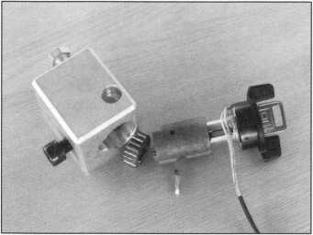

The Sectorater GM holds the locks so the steel wedge can punched out with a 3/32- pin punch, and it presses the lock apart in seconds. A vice is not needed.

The milled space on the side allows a lock casing to be attached to the tool with a 1/4 20 bolt. Simply align the wire past the notch and insert the casing into the steering column bowl. The Sectorater GM is easy to use. For more information, contact Robert Bullard at (520) 790-2290.

Reader Service #28

SPEEDYPIK®

The automatic key ID system. This com­pact unit fits inside your IBM compatible computer in a 51/4 bay the same as a disk drive. The latest addition is a 5,000 key pre-programmed database. Now you can leave the key cutting in the care of an

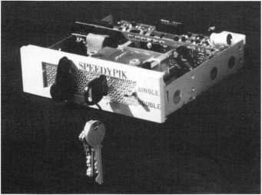

apprentice without a long training period.  
This will free the locksmith up to do other  
work.

(617) 567-1111; FAX (617) 277-7777;  
e-mail: [SPEEDYPIK@juno.com](mailto:SPEEDYPIK@juno.com)  
Reader Service #29

Allstate Locksmith Insurance Program

As a retail or  
mobile locksmith,  
you understand  
how important it  
is to rely on a  
solid, reputable  
company to help  
you with your  
business insurance  
needs. If you have  
any questions  
about your insur-  
ance needs in gen-  
eral, an Allstate  
Agent can provide  
you with addition-  
al information. To  
be referred to an

Allstate Agent, please call 1-800-669-6711.

Reader Service #30

New Tools from Pro-Lock

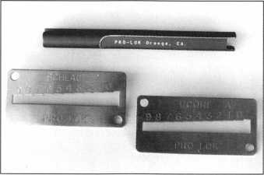

Pro-Lock introduces three new service tools for professional locksmiths. The LT370 MP Removal/Follower is a machined aluminum follower tool that allows removal of upper chamber master pins with a quick twist. New key decoders fashioned from high- grade stainless steel are the KDSC (fits all Schlage keys) and the KDIC for Best/Falcon style IC/A2 interchangeable core keys. Both utilize a “Sure-Step” design and use factory



Allstate

Locksmith

Insurance

Program

Competitive Rates From A Reputable Company

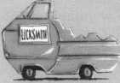

/instate

specifications and tolerances. For more infor­mation, contact: Pro-Lock at (714) 633- 0681

Reader Service #31

Solutions for Auto Lockouts

Pro-Lock offers a new 1997 Car Opening Update. The MACBUP97 Update “All-On- 1 ” format concentrates on specific opening details, color photos and related technical data—devoting one page to each new vehi­cle. The company also announces the A056 Deluxe Zippered Case and two new entry tools—A044 Camry/LexusTool for ’97 models and A045 Loop-D-Loop for late model Mercedes, Volvo and BMW sedans. For more information, contact: Pro-Lock at (714) 633-0681

Reader Service #32

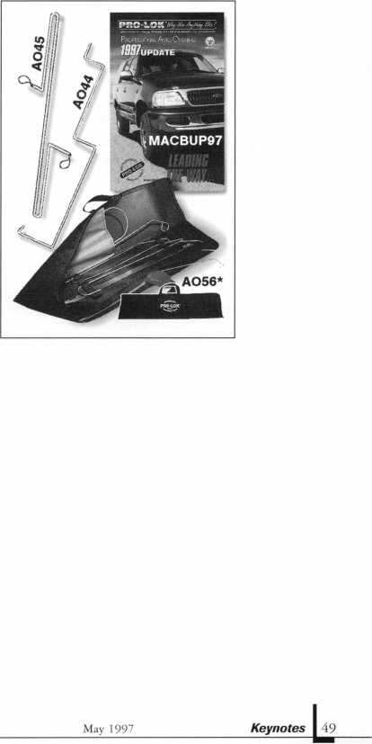

Keynotes

Classified

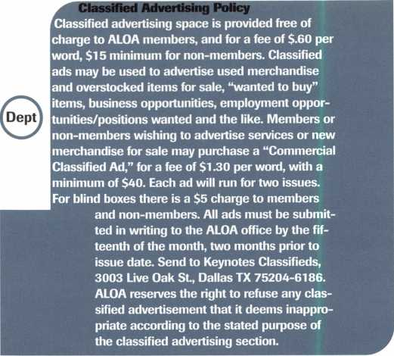

■Employment Opportunities

Help Wanted

Locksmith apprentice. U.S.

Dept, of Labor Certificate pro­gram. Experience and/or a desire to learn, and a penchant for problem-solving a plus. Residence in Boulder, CO desired. Resume by e-mail to: [locksl234@aol.com](mailto:locksl234@aol.com) or

City Lock

2900-C Valmont Road Boulder, CO 80301

Manager

Able Lock has a management position available for an individ­ual with 5 + years experience in the locksmith or related indus­try who is willing to relocate to Las Vegas. Must have the proven ability to supervise employees and manage business operations, including sales and marketing, purchasing, invento­ry control and payroll. Commitment to quality cus­tomer service required. We offer competitive salery and excellent benefit package, including med­ical/dental, matching 40IK and employee stock purchase plan.

Please send resume to:

1911 E. Charleston Blvd.

Las Vegas, NV 89104 ATTN: M. Joseph

Help Wanted

Prominent manufacturer of elec­tronic locks in Atlanta, GA, seeks VP Operations and Logistics. Position requires degree in mechanical engineer­ing and a minimum of 4+ years of experience in industrial pro­ject managment in the electron­ic locks field. 115K. Fax resume to:

Keynotes Classified

(214)827-1810

(Be sure to reference this ad on

cover sheet)

Locksmith Wanted

Locksmith wanted for fast growing company in north western Montana. Prefer CRL, but will train right person.

Needed for counter and outside service person. Salary with pos­sible advancement. Person should have good phone and sales skills. Organized, friendly and clean cut. Fax resume to: (406)543-1173

or call number after 7:00 p.m. Missoula Valley Locksmith ATTN: Peter

Locksmith Wanted

Locksmith wanted for large growing company in Richmond, VA. Must have experience and neat appearance. Earn 35K-40K, paid health insurance, vacation, sick pay and profit sharing. Call or write: Richmond Lock and Safe 711 Johnston Willis Dr.

Richmond, VA 23236 (804) 378-1010

Technician Wanted

Do you enjoy being challenged? We are a fast growing company looking for good technicians to join our progressive company. Must be clean cut and bond- able. Electronics and safe experi­ence helpful. Send resume to: ABC Locksmith Service 4063 Seneca St.

Buffalo, NY 14224

Experienced Locksmith

Experienced locksmith good with hands, excellent with peo­ple. Room to grow with expanding company in Texas. Five-day week, health and life insurance, paid vacation and holidays, profit sharing plan and uniforms. If you want a profes­sional work place with multiple locations, send resume with ref­erences and earning record to: Darvid Inc.

4021 Belt Line Road Suite 104

Dallas, TX 75244-2322

Locksmith Wanted

An established locksmith com­pany in Maine needs a lock­smith experienced in all phases, including masterkeying, safes, access control and high security. This is a growth opportunity for

the right person. Competitive wage plus comprehensive bene­fit package. Send resume to: General Manager Lock, Stock & Barrell, Inc.

P.O. Box 939 Portland, ME 04104

Eager & Willing?

Work? Plenty of it! Looking for the right, three years plus expe­rienced locksmith who is hard working and willing to work night calls and weekends. Must have good personality, well groomed and a people person. Customer service is number one in this company. Must work well under pressure. Positive attitude a must. Must have per­sonal vehicle and tools. Auto, residential, commercial and safe background a plus. Most impor­tant-need somone who is trust­worthy and honest. Please send resume and photo to:

Lockbusters, Inc.

P.O. Box 720475 Houston, TX 77272-0475

Experienced Technicians

If you are good at locksmithing and/or access control, consider this: A well established compa­ny in suburban Arlington, VA, is looking for motivated indi­viduals. You will earn the best salary and bonuses, excellent retirement plan, paid medical and dental, paid vacations and holidays, all tools, truck and uniforms and paid classes. No on-call. You should be a team player, hard-working with a positive attitude, and well versed in locksmith skills. Safe work a plus. Call:

Federal Lock and Safe, Inc.

(703) 525-1436 (703) 525-1637 (FAX)

Unlock Your Potential

Virginia Safe and Lock Serive is experiencing continued business growth. To keep pace with this growth, we are looking for ener­getic, neat, dependable, profes­sional secuity technicians who can perform a multitude of safe and locksmithing duties. Ideal candidate must have excellent driving record and dedication to safety. Minimum three years of commercial related experience and a high school diploma required. Salary commensurate with experience. Benefits include: relocation allowance, company-provided vehicle, free uniforms with weekly cleaning, overtime commission, tuition reimbursement, medical, paid vacations, holidays and sick leave provisions, congenial work environment and employee pen­sion/IRA.

The Washington D.C. and northern Virginia area boasts some of the finest hospitals, aca­demic institutions, shopping centers, and weather. Cost of liv­ing is affordable. Great reloca­tion opportunity.

Qualified applicants contact: Harry Werner (800) 551-2236

Security Technicians Needed

Get lucky and work in booming Las Vegas. Great work environ­ment, great weather, great income potential for experi­enced, motivated, hardworking technicians. Paid holidays, vaca­tion, medical, 401K plan, and in-house training. Don’t delay. Fax your resume today.

Liberty Lock & Safe (702)871-5397 (702) 876-5470 (FAX)

Keynotes

May 1997

Position Desired

CRL wishes position in lock­smith shop as inside/outside field technician. Twenty five years in own business closed due to economy of area. Desires warm/fair weather area. Salary/benefits package equal to experience. Have own equip­ment, but will need van if mobility is required. Contact: Chris

P.O. Box #225

Great Fall, SC 29055-0225

■Business for Sale

Locksmith Business For Sale

Twenty-seven years in business, want to retire. Was asking $50,000—reduced to $30,000. This is a give-away price. Includes inventory, equipment, tools and fully stocked ‘88 3/4- ton Chevy van (42,300 miles) with Adrian cabinets. Move all to your location. Contact: Kenneth Bland (304) 525-0574

Business For Sale

Locksmith business for sale in the heart of London. Established 28 years, family run, good repu­tation. Ideal opportunity. Open to offers. Please contact:

Mr. Fox

(Dial 01144 before area code) (017) 836-2902 (017) 379-8676 (FAX)

Business For Sale

Are you ready to run?

Locksmith business, full service, established 23 years. Located in nice Arden area of Sacremento. 90% established commercial accounts. Two service vans, four employees. Highly visible, excellent reputation. Owners health at risk. 35OK carry note. (916) 674-3411 after7p.m. or weekends

Business For Sale

Locksmith company, residential, commercial, 17 years servicing Washington, D.C. metropolit- ian area. Owners relocating. Contact:

Phil Friedman (410) 484-5272

**Keynotes**

Classmed

Business For Sale

Excellent opportunity for owner/operator in retail/service locksmith business located in northeastern Connecticut. $200,000 total price with 50% seller financing, inventory, equipment, trucks and training included. Large no-competition service area. For details call: Michael Rice

Century 21 Elite Associates (860) 456-9288

Thriving Locksmith Business

Established in 1979 in the Branson, MO, area and has in excess of 250 steady customers plus the potential to obtain a very large number more. Owner is wanting to retire and will assist a buyer with introductions to his existing clientele and will help in obtaining more, also will “help” in any way possible, for a period of one year, the training and hands-on operation of this business. Send inquiries to:

DONSINC P.O. Box 72 Larnpe, MO 65681 [donsinc@tri-lakes.net](mailto:donsinc@tri-lakes.net) (email)

Business For Sale

Lock Technology Corp. New Rochelle, NY Lock Mfg. Co., est. 1974. For details, call and ask for Frank. Owner is retiring. Call (914) 632-4373

For Sale

Sunny Southern CA—successful retail and mobile lock and safe business. Established in 1962. Sale includes: van, inventory, equipment and commercial property. Many commercial accounts. Owner will stay dur­ing transition.

(909) 658-2777

Locksmith Business For Sale

Excellent growth potential, highly profitable, well estab­lished (over 12 years), Chicago, IL, surburban locksmith compa­ny for sale. 80% commerical long-term accounts base. Sales exceeding 500K for last three years. Turnkey operation, fully equipped service vehicles, ideal location showroom and shop on main street, low rent. Owners

can stay on to train. Additional information available to quali­fied buyers. Respond to:

Keynotes Classifieds 3003 Live Oak Street Dallas, TX 75204

Shop For Sale

Southern California locksmith shop in beautiful mountain community. Established over 20 years. Handles 75 percent of surrounding community. Large commercial accounts. Residential, automotive servic­ing. Grosses $110,000 per year. $95,000 with $25,000 down. Seller will carry. Call:

(909) 272-5871

■Wanted to Buy/Sell

For Sale

Redi-line generator—500w continuous. For service van. Automatically turns itself on and off when electrical device (such as HPC 1200) is used. Recently serviced and works perfectly. Sells for $450 new. Will sell for $225 or trade for decent duplicating machine. Call:

Mid-Florida Locksmith (407) 864-9003

Wanted to Buy

Used Ilco KD 87 old style abloy machine and keying kit.

Contact:

Glen Johnson (218)624-4136

For Sale

A-l Pak-a-Punch, brand new in box, never used. Does not have quick change kits. $195. Arrow six-pin originals precut factory keys $.60 per set. Contact:

Ehel’s Lock Service P.O. Box 35973 Las Vegas, NV 89133 (702) 655-7280

For Sale

Silca Club Junior. Like new with assorted keys. Also, cutter for Dom keys—$800. Call:

Dave at (201) 827-5060

For sale

Open Tidel TACC 11 safes with ease. Sometimes they can be opened without drilling. $19-95

shipping and handling for tips and drill points. Send check, credit card or money order to: Lonnie McKinney, CML P.O. Box 3691 Salina, KS 67402-3691

Wanted to Buy

Medeco code machine for 10-11 series commercial keys. Contact: Leroy

Donaco Enterprises (505) 526-4106 (phone!fax)

For Sale

Diebold safe and safe deposit locks, cases, time movements, handles, cylinders and related products. Call for fax list. Safemasters at (301) 565-2100

■Commercial Classified

High Security Auto Keys

Aero Lock provides high securi­ty auto keys by code. Shipped via express mail. Cut and out the same day. $22 delivered. Price good in U.S. territory only.

Aero Lock

3675 New Getwell Rd. #9 Memphis, TN 38118 (800) 627-9433

aerolock@ix. netcom.com

Help! Masterkeying.

Let us do your masterkeying. Computer generated custom systems created. We can: formu­late only (key schedule/bitting); formulate and supply system (“soup to nuts”); key your cores sent to our facility; high securi- ty-Medeco, Schlage, Primus, etc.; cut all keys necessary. Commercial Lock, Inc.

Ill Broadway NY, NY 10006 (212) 766-0774

May 1997

Keynotes



|  |  |  |  |  |
| --- | --- | --- | --- | --- |
| 1 |  |  |  | Report _ |
| j |  | | |  |
|  | | | | J James Watt, CML  Committee Chairman |

ALOA is asking chapters sponsoring educational events to help  
promote the PRP.

**PRP Dates June 8**

Portland, OR Clark Security Products Amy Barrett [206) 467-3000

June 8

Ruidoso, NM New Mexico Chapter Steven Highland, CML [505) 884-0046

June 22

Fargo, ND

North Dakota Chapter Todd Ladwig, CML [701) 232-9440

June 29

Rosemont, IL Clark Securitiy Products Marlene Sealey-Frey [619) 974-5273

July 19

Boston, MA

North Bennet Street School Jack Hobin, CPL (617) 227-0155

July 31

Reno, NV ALOA ‘97 Jessica Vasquez (214) 827-1701

August 1

Reno, NV ALOA ‘97 Jessica Vasquez (214) 827-1701

August 16

Charlotte, NC

North Carolina Locksmiths Association Granger Marley, CML (919) 859-6060 (919) 851-6928 FAX

August 17

Ellicott City, MD Clark Security Products Marlene Sealey-Frey (619) 974-5273 (619) 974-5284 FAX

30 Day Application Period on PRP Classes

I would like to announce that Jim Glazier, your education chairman, and I have worked out a special deal for ACE education, the PRP and ALOA chapters. With the new lower cost of education to the chapter pro­grams announced last fall, I approached Jim about holding PRPs in conjunction with these educational opportunities. Jim and I finalized the following agreement:

Any chapter that contracts with ALOA for an ACE education class or classes may also schedule a PRP sitting for the same event. In the past, chapters had to abide by the rules of the PRP meeting the require­ment of a minimum of 15 people per sit­ting. For this new joint program, the PRC will waive the number of people required; however, it is suggested that the PRC would like to have at least six to eight people regis­tered to help defray PRP shipping costs. With the program of bringing education and the PRP to chapters, ALOA is asking chapters sponsoring educational events to help promote the PRP.

The only other requirement is to inform the PRC chairman or the Education chair­man at least 90 days in advance of the event date to make sure that all paperwork can be completed and the necessary forms mailed to the sponsoring organization. The same PRP sitting per person costs will still apply, as well as all other PRP rules.

If you have any questions about this pro­gram, please call either Jim Glazier or me for further details.

**Illinois State Locksmith Licensing Test**

The state of Illinois and the Department of Professional Registration gave the first Illinois State Locksmithing Licensing exam on March 8 in Hillside, IL.

Former president Stanley Haney, CPL, attended as the official ALOA representative for this first historic sitting. Eight lock­smiths sat and completed the mandatory and two electives. The comments made about the exam were favorable.

Those locksmiths who pass the Illinois State Locksmith Licensing exam may apply to the ALOA Proficiency Registration

Committee for ALOAs Certified Registered Locksmith (CRL) status for a fee of $15. By applying, you will receive your CRL certifi­cate and lapel pin. It will also entitle you to proceed in the proficiency registration pro­gram to obtain your Certified Professional Locksmith (CPL) and Certified Master Locksmith (CML) credentials, if you so desire.

**Obtaining RL Status**

When the original PRP was developed, there were three certifications: RL, CPL and CML. At that time, there were RLs (those with ALOA memberships numbers indicat­ing they had been in the industry a consider­able number of years) who had been grandfa­thered into RL status, and those who has passed the mandatory and two electives for RL status.

In 1990, the PRC upgraded the designa­tion for those persons who have passed the first level—RL—via testing to Certified Registered Locksmith—CRL. The rationale for the change was that those persons who had taken and passed the ALOA qualifying exams for RL status had been certified through a definitive process. The persons who applied for and were grandfathered into RL status achieved that status via a more arbitrary method—as un-tested. While being un-tested is not viewed as being a less­er status, a PRP category was created that allowed people to achieve certification by means other than testing. One of the ways to receive RL status was through ACE Education AEUs (ALOA Educational Units)—a common standard throughout the country for advanced education.

Shortly after the first of the year, several members have sent requests for RL status. Since the PRC has developed the possibility of receiving an RL certification, we have received five requests for that certification.

It would probably help the rest of you who might want to achieve certification in this manner if you knew what the criteria for RL status was. The following is ALOAs cri­teria for RL status:

The PRC will award a Registered Locksmith (RL) certification to any person

52

Keynotes

May 1997

who submits written proof-of-attendance for at least 12 full day, eight hour class certificates awarded between 1994 and present. Upon verification of the submitted certificates against that person’s education history record, they will be awarded an RL certificate and lapel pin.

Should a person with an RL certification wish to advance further in ALOA PRP, they must complete all requirements needed for Certified Registered Locksmith status through testing.

For an application for RL Certification, please contact Jessica Vasquez, Meetings and Education Coordinator for the ALOA head­quarters, at 214-827-1701, or James M. Watt, CML, CPS, PRC chairman at 406-721-9797.

**New Certifications:**

CMLs

Mayo, John R./Charlottesville, VA

CRLs

Bellizzi, Frank H./Altus,OK Brasel, Robert W./Prattville, AL Burgau, Lonny R./East Grand Forks, MN Burger, Joseph A./Lawrenceville, GA Calabro, Anthony C./Exeter, NH Campbell, John P./Independence, KS Fincher, Craig M./Cleveland, TN Fiorini, Anthony C./Kenhorst, PA Griswold, Fred B./Old Saybrook, CT Hamilton, Phil/Bozeman, MT Haynie, Michael K./Warner Robins, GA Holger, Roger G./Stillwater, MN Lindemann, Michael D./Coon Rapids, MN Luhrs, John P./Florence, AL Murray, Stephen K./Douglas, MA Nicholas, Roderick K. Jr./Hampton, CT Parsons, Bert R./Tulsa, OK Portie, James E./Slidell, LA Rice, Jerry E./Okahoma, OK Tascott, Bret L./Kailua, HI Wark, Gay la E./Auburn, AL

IB?, v A About the Chairman: James Watt, CML, CPS, owns and oper­ates Art and Ray’s Lock and Safe in Missoula, MT. He has been an ALOA member since 1977 and is also serving as the Northeast Regional Vice President of ALOA.

'MAHA you ne^d it ft

WHOLESALE

lARDWARE

* LCN
* Von Duprin
* ILCO
* Sargent & Greenleaf

(Arm-A-Door)

* Roton
* Detex
* Simplex
* Norton
* Stanley
* Rixson
* Glynn-Johnson
* Adams Rite
* Jackson
* Master Padlock
* Folger Adam
* Locknetics
* Rutherford

(EFF-EFF)

* Telkee

To Order Call Toll Free

Phone: 800-238-4566 • Fax: 800-538-4566



Call Or Write for our FREE Full Line Catalog

Omaha Wholesale Hardware  
P.O. Box 3628 • Omaha, Nebraska 68103



Reader Service #6

NEW ILCO DISTRIBUTOR!!

Monday Security Corporation  
**1-800-886-6721**

Contact Laura for details  
on dealer discounts

We carry almost every make  
and model of new and  
used safe deposit locks,  
and safe parts, specializing  
in the antique parts.

Have you received our  
catalog?

Reader Service #7

May 1997***Keynotes \ 53***

|  |  |
| --- | --- |
| nr*, j | lips |
| Trade |  |
|  | ■ |

No Need to Buy New

Every once in a while you encounter a key in the knob lock that you cannot pick, and after exhausting all other avenues to bypass this lock, you pull out the drill and destroy an expensive cylinder.

Well, there is an easier, faster and less expensive way. If you take that same drill and a 11/2-inch hole saw—without the pilot drill—you can saw the front of the knob off and expose the cylinder for easy removal. If it is an Orbit or Ball style of knob, you don’t even need a guide as the saw will tend to stay centered on the knob.

A Plymouth or other flat face style may need a guide to keep you from wandering.

In this case, all you need is a small piece of 1/4-inch plywood about two-inches by six- inches. Saw a hole with the same hole saw towards one end. You will have to use your pilot drill, of course, but then you can hold the plywood against the face of the knob and grasp the knob at the same time with one hand and use the drill with the other hand. This is all the control you will need to keep the saw on course.

You will be surprised how fast and easy it is to saw the face off the knob. A new replacement from Schlage retails for $13.50, but we have all used locksets lying around that we can rob a used knob from.

Tom Taylor, CPL #6835

Here’s the Difference

Ford 8-cut and 10-cut—what’s the differ­ence?

Distance from tip to center of cut (spac­ing) given in inches.

As you can see, the spaces and depths for the 8-cut and 10-cut are almost the same. In fact, you can use a H60 key blank (10-cut) and put the right 8-cut space and depth and code on it, and the key will work all the locks on the 8-cut system. You can use the Curtis cam and carriage for the 10-cut with a H60 keyblank and cut your 8-cut X code series—remember not to use the spaces next to the bow—and the key will work the locks. If you want to use the 8-cut blanks or the blanks with a transponder, you can take the H60 key you have cut and duplicate it. Be sure that your key wise is bottoming on the bottom of the key blade and not on the groove. The blade dimension on the 10-cut and 8-cut are the same (.354).

Advantages: You do not have to buy and carry the Curtis cam and carriage (Ford 5) or Framon spacing block #3 and stop F#2MS552.1 do not know about the Ilco Exacta plate, punch and die or the HPC1200CM cards, but if the blade of the keyblank is not in contact with any of the holding methods, you can use your 10-cut tooling on the 8-cut key blank. (Except for the Curtis clipper where you have to use the H60 keyblank.) If you’re out of the H75, you now know you can use the H60 key- blank.

George Steiner #021685

No Lockout

Upon arrival at a Honda Civic lockout, I

|  |  |  |  |  |
| --- | --- | --- | --- | --- |
| A,B,C,D,E Code Series | | | | |
| 10 9 8 | 7 6 | 5 | 4 3 | 2 1 |
| 10-cut H60 1.032 .941 .848 | .756 .664 | .571 | .478 .386 | .293 .201 |
| 0001X-1706X Code Series | | | | |
| 1 2 3 | 4 5 | 6 | 7 8 |  |
| 8-cut H75 .875 .753 .661 | .568 .476 | .384 | .292 .200 |  |
| Depths (8) Cut 1=354 | 2=329 | 3=304 | 4=279 | 5=254 |
| Depths (10) Cut 1=352 2= 326  Codes on the 10-cut are given from tip to bow. Codes on the 8-cut are given from bow to tip | | 3=301 | 4=275 | 5=250 |

54

Keynotes

May 1997

/How To Become A Trade Tipper

Each month, the Associated Locksmiths of America (ALOA) holds a “Trade Tips” con­test in Keynotes for ALOA members. In addition to helping other locksmiths by sharing your knowledge, there are three levels of prizes to be awarded:

June 1997

Sargent & Greenleaf 6120 electronic safe lock

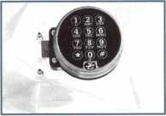

Grand Prize: An expense-paid trip to the ALOA ’98 Security Expo

Each year, the ALOA Publications Commit­tee selects one outstanding tip, the author of which receives a seven-day ALOA con­vention package that includes travel and accomodations.

Authors of any Trade Tip published will still receive $20.

Want to Participate?

Mail your best idea (including photos,

illustrations or parts, if necessary) to

Keynotes

Trade Tips Editor

3003 Live Oak St.

Dallas, TX, 75204-6186.

All entries are sent to the Trade Tips editor with the author’s identity deleted. The tips must be submitted exclusively to Keynotes and become the exclusive property of ALOA. Tips are judged on the basis of accuracy, professionalism, ethical stan­dards, originality and usefulness.



found that the keys were in the trunk. After opening the passenger door, I found no key lock on the glove box from which to obtain a code, and the manual trunk release beside the driver’s seat was locked. Inspecting the cover for the trunk release gas flap, I found a rectangular snap-out tab on the cover’s top. Raising the tab exposes a Phillip’s screw. With the screw out, the cover can be removed—if the trunk lever is not locked, but if it is locked, don’t despair. Pry the cover up gently from the side nearest the driver’s door while using a second small screwdriver to move the cover toward the rear of the car, clearing the two-lever han­dles. When the cover is removed, you will readily see how to move the cam that blocks movement of the tmnk lever. You have just done the same thing that the key does. Replace the cover and you are through.

Larry Wright #9558

Editors Note: Since there was not a column in the April issue of Keynotes, there will not he an April monthly winner. The May winner will he announced in the June issue.

The 1997 Grand Prize winner is Tom Kipp, #21921, for his winning tip “Primus” in the December 1996 issue of Keynotes.

AAbout the Department Editor: Tony

Ramunno, CML, CPS, owns and operates Allied  
Locksmiths of Youngstown in Youngstown, OH.  
He has been in the locksmithing business for 25  
years and has been an ALOA member for 25  
years. He also serves as the chairman of the  
Library-Museum Committee for ALOA.

ALOA

Extra



Dept]

**Combined Keynotes**

Just another reminder that you will be receiving a combined November/December 1997 issue of Keynotes. The funds from the separate December issue are being used for the membership survey to be sent to all ALOA members in late spring 1997. Make the most of this change to make your needs and opinions known and help ALOA pre­pare to restructure member benefits and pro­cedures in your best interest.

**Gotta Have the Word**

If you’re planning to go online to get the lat­est scoop on ALOA happenings, you must have the correct password: lockup97. The ALOA web site is full of helpful informa­tion, so be sure to stop by.

**HUF Requests**

Interested in obtaining a copy of the key codes for the HUF 10-cut key system? ALOA will be happy to provide you with a copy—upon request. Please fax your request to ALOA headquarters at 214-827-1810.

Fax requests will be filled within 60 days.

**More Study Help**

In the March ’97 Keynotes article “Master Masterkeying on the PRP” by Claire Cohen, CML, one item was inadvertently omitted from the list of “suggested study material.” Masterkeying by the Numbers (RSG Publishing Corporation) by Billy B. Edwards, CML, should also be consulted.

**Directories Online**

The ALOA staff has been receiving several phone calls from members wondering where their new directory is. The staff would like remind you that membership directories will now be printed every other year. Updates and additions will be made on the ALOA web page at [www.aloa.org](http://www.aloa.org).

**Goodbye to a Friend**

James L. Faul died Feb. 8, 1997, following complications associated with congestive heart failure. Jim operated Jim’s Lock and Key Company.

Jim is survived by his wife Gaylene A. Faul and his son, Zan T. (Vicki) Faul. He will be missed.

**Sign Contest**

It’s time again for the ALOA Truck and Storefront Signage Contest. It’s easy to join in the fun—simply follow these contest rules:

* Participants should send in a color 3x5 photograph by July 1, 1997. Be sure your photo is current—last years photos are not acceptable.
* Last year’s winners are not eligible to par­ticipate and all entries become the exclu­sive property of Keynotes.
* Judging will be done by the Publications Committee and Keynotes staff.

Entrants will be published in Keynotes and the winners will be announced at the ALOA ’97 Security Expo.

This year’s prizes have been generously donated by Mike Groover of IDN and John Cannon, CML, of Locks Unlimited. Details next month!

Keynotes Advertisers Index

|  |  |  |
| --- | --- | --- |
| RS# | Advertiser | Page |
| 10 | DHI | IBC |
| 9 | JLM Wholesale, Inc. | 58 |
| 100 | Jet Hardware Mfg, Inc. | BC |
| 8 | Locksmith Publishing Corp. | 56 |
| 2 | Mas-Hamilton Group | 8 |
| 5 | Mas-Hamilton Group | 29 |
| 7 | Monday Security Group | 53 |
| 6 | Omaha Wholesale Hardware | 53 |
| 3 | Security Technology & Design | 1 |
| 4 | Winfield Architectural Lock | 25 |

May 1997

Keynotes



WSWWPWBWW

**order contact:**

850 Busse Highway • Park [847] 6^2-5940

Locksmith Publishing Corp

Fr<=»p> Information - Rp^rlpr ^p»r\/irp» (~arH ifR



Focus

3n Education

llame^Tazier, CML

Education Chairman

Education is becoming more prevalent in the market place.

**/Upcoming ACE Classes**

ALOA ’97

July 28-Aug. 1, 1997 Reno, NV

Contact: ALOA Meetings Department [214] 827-1810 FAX; [800] 532-2562 Approx. 45 full-day classes, 30 half-day classes and six evening seminars More information TBA

Gateway Locksmith Association

September 6-7, 1997 St. Louis, MO

Contact: Steven Meinhardt [314] 638-6440

Master Key Methods & Formats Instructor: Jerome Andrews, CML

Nutmeg Chapter

May 31, 1997

Meridian, CT

CCTV for the Locksmith

Instructor: James H. Glazier, CML

New Mexico Convention

June 6-7, 1997 Ruidoso, NM

Contact: Steve E.Highland, CML [505] 884-0046 Five ACE Classes

North Dakota Chapter

June 21, 1997 Fargo, ND

Contact: Todd Ladwig, CML [701] 232-9440

Professional Bypass Techniques Instructor: C. Allen Halverson

Grand Canyon Chapter

October 18-19, 1997 Phoenix, AZ Contact: John Ilk [520] 474-8879 Domestic Auto Service Instructor: Ray DAdamo, CML

By the time you read this, ACE will have completed a five-day basic locksmithing class for 15 students at the Defense Personnel Support Center in Philadelphia,

PA. Jim Glazier, CML and C. Allen Halverson will have brought 15 employees of the Defense Department a very compre­hensive basic locksmithing class that will prepare them for an apprenticeship in the locksmithing industry. Each student will be offered an apprentice membership in ALOA as a part of this program, which is intended to prepare employees of the Defense Department for the job market if and when they are laid off.

Such education is becoming more preva­lent in the market place as many employers are downsizing their staff. ALOA/ACE will be there to provide the education and sup­port these individuals who will be looking for a position in the locksmithing industry.

It is felt that by offering such education, this will not only benefit the student, but should be of great benefit to the prospective lock­smith employer—who can now find trained personnel. ACE will be looking for more opportunities such as this in the near future in the hopes we can assist the industry.

Time is Growing Short! If you haven’t sent in your registration yet for ALOA ’97 Security Expo and classes in Reno, NV, there is no better time than right now. We will be having many new and exciting classes this year. Just review the brochure, and if you haven’t gotten one yet, call ALOA at 800- 532-2562 and get one so you can be a part of this exciting Security Expo and the educa­tion that will be available. This is a great time to renew friendships and meet with the distributors and manufacturers who have many new products available this year. Our industry is growing by leaps and bounds, and you certainly want to be a part of this growth. Without the knowledge that you gain at a convention and trade show, you may be left behind while others are making all the money! The dates for the expo are July 28 to Aug. 1, 1997, in beautiful Reno,

NV, where there are many exciting side trips

for the family and you. Come and join us for a great time, and please don’t forget the membership meeting where you will be asked to elect 80 percent of the Board of Directors and officers. This will be a Saturday morning breakfast meeting with all business completed in time to attend the show.

The Education Committee and the Proficiency Registration Committee had worked out a new program at the spring board meeting in March. In all future ACE classes, we will be attempting to have a PRP sitting the next day, or, for a two-day class, possibly on Sunday evening. The instructor will then be able to proctor the PRP sitting, and this will help to defer expenses of the PRP test. The 15-person minimum will not be in effect in these cases and we can hold a sitting with as few as six to eight individuals. Another program to help the chapters and associations keep costs down!

One more new help for the members will be the Association Officers’ Training Class, which was given to all the officers and direc­tors present at the spring board meeting in March. They are now available and ready to train any and all chapter or association offi­cers, free of charge! This is a deal no one can refuse because this is an excellent class for any present or prospective officers of the chapter or association. The manual, which will be provided, will help with: conducting meetings, setting up and negotiating with hotels for free rooms, keeping members interested in attending meetings, advertis­ing and special programs that enhance your membership. The education committee and ALOA will be picking up most of the cost and only ask that the host chapter or associ­ation arrange for the classroom, a white board, markers and a flip chart. The host will also be asked to provide lodging for the officer or director, their travel expenses and meals while they’re instructing. Consider inviting one of your ALOA officers or direc­tors to put this class on for you. I can guar­antee that your chapter or association will

Continued on page 58

May 1997

Keynotes



Not only are we stocked with the products just an “order takef’ you are getting a you see below but we are equally stocked security hardware professional that really with quality people too. JLM’s technical knows what they are doing. Offering ability to solve your problems wholesale prices, superior

are second to none. With years StOCk! sa*es assistance, topofthe line

of experience in the security *" * products, large inventory and

hardware business, JLM provides sales a customer focused attitude, JLM can assistants that are trained and up to date lead you to new areas of higher profits and on the latest advances in the industry, success rather than leaving you wonder- When you call JLM, you are not getting ing what went wrong.

Aiphone **/** Altronics /Adams Rite /Alarm Lock / Folger Adam Security  
Glynn Johnson f LCN Closers / Locknetics Security Engineering  
Select Products / Roton l Securitron / Security Door Controls / Von Duprin

sale Prices Superior Service

Phone: 800-522-2940 / 810-628-6440  
Fax: 800-782-1 160 / 810-628-6733  
Website: wvww.jlmwholesale.com

Wholesale Prices

Reader Service #9

**CS** ik r **program has**

Helped Children for «s£> long,

W e remember making these

w \ th macarOni I n .s J" e a d of

pas ^_a.

FocusOn Education

Continued from page 57

be better if the officers are properly trained in this class. If you have any questions, do not hesitate to contact me at 301-831-5454.

As a matter of clarification, Education and PRP reviewed the poli­cy established on awarding the RL designation to those who had completed and received 12 AEUs. It is evident that there may be some confusion on this and as a result, it was decided that an AEU will be awarded for each “full-day ACE class.” This is to be defined as a class scheduled by ACE/ALOA with an ACE instructor, where there is at least seven and a half hours of instruction given to the stu­dent. Half-day classes will not be eligible for the award of an AEU.

It is the student’s responsibility to request the RL certification. Send your request to Jessica Vasquez, ALOA headquarters, 3003 Live Oak St., Dallas, TX 75204. Included in this request must be a listing of the ACE qualifying classes that have been taken since July 1993 when the program begun. No credit will be given for classes prior to July 1993 since the program was not in operation before then. It is suggested that copies of the class certificates be included with the request as proof that the class was successfully completed. If there have been 12 AEUs as a result, the PRP chairman will award the designation of “RL” to the requester.

I truly hope to see all of you at ALOA ’97 Security Expo in Reno. Please stop by the Education Office and let myself, Vice Chairman Bob Stafford or Jessica Vasquez know what we can do to better serve you. This is our desire and hope, so let us know about your feelings on this subject. Until next time, have a very successful day and learn something new today.

I About the Chairman; James Glazier, CML, #14240, is a

retired police officer and operates Security Plus in Mount Airy, MD. He also serves on the Finance, Convention and Personnel Committees of the ALOA Board.

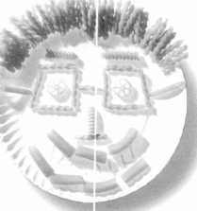

Many things have changed at Head Start since we opened in 1965. The need for help from the  
business community hasn’t. Whether you work at a grocery store or paint store, automotive shop or  
copy shop, ad agency or insurance agency, the donation of your goods and services makes a big  
difference in the quality of our program. And in the lives of all the little faces who benefit from it.  
To find out how you can help, call your local Head Start.

rm j* Nurture the future

BE A HEAD START VOLUNTEER

Keynotes

May 1997



|  |  |
| --- | --- |
|  | News _ . .... |
| , r  Chapter |  |
|  | ■ DanEnJamum, CML  Committee Chairman |

It is fantastic and packed full of great ideas

In this issue of Keynotes, I would like to give you a special report from the ALOA board meeting concerning chapters. One of the first things I would like to report to you is that plans are underway for the third annual Chapter Officers’ Social to be held at ALOA ’97 in Reno, Nevada. Through this once a year special event, your association—

ALOA—can pay tribute to the officers— past and present—and give special recogni­tion to those who work hard to motivate and build the chapters, and who contribute many hours of their own time and finances to better the industry. This event is planned for Friday afternoon and will take on the same format as last year with the highlight being an attendance contest. The rules are simple. The chapter with the most number of past and present officers attending the social meeting will take home to their chap­ter a grand prize of three hundred ALOA bucks. There will also be a second prize of two hundred, and a third prize of one hun­dred. These ALOA bucks may be distrib­uted any way the winning chapters choose. They may be redeemed for individual mem­bership dues or put together to pay a portion of an ALOA ACE training class at your chapter. They may also be redeemed for use at the next ALOA show.

Another announcement I am excited to inform you about is that of the newly com­pleted Association and Chapter Officers training course. This training course was designed especially for ALOA by Mr. Bob Lawrence, CML, from San Diego, CA. It will be presented in its new form for the first time at the MLANJ trade show May 19, 1997. The instructor will be Mr. Jim Glazier, CML, chairman of the ALOA Education Committee. If you want to learn how to improve attendance, increase interest and participation, make better meeting plans or just try to be a better officer, this class is for you! It is fantastic and packed full of great ideas that will energize any crowd! This is approximately a six hour training course and can be given at individual chap­ters or tied in with other training classes, such as MLANJ is doing.

Here are a few suggestions you might put to use right away to improve your chapters and make stronger, better meeting sched­ules. In a recent article, I wrote about the importance of putting together a good pro­gram committee and what their responsibili­ties were to the rest of the chapter. For the program committee, it is very important to choose an interesting subject to learn about, but it is also equally important to choose a good speaker. Speakers can sometimes make or break a workshop or training class. Their delivery and attitude, as well as the informa­tion they provide, is essential for an educa­tional and successful meeting. As you con­sider speakers, their knowledge of the sub­ject matter is vital, and up-to-date informa­tion must be at hand. Don’t be afraid to question a potential speaker to determine their qualifications to teach. It’s better to determine that someone is not qualified ahead of time than in front of the group after a bad presentation. One way to find out about a particular speaker is the same way some of our customers choose to call us— personal references. You can ask chapter members to suggest a speaker they may have had in the past. If you are considering a manufacturer’s rep, ask questions about who they will send and let them know you expect their best qualified person. A little research ahead of time can save embarrassment later. Another plus will be increased attendance if word gets out that the meeting someone missed was great.

That’s all for now. Don’t forget to make those plans for ALOA ’97 in Reno, NV. See ya there!

**From the Chapters**

News from OK

The Oklahoma Master Locksmith Association would like to welcome four new members:

Thomas E. Humes

Ed Humes Locksmith, Edmond, OK Harvey Rasmussen

McAlester Lock, McAlester, OK Frank M. Wirth

OK County Sheriffs Office, OKC, OK

Terry Horton

Holder’s Security, Tulsa, OK

Send in Address

The Penn-Ohio Locksmith Association is in the process of compiling a list of e-mail addresses of POLA members. If you have an e-mail address and/or web page, send your information to [brasskey@wcnet.org](mailto:brasskey@wcnet.org)

Grand Canyon Chapter

The Grand Canyon Chapter will be running a copy of the ALOA scholarship application in their newsletter. The chapter decided to match funds from ALOA to any GCC mem­ber who wins a scholarship.

North Dakota Chapter

The North Dakota Chapter and the Northern Prairie Locksmith Association will now be co-publishing a joint newsletter.

News About Dues

If you haven’t had a chance to pay dues to your chapter or association, there’s no time like now! Be sure to send in your dues as soon as possible—your chapter or association thanks you!

JAbout the Chairman: Dana

Bamum, CML, #05444, operates South Penn  
Lock & Safe Co. in Media, PA. He also serves on  
the ALOA Membership, Chapters, Scholarship  
and Convention committees, as well as having been  
on the board of directors of the Greater  
Philadelphia Locksmiths Association (GPLA).  
Dana has also sponsored many new ALOA mem-  
bers. Dana can be reached at FAX (610) 565-  
9902 or e-mail him at [dlbamum@aol.com](mailto:dlbamum@aol.com).

May 1997

Keynotes

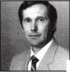

**Back**

Page

by Laurie Kline

To Stop a

Swindle

(To Catch a Thief was already taken)



He said it was no big deal. He said anyone wouldVe done it. He even said it was part of his job. But to Linda Ramsey, what he did ranked higher than just “a good deed”—what he did helped her business keep its word.

Linda is the owner of B & B Enterprises, Inc., a recovery agency located in Fayet­teville, North Carolina, with 272 branches nationally. Recently, the automotive repo division at the Davenport, Michigan loca­tion had taken two ’96 Honda all-terrain vehicles (ATVs) into possession. The ATVs were anchored-chained to the wall on the lot. The lot sits inside a thick barbed wire fence with a not-too-friendly rottweiler standing guard.

One evening, a daring but dumb thief decided he wanted to call the ATV his own. He hacked through the fence, drugged the dog and cut the padlocks. And after a while, he hauled his new toy all the way home.

The catch? Mr. Thief didn’t have the origi­nal key. Unbeknownst to him, this would be his tragic flaw because, short of hotwiring the vehicle for every joy ride, he’d have to get one made. And Linda was one step ahead of him.

She told the manager at the Davenport lot to notify all the locksmiths within a 200 mile radius. The manager called around and explained to the locksmiths that if someone came into their shop to have a key made for this vehicle, they should notify Linda. Four days later, Linda received a call from Betten­dorf Lock and Key, located in Iowa.

Steve Malmberg, the general manager/part owner of Bettendorf, heard about the robbery and taped a note by his cash register with Linda’s number—just in case anyone inquired about getting a key cut for the Honda. When a man called and said he was bringing in his Honda ATV’s actual ignition so he could have a key made, Steve got suspicious. He called up the Dav­enport office, but in order to avoid accusing the wrong person, they had to ensure that the ATV key they had—the original—fit the ignition the caller had. So, they brought

the original key right over. Steve stood by and waited.

Soon the man who had called entered the shop and asked to have a key made. He handed the ignition to Steve. He took it to the back to see if the key from Davenport fit. It did. A perfect match.

Steve called the police and then had to find a way to stall the man until they arrived. He did everything he could to detain him, but he soon ran out of things to do. At this point, he had not choice but to hand over the ATV key. Luckily, another customer in the shop had a cellular phone and agreed to follow the man and keep con­tact with Steve on his whereabouts. Later that afternoon, thanks to Steve, his cus­tomer with the cell phone and the police, the thief was caught—but not without an almost-mishap. In all the confusion between the cars, the helpful customer was almost pulled over instead of the thief. Luckily, the police were able to act quickly and appre­hend the right person. The thief was brought up on charges and the ATV was returned to the Davenport lot.

“If Steve had not called us, there would’ve been no way we could’ve found it,” said Linda.

But to hear Steve tell the story, it’s as if he’s helped stop crimes on a daily basis.

“I don’t think of it as a big deal,” he said. “If you call me up and say it’s stolen, I’ll help you out.”

Linda said she offered Steve a reward, but he didn’t want any compensation. To him, returning the ATV to its rightful place was simply something he should do.

“In my line of work, “ she said, “I never get to see the ‘help-your-neighbor’ side of people.”

Through the years, Linda’s company has maintained a 100 percent recovery record. And with one locksmith’s help, the compa­ny’s reputation remains intact.

“It wasn’t anything,” replied Steve. “I just did my job.”

But stopping a swindle is something.

It’s something that helped someone else.

Keynotes

May 1 997

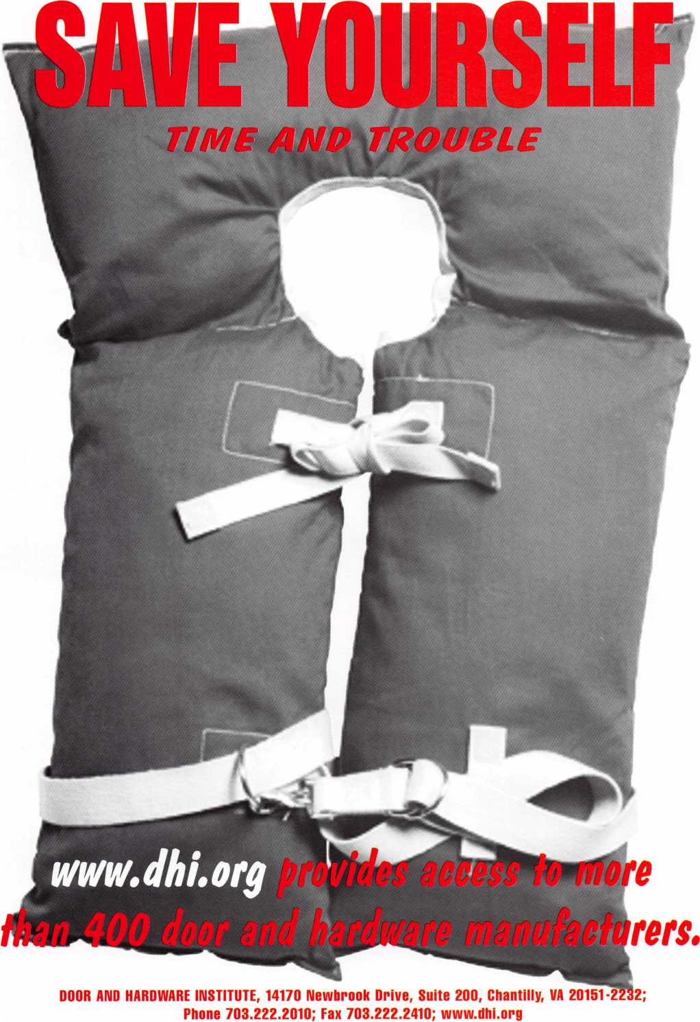

Free Information - Reader Service Card #10

**Have You**

**Cut a**

**Lately?**

■***&<->

**N\*** ;:*&*’ **H : -**

**Official Licensed Product 1**

Licensed Product

**PRECISION ENGINEERED AND MANUFACTURI  
USING THE FINEST BRASS AND NICKEL PL ATI**

**AVAILABLE NOW FROM YOUR JET DISTRIBUTt**

Free Information - Reader Service Card #100

**JET HARDWARE MANUFACTURING CORP**

800 Hinsdale Street, Brooklyn NY 11207

